UNITED STATES
SECURITIES AND EXCHANGE COMMISSION
Washington, D.C. 20549

FORM 8-K

CURRENT REPORT
PURSUANT TO SECTION 13 OR 15(d) OF THE SECURITIES EXCHANGE ACT OF 1934

Date of Report (Date of earliest event reported): July 21, 2026

UNITED COMMUNITY BANKS, INC.
(Exact name of registrant as specified in its charter)

Georgia | 001-35095 | 58-1807304
(State or other jurisdiction of incorporation) | (Commission file number) | (IRS Employer Identification No.)

200 East Camperdown Way
Greenville, South Carolina 29601
(Address of principal executive offices)

Registrant’s telephone number, including area code:
(800) 822-2651

Not applicable
(Former name or former address, if changed since last report)

Check the appropriate box below if the Form 8-K filing is intended to simultaneously satisfy the filing obligation of the registrant under any of the following provisions:

 | ☐ | Written communications pursuant to Rule 425 under the Securities Act (17 CFR 230.425)
 | ☐ | Soliciting material pursuant to Rule 14a-12 under the Exchange Act (17 CFR 240.14a-12)
 | ☐ | Pre-commencement communications pursuant to Rule 14d-2(b) under the Exchange Act (17 CFR 240.14d-2(b))
 | ☐ | Pre-commencement communications pursuant to Rule 13e-4(c) under the Exchange Act (17 CFR 240.13e-4(c))

Securities registered pursuant to Section 12(b) of the Act:

Title of Each Class |  | Trading Symbol(s) |  | Name of Each Exchange on Which Registered
Common stock, par value $1 per share |  | UCB |  | New York Stock Exchange

Indicate by check mark whether the registrant is an emerging growth company as defined in Rule 405 of the Securities Act of 1933 (§230.405 of this chapter) or Rule 12b-2 of the Securities Exchange Act of 1934 (§240.12b-2 of this chapter).

Emerging growth company ☐

If an emerging growth company, indicate by check mark if the registrant has elected not to use the extended transition period for complying with any new or revised financial accounting standards provided pursuant to Section 13(a) of the Exchange Act. ☐

Item 2.02 | Results of Operations and Financial Condition.
On July 21, 2026, United Community Banks, Inc. (“United Community”) issued a press release announcing financial results for its second fiscal quarter of 2026. The press release is furnished as Exhibit 99.1 to this Current Report on Form 8-K.

The information furnished pursuant to this Item 2.02, including Exhibit 99.1, shall not be deemed “filed” for purposes of Section 18 of the Securities Exchange Act of 1934 (the “Exchange Act”) or otherwise subject to the liabilities under Section 18 of the Exchange Act and shall not be deemed to be incorporated by reference into any filing of the Company under the Securities Act of 1933 or the Exchange Act.
Item 7.01 | Regulation FD Disclosure.
On July 21, 2026, United Community will hold an earnings conference call and webcast at 9:00 a.m. (Eastern Time) to discuss financial results for its second fiscal quarter of 2026. The press release referenced above in Item 2.02 contains information about how to access the conference call and webcast. A copy of the slide presentation to be used during the earnings call and webcast is furnished as Exhibit 99.2 to this Current Report on Form 8-K. The slide presentation also will be available on our website, www.ucbi.com, under the “Investor Relations – Events and Presentations” section.

The information furnished pursuant to this Item 7.01, including Exhibit 99.2, shall not be deemed “filed” for purposes of Section 18 of the Exchange Act or otherwise subject to the liabilities under Section 18 of the Exchange Act and shall not be deemed to be incorporated by reference into any filing of the Company under the Securities Act of 1933 or the Exchange Act.

Item 9.01 | Financial Statements and Exhibits.
(d) Exhibits

EXHIBIT INDEX

Exhibit No. |  | Description
99.1 |  | United Community Banks, Inc. Press Release, dated July 21, 2026.
99.2 |  | Slide presentation to be used during July 21, 2026 earnings call.
104 |  | The cover page from this Current Report on Form 8-K, formatted in Inline XBRL.

SIGNATURES

Pursuant to the requirements of the Securities Exchange Act of 1934, the registrant has duly caused this report to be signed on its behalf by the undersigned hereunto duly authorized.

 | UNITED COMMUNITY BANKS, INC.
 | By: | /s/ Jefferson L. Harralson
 |  | Jefferson L. Harralson
 |  | Executive Vice President and Chief Financial Officer

Date: July 21, 2026

Exhibit 99.1



For Immediate Release

For more information:
Jefferson Harralson
Chief Financial Officer
(864) 240-6208
Jefferson_Harralson@ucbi.com

United Community Banks, Inc. Reports Second Quarter Earnings
Strong Loan Growth, Sixth Consecutive Quarter of Margin Expansion, and Focus on Core Banking Business Drive Quarterly Results

GREENVILLE, SC – July 21, 2026 – United Community Banks, Inc. (NYSE: UCB) (United) today announced financial results for the quarter ended June 30, 2026, with strong spread income driven by 6.8% annualized loan growth and margin expansion for the sixth consecutive quarter.

Chairman and CEO Lynn Harton stated, “Our second quarter results reflect strong loan growth and a strategic emphasis on our core banking business. Our loan portfolio grew $332 million in the second quarter, an annualized rate of 6.8%, reflecting the demographic strength of our geographic footprint and the diligence of our bankers. Excluding the sale of our Navitas equipment finance business, which is expected to close in the third quarter, per a previously announced agreement, we had over $1 billion in loan production and grew loans 6.4%, annualized. We further widened our net interest margin, which is up for the sixth consecutive quarter, while maintaining our focus on disciplined relationship pricing.”

Harton continued, “We’ve recently announced the acquisition of Peach State Bank and the sale of Navitas, two strategic actions that I’m confident will be catalysts to the opportunities United has to expand and deepen relationships in the Southeast, one of the best footprints in banking. These transactions strengthen our ability to focus on our core business and position us for greater long-term success.”

Second Quarter 2026 Financial Highlights:

 | • | EPS of $0.95 was up $0.32 on a GAAP basis compared to second quarter of 2025, and EPS of $0.71 was up $0.05, or 8%, on an operating basis compared to second quarter of 2025.

 | o | GAAP EPS included a $38.5 million pre-tax provision release resulting from the reclassification of Navitas equipment finance loans to held-for-sale in the second quarter, pursuant to a previously announced agreement, which is expected to close in the third quarter of 2026.

 | • | Net income of $115.6 million and pre-tax, pre-provision income of $119.4 million, up $36.9 million and $7.0 million, respectively, from a year ago.
 | • | Total revenue of $279.3 million improved $19.0 million, or 7%, from a year ago.
 | • | Net interest margin of 3.68% increased by 18 basis points from a year ago and 3 basis points from the first quarter of 2026. The improvement from a year ago results from a lower cost of funds and improving asset mix.

 | • | Provision for credit losses was a negative $29.8 million, reflecting the $38.5 million release of the allowance on the Navitas loans that were reclassified to held-for-sale.

 | o | Excluding the release, the provision was $8.7 million, down $3.1 million from a year ago and $2.2 million from the first quarter.
 | o | Allowance for credit losses coverage was 1.04% of total loans; net charge-offs were $7.9 million, or 0.16% of average loans, annualized. Second quarter net charge-offs include $3.7 million on the Navitas portfolio.

 | • | Noninterest expense was up $2.6 million on a GAAP basis and up $7.4 million on an operating basis compared to the first quarter.

 | o | Included in noninterest expense is a settlement payment to the State of California to obtain a lender’s license for Navitas. Navitas previously held a California lender’s license; however, after being acquired by United, Navitas believed that, as a bank subsidiary, they were no longer required to hold a license. The matter has been closed and license obtained. United incurred a $4.5 million expense in the second quarter, representing a payment to the California Department of Financial Protection and Innovation (DFPI) and our associated legal fees.

 | • | Efficiency ratio of 57.0% on a GAAP basis, or 56.7% on an operating basis, up slightly from a year ago and first quarter mostly due to the Navitas California license settlement.
 | • | Loan growth of $332 million, or 6.8% annualized, from the first quarter.
 | • | Customer deposits were down $295 million from the first quarter, mostly due to seasonal public funds outflows.
 | • | Return on assets was 1.63% on a GAAP basis and 1.22% on an operating basis.
 | • | Return on common equity and return on tangible common equity on an operating basis were 12.6% and 13.0%, respectively.
 | • | Maintained strong capital ratios with preliminary Common Equity Tier 1 of 13.5%.
 | • | Quarterly common dividend of $0.25 per share declared during the quarter, up 4% year over year.

Conference Call

United will hold a conference call on Tuesday, July 21, 2026 at 9:00 a.m. EDT to discuss the contents of this press release and to share business highlights for the quarter. Participants can pre-register for the conference call by navigating to https://dpregister.com/sreg/10209320/1040bcbbd98. Those without internet access or unable to pre-register may dial in by calling 1-844-676-1337. The conference call also will be webcast and can be accessed by selecting “Events and Presentations” under “News and Events” within the Investor Relations section of the company's website, ucbi.com.

UNITED COMMUNITY BANKS, INC.
Selected Financial Information
(in thousands, except per share data)

 |  | 2026 |  |  |  |  |  |  |  | 2025 |  |  |  |  |  |  |  |  |  |  |  |  |  |  |  | For the Six Months  Ended June 30,
 |  | Second  Quarter |  |  |  | First  Quarter |  |  |  | Fourth  Quarter |  |  |  | Third  Quarter |  |  |  | Second  Quarter |  |  |  | Second  Quarter  2026 - 2025  Change |  |  |  | 2026 |  |  |  | 2025 |  |  |  | YTD  2026 - 2025  Change
INCOME SUMMARY
Interest revenue |  | $ | 344,371 |  |  | $ | 333,961 |  |  | $ | 346,367 |  |  | $ | 353,850 |  |  | $ | 347,365 |  |  |  |  |  |  | $ | 678,332 |  |  | $ | 682,722
Interest expense |  |  | 103,471 |  |  |  | 101,197 |  |  |  | 108,441 |  |  |  | 120,221 |  |  |  | 121,834 |  |  |  |  |  |  |  | 204,668 |  |  |  | 245,170
Net interest revenue |  |  | 240,900 |  |  |  | 232,764 |  |  |  | 237,926 |  |  |  | 233,629 |  |  |  | 225,531 |  |  |  | 7 | % |  |  | 473,664 |  |  |  | 437,552 |  |  |  | 8 | %
Noninterest income |  |  | 38,380 |  |  |  | 43,746 |  |  |  | 40,462 |  |  |  | 43,219 |  |  |  | 34,708 |  |  |  | 11 |  |  |  | 82,126 |  |  |  | 70,364 |  |  |  | 17
Total revenue |  |  | 279,280 |  |  |  | 276,510 |  |  |  | 278,388 |  |  |  | 276,848 |  |  |  | 260,239 |  |  |  | 7 |  |  |  | 555,790 |  |  |  | 507,916 |  |  |  | 9
Provision for credit losses |  |  | (29,803 | ) |  |  | 10,853 |  |  |  | 13,662 |  |  |  | 7,907 |  |  |  | 11,818 |  |  |  | n/m |  |  |  | (18,950 | ) |  |  | 27,237 |  |  |  | n/m
Noninterest expense |  |  | 159,915 |  |  |  | 157,302 |  |  |  | 152,048 |  |  |  | 150,868 |  |  |  | 147,919 |  |  |  | 8 |  |  |  | 317,217 |  |  |  | 289,018 |  |  |  | 10
Income before income tax expense |  |  | 149,168 |  |  |  | 108,355 |  |  |  | 112,678 |  |  |  | 118,073 |  |  |  | 100,502 |  |  |  | 48 |  |  |  | 257,523 |  |  |  | 191,661 |  |  |  | 34
Income tax expense |  |  | 33,530 |  |  |  | 24,066 |  |  |  | 26,223 |  |  |  | 26,579 |  |  |  | 21,769 |  |  |  | 54 |  |  |  | 57,596 |  |  |  | 41,515 |  |  |  | 39
Net income |  |  | 115,638 |  |  |  | 84,289 |  |  |  | 86,455 |  |  |  | 91,494 |  |  |  | 78,733 |  |  |  | 47 |  |  |  | 199,927 |  |  |  | 150,146 |  |  |  | 33
Non-operating items |  |  | (37,582 | ) |  |  | 508 |  |  |  | 606 |  |  |  | 3,468 |  |  |  | 4,833 |  |  |  |  |  |  |  | (37,074 | ) |  |  | 6,130
Income tax benefit of non-operating items |  |  | 8,347 |  |  |  | (113 | ) |  |  | (133 | ) |  |  | (751 | ) |  |  | (1,047 | ) |  |  |  |  |  |  | 8,234 |  |  |  | (1,328 | )
Net income - operating (1) |  | $ | 86,403 |  |  | $ | 84,684 |  |  | $ | 86,928 |  |  | $ | 94,211 |  |  | $ | 82,519 |  |  |  | 5 |  |  | $ | 171,087 |  |  | $ | 154,948 |  |  |  | 10
Pre-tax pre-provision income (5) |  | $ | 119,365 |  |  | $ | 119,208 |  |  | $ | 126,340 |  |  | $ | 125,980 |  |  | $ | 112,320 |  |  |  | 6 |  |  | $ | 238,573 |  |  | $ | 218,898 |  |  |  | 9
PERFORMANCE MEASURES
Per common share:
Diluted net income - GAAP |  | $ | 0.95 |  |  | $ | 0.69 |  |  | $ | 0.70 |  |  | $ | 0.70 |  |  | $ | 0.63 |  |  |  | 51 |  |  | $ | 1.65 |  |  | $ | 1.21 |  |  |  | 36
Diluted net income - operating (1) |  |  | 0.71 |  |  |  | 0.70 |  |  |  | 0.71 |  |  |  | 0.75 |  |  |  | 0.66 |  |  |  | 8 |  |  |  | 1.41 |  |  |  | 1.25 |  |  |  | 13
Cash dividends declared |  |  | 0.25 |  |  |  | 0.25 |  |  |  | 0.25 |  |  |  | 0.25 |  |  |  | 0.24 |  |  |  | 4 |  |  |  | 0.50 |  |  |  | 0.48 |  |  |  | 4
Book value |  |  | 31.27 |  |  |  | 30.54 |  |  |  | 30.17 |  |  |  | 29.44 |  |  |  | 28.89 |  |  |  | 8 |  |  |  | 31.27 |  |  |  | 28.89 |  |  |  | 8
Tangible book value (3) |  |  | 23.31 |  |  |  | 22.56 |  |  |  | 22.24 |  |  |  | 21.59 |  |  |  | 21.00 |  |  |  | 11 |  |  |  | 23.31 |  |  |  | 21.00 |  |  |  | 11
Key performance ratios:
Return on common equity - GAAP (2)(4) |  |  | 12.56 | % |  |  | 9.35 | % |  |  | 9.48 | % |  |  | 9.20 | % |  |  | 8.45 | % |  |  |  |  |  |  | 10.97 | % |  |  | 8.18 | %
Return on common equity - operating (1)(2)(4) |  |  | 9.39 |  |  |  | 9.39 |  |  |  | 9.53 |  |  |  | 9.83 |  |  |  | 8.87 |  |  |  |  |  |  |  | 9.39 |  |  |  | 8.45
Return on tangible common equity - operating (1)(2)(3)(4) |  |  | 12.98 |  |  |  | 13.05 |  |  |  | 13.31 |  |  |  | 13.56 |  |  |  | 12.34 |  |  |  |  |  |  |  | 13.02 |  |  |  | 11.78
Return on assets - GAAP (4) |  |  | 1.63 |  |  |  | 1.22 |  |  |  | 1.21 |  |  |  | 1.29 |  |  |  | 1.11 |  |  |  |  |  |  |  | 1.43 |  |  |  | 1.06
Return on assets - operating (1)(4) |  |  | 1.22 |  |  |  | 1.22 |  |  |  | 1.22 |  |  |  | 1.33 |  |  |  | 1.16 |  |  |  |  |  |  |  | 1.22 |  |  |  | 1.10
Return on assets - pre-tax pre-provision, excluding non-operating items(1)(4)(5) |  |  | 1.70 |  |  |  | 1.73 |  |  |  | 1.78 |  |  |  | 1.83 |  |  |  | 1.66 |  |  |  |  |  |  |  | 1.71 |  |  |  | 1.61
Net interest margin (fully taxable equivalent) (4) |  |  | 3.68 |  |  |  | 3.65 |  |  |  | 3.62 |  |  |  | 3.58 |  |  |  | 3.50 |  |  |  |  |  |  |  | 3.66 |  |  |  | 3.43
Efficiency ratio - GAAP |  |  | 57.01 |  |  |  | 56.66 |  |  |  | 54.40 |  |  |  | 54.30 |  |  |  | 56.69 |  |  |  |  |  |  |  | 56.84 |  |  |  | 56.71
Efficiency ratio - operating (1) |  |  | 56.69 |  |  |  | 55.65 |  |  |  | 54.19 |  |  |  | 53.05 |  |  |  | 54.84 |  |  |  |  |  |  |  | 56.18 |  |  |  | 55.51
Equity to total assets |  |  | 12.89 |  |  |  | 12.97 |  |  |  | 12.99 |  |  |  | 12.78 |  |  |  | 12.86 |  |  |  |  |  |  |  | 12.89 |  |  |  | 12.86
Tangible common equity to tangible assets (3) |  |  | 9.94 |  |  |  | 9.92 |  |  |  | 9.92 |  |  |  | 9.71 |  |  |  | 9.45 |  |  |  |  |  |  |  | 9.94 |  |  |  | 9.45
ASSET QUALITY
Nonperforming assets ("NPAs") |  | $ | 103,387 |  |  | $ | 98,623 |  |  | $ | 93,498 |  |  | $ | 97,916 |  |  | $ | 83,959 |  |  |  | 23 |  |  | $ | 103,387 |  |  | $ | 83,959 |  |  |  | 23
ACL - funded loans |  |  | 168,705 |  |  |  | 208,396 |  |  |  | 210,429 |  |  |  | 215,791 |  |  |  | 216,500 |  |  |  | (22 | ) |  |  | 168,705 |  |  |  | 216,500 |  |  |  | (22 | )
ACL - total |  |  | 188,329 |  |  |  | 225,996 |  |  |  | 225,520 |  |  |  | 228,276 |  |  |  | 228,045 |  |  |  | (17 | ) |  |  | 188,329 |  |  |  | 228,045 |  |  |  | (17 | )
Net charge-offs |  |  | 7,864 |  |  |  | 10,377 |  |  |  | 16,418 |  |  |  | 7,676 |  |  |  | 8,225 |  |  |  | (4 | ) |  |  | 18,241 |  |  |  | 17,832 |  |  |  | 2
ACL - funded loans to loans |  |  | 0.94 | % |  |  | 1.06 | % |  |  | 1.09 | % |  |  | 1.13 | % |  |  | 1.14 | % |  |  |  |  |  |  | 0.94 | % |  |  | 1.14 | %
ACL - total to loans |  |  | 1.04 |  |  |  | 1.15 |  |  |  | 1.16 |  |  |  | 1.19 |  |  |  | 1.21 |  |  |  |  |  |  |  | 1.04 |  |  |  | 1.21
Net charge-offs to average loans (4) |  |  | 0.16 |  |  |  | 0.22 |  |  |  | 0.34 |  |  |  | 0.16 |  |  |  | 0.18 |  |  |  |  |  |  |  | 0.19 |  |  |  | 0.20
NPAs to total assets |  |  | 0.36 |  |  |  | 0.35 |  |  |  | 0.33 |  |  |  | 0.35 |  |  |  | 0.30 |  |  |  |  |  |  |  | 0.36 |  |  |  | 0.30
AT PERIOD END ($ in millions)
Loans held for investment |  | $ | 18,024 |  |  | $ | 19,602 |  |  | $ | 19,384 |  |  | $ | 19,175 |  |  | $ | 18,921 |  |  |  | (5 | ) |  | $ | 18,024 |  |  | $ | 18,921 |  |  |  | (5 | )
Investment securities |  |  | 6,377 |  |  |  | 5,889 |  |  |  | 5,988 |  |  |  | 6,163 |  |  |  | 6,382 |  |  |  | — |  |  |  | 6,377 |  |  |  | 6,382 |  |  |  | —
Total assets |  |  | 29,051 |  |  |  | 28,177 |  |  |  | 28,003 |  |  |  | 28,143 |  |  |  | 28,086 |  |  |  | 3 |  |  |  | 29,051 |  |  |  | 28,086 |  |  |  | 3
Deposits |  |  | 23,724 |  |  |  | 24,025 |  |  |  | 23,798 |  |  |  | 24,021 |  |  |  | 23,963 |  |  |  | (1 | ) |  |  | 23,724 |  |  |  | 23,963 |  |  |  | (1 | )
Shareholders’ equity |  |  | 3,745 |  |  |  | 3,655 |  |  |  | 3,639 |  |  |  | 3,597 |  |  |  | 3,613 |  |  |  | 4 |  |  |  | 3,745 |  |  |  | 3,613 |  |  |  | 4
Common shares outstanding (thousands) |  |  | 119,764 |  |  |  | 119,684 |  |  |  | 120,598 |  |  |  | 121,553 |  |  |  | 121,431 |  |  |  | (1 | ) |  |  | 119,764 |  |  |  | 121,431 |  |  |  | (1 | )

(1) Excludes non-operating items as detailed on Non-GAAP Performance Measures Reconciliation. (2) Net income less preferred stock dividends, divided by average common equity. (3) Excludes effect of acquisition related intangibles and associated amortization. (4) Annualized. (5) Excludes income tax expense and provision for credit losses.

UNITED COMMUNITY BANKS, INC.
Loan Portfolio Composition at Period-End

 |  | 2026 |  |  |  |  |  |  |  | 2025
(in millions) |  | Second  Quarter |  |  |  | First  Quarter |  |  |  | Fourth  Quarter |  |  |  | Third  Quarter |  |  |  | Second  Quarter |  |  |  | Linked  Quarter  Change |  |  |  | Year over  Year  Change
LOANS BY CATEGORY
Owner occupied commercial RE |  | $ | 4,117 |  |  | $ | 4,041 |  |  | $ | 3,950 |  |  | $ | 3,678 |  |  | $ | 3,563 |  |  | $ | 76 |  |  | $ | 554
Income producing commercial RE |  |  | 5,018 |  |  |  | 4,984 |  |  |  | 5,032 |  |  |  | 4,534 |  |  |  | 4,548 |  |  |  | 34 |  |  |  | 470
Commercial & industrial (1) |  |  | 2,859 |  |  |  | 2,771 |  |  |  | 2,696 |  |  |  | 2,593 |  |  |  | 2,516 |  |  |  | 88 |  |  |  | 343
Commercial construction & land |  |  | 1,143 |  |  |  | 1,072 |  |  |  | 998 |  |  |  | 1,734 |  |  |  | 1,752 |  |  |  | 71 |  |  |  | (609 | )
Equipment financing (1) |  |  | — |  |  |  | 1,897 |  |  |  | 1,848 |  |  |  | 1,808 |  |  |  | 1,778 |  |  |  | (1,897 | ) |  |  | (1,778 | )
Total commercial |  |  | 13,137 |  |  |  | 14,765 |  |  |  | 14,524 |  |  |  | 14,347 |  |  |  | 14,157 |  |  |  | (1,628 | ) |  |  | (1,020 | )
Residential mortgage |  |  | 3,101 |  |  |  | 3,122 |  |  |  | 3,157 |  |  |  | 3,198 |  |  |  | 3,210 |  |  |  | (21 | ) |  |  | (109 | )
Home equity |  |  | 1,403 |  |  |  | 1,344 |  |  |  | 1,319 |  |  |  | 1,252 |  |  |  | 1,180 |  |  |  | 59 |  |  |  | 223
Residential construction & land |  |  | 195 |  |  |  | 185 |  |  |  | 191 |  |  |  | 178 |  |  |  | 174 |  |  |  | 10 |  |  |  | 21
Consumer |  |  | 193 |  |  |  | 187 |  |  |  | 188 |  |  |  | 192 |  |  |  | 191 |  |  |  | 6 |  |  |  | 2
Other |  |  | (5 | ) |  |  | (1 | ) |  |  | 5 |  |  |  | 8 |  |  |  | 9 |  |  |  | (4 | ) |  |  | (14 | )
Total loans held for investment |  | $ | 18,024 |  |  | $ | 19,602 |  |  | $ | 19,384 |  |  | $ | 19,175 |  |  | $ | 18,921 |  |  | $ | (1,578 | ) |  | $ | (897 | )
LOANS BY MARKET
Georgia |  | $ | 4,662 |  |  | $ | 4,617 |  |  | $ | 4,635 |  |  | $ | 4,584 |  |  | $ | 4,551 |  |  | $ | 45 |  |  | $ | 111
South Carolina |  |  | 3,130 |  |  |  | 3,037 |  |  |  | 2,971 |  |  |  | 2,926 |  |  |  | 2,872 |  |  |  | 93 |  |  |  | 258
North Carolina |  |  | 2,706 |  |  |  | 2,722 |  |  |  | 2,712 |  |  |  | 2,676 |  |  |  | 2,626 |  |  |  | (16 | ) |  |  | 80
Tennessee |  |  | 1,962 |  |  |  | 1,895 |  |  |  | 1,913 |  |  |  | 1,902 |  |  |  | 1,881 |  |  |  | 67 |  |  |  | 81
Florida |  |  | 3,283 |  |  |  | 3,229 |  |  |  | 3,102 |  |  |  | 3,040 |  |  |  | 2,966 |  |  |  | 54 |  |  |  | 317
Alabama |  |  | 1,082 |  |  |  | 1,049 |  |  |  | 1,050 |  |  |  | 1,054 |  |  |  | 1,016 |  |  |  | 33 |  |  |  | 66
Commercial Banking Solutions (2) |  |  | 1,199 |  |  |  | 3,053 |  |  |  | 3,001 |  |  |  | 2,993 |  |  |  | 3,009 |  |  |  | (1,854 | ) |  |  | (1,810 | )
Total loans held for investment |  | $ | 18,024 |  |  | $ | 19,602 |  |  | $ | 19,384 |  |  | $ | 19,175 |  |  | $ | 18,921 |  |  | $ | (1,578 | ) |  | $ | (897 | )

(1) Substantially all equipment financing loans were transferred to held for sale in the second quarter of 2026 as a result of the pending sale of Navitas Credit Corp. The remaining $35.9 million to be retained were reclassified to the commercial & industrial line as equipment financing no longer represents a significant held-for-investment category at June 30, 2026.

(2) Reduction in the second quarter of 2026 reflects the transfer of substantially all equipment financing loans to held for sale.

UNITED COMMUNITY BANKS, INC.
Credit Quality
(in thousands)

 |  | 2026 |  |  |  |  |  |  |  | 2025
 |  | Second  Quarter |  |  |  | First  Quarter |  |  |  | Fourth  Quarter
NONACCRUAL LOANS
Owner occupied RE |  | $ | 20,027 |  |  | $ | 18,265 |  |  | $ | 11,165
Income producing RE |  |  | 11,655 |  |  |  | 11,037 |  |  |  | 11,488
Commercial & industrial |  |  | 21,147 |  |  |  | 19,890 |  |  |  | 18,294
Commercial construction & land |  |  | 916 |  |  |  | 17 |  |  |  | 18
Equipment financing (1) |  |  | — |  |  |  | 8,024 |  |  |  | 10,383
Total commercial |  |  | 53,745 |  |  |  | 57,233 |  |  |  | 51,348
Residential mortgage |  |  | 30,506 |  |  |  | 31,906 |  |  |  | 32,423
Home equity |  |  | 6,435 |  |  |  | 6,209 |  |  |  | 5,247
Residential construction & land |  |  | 338 |  |  |  | 355 |  |  |  | 1,079
Consumer |  |  | 977 |  |  |  | 1,009 |  |  |  | 1,001
Total nonaccrual loans held for investment |  |  | 92,001 |  |  |  | 96,712 |  |  |  | 91,098
Equipment finance nonaccrual loans held for sale (1) |  |  | 9,392 |  |  |  | — |  |  |  | —
OREO and repossessed assets |  |  | 1,994 |  |  |  | 1,911 |  |  |  | 2,400
Total NPAs |  | $ | 103,387 |  |  | $ | 98,623 |  |  | $ | 93,498

(1) Substantially all equipment financing loans were transferred to held for sale in the second quarter of 2026 as a result of the pending sale of Navitas Credit Corp.

 |  | 2026 |  |  |  |  |  |  |  |  |  |  |  |  |  |  |  | 2025
 |  | Second Quarter |  |  |  |  |  |  |  | First Quarter |  |  |  |  |  |  |  | Fourth Quarter
(in thousands) |  | Net  Charge-Offs |  |  |  | Net  Charge-Offs  to Average  Loans (1) |  |  |  | Net  Charge-Offs |  |  |  | Net  Charge-Offs  to Average  Loans (1) |  |  |  | Net  Charge-Offs |  |  |  | Net  Charge-Offs  to Average  Loans (1)
NET CHARGE-OFFS (RECOVERIES) BY CATEGORY
Owner occupied RE |  | $ | (3,447 | ) |  |  | (0.34 | )% |  | $ | 666 |  |  |  | 0.07 | % |  | $ | 1,610 |  |  |  | 0.17 | %
Income producing RE |  |  | 57 |  |  |  | — |  |  |  | (85 | ) |  |  | (0.01 | ) |  |  | (116 | ) |  |  | (0.01 | )
Commercial & industrial |  |  | 6,859 |  |  |  | 0.97 |  |  |  | 3,309 |  |  |  | 0.50 |  |  |  | 7,557 |  |  |  | 1.15
Commercial construction & land |  |  | (22 | ) |  |  | (0.01 | ) |  |  | 6 |  |  |  | — |  |  |  | 1,484 |  |  |  | 0.35
Equipment financing |  |  | 3,697 |  |  |  | 0.78 |  |  |  | 5,835 |  |  |  | 1.29 |  |  |  | 5,092 |  |  |  | 1.12
Total commercial |  |  | 7,144 |  |  |  | 0.19 |  |  |  | 9,731 |  |  |  | 0.27 |  |  |  | 15,627 |  |  |  | 0.43
Residential mortgage |  |  | 57 |  |  |  | 0.01 |  |  |  | 133 |  |  |  | 0.02 |  |  |  | 126 |  |  |  | 0.02
Home equity |  |  | (24 | ) |  |  | (0.01 | ) |  |  | (54 | ) |  |  | (0.02 | ) |  |  | (94 | ) |  |  | (0.03 | )
Residential construction & land |  |  | (6 | ) |  |  | (0.01 | ) |  |  | 12 |  |  |  | 0.03 |  |  |  | 16 |  |  |  | 0.03
Consumer |  |  | 693 |  |  |  | 1.47 |  |  |  | 555 |  |  |  | 1.21 |  |  |  | 743 |  |  |  | 1.55
Total |  | $ | 7,864 |  |  |  | 0.16 |  |  | $ | 10,377 |  |  |  | 0.22 |  |  | $ | 16,418 |  |  |  | 0.34

(1) Annualized.

UNITED COMMUNITY BANKS, INC.
Consolidated Balance Sheets (Unaudited)

(in thousands, except share and per share data) |  | June 30,  2026 |  |  |  | December 31,  2025
ASSETS
Cash and due from banks |  | $ | 129,113 |  |  | $ | 202,586
Interest-bearing deposits in banks |  |  | 325,984 |  |  |  | 193,168
Cash and cash equivalents |  |  | 455,097 |  |  |  | 395,754
Trading securities |  |  | 91,377 |  |  |  | —
Debt securities available-for-sale |  |  | 4,106,366 |  |  |  | 3,750,863
Debt securities held-to-maturity (fair value $1,848,900 and $1,918,426, respectively) |  |  | 2,179,043 |  |  |  | 2,237,356
Mortgage loans held for sale |  |  | 53,518 |  |  |  | 39,381
Equipment financing receivables held for sale |  |  | 1,909,186 |  |  |  | —
Loans and leases held for investment |  |  | 18,024,130 |  |  |  | 19,384,317
Less allowance for credit losses - loans and leases |  |  | (168,705 | ) |  |  | (210,429 | )
Loans and leases, net |  |  | 17,855,425 |  |  |  | 19,173,888
Premises and equipment, net |  |  | 394,343 |  |  |  | 393,714
Bank-owned life insurance |  |  | 367,506 |  |  |  | 364,184
Goodwill and other intangible assets, net |  |  | 961,881 |  |  |  | 967,882
Other assets |  |  | 677,400 |  |  |  | 679,532
Total assets |  | $ | 29,051,142 |  |  | $ | 28,002,554
LIABILITIES AND SHAREHOLDERS' EQUITY
Liabilities:
Deposits:
Noninterest-bearing demand |  | $ | 6,449,517 |  |  | $ | 6,252,252
NOW and interest-bearing demand |  |  | 5,677,423 |  |  |  | 5,969,864
Money market |  |  | 6,678,206 |  |  |  | 6,696,530
Savings |  |  | 1,094,565 |  |  |  | 1,085,331
Time |  |  | 3,665,862 |  |  |  | 3,619,189
Brokered |  |  | 158,636 |  |  |  | 175,264
Total deposits |  |  | 23,724,209 |  |  |  | 23,798,430
Short-term borrowings |  |  | 360,000 |  |  |  | 85,000
Federal Home Loan Bank advances |  |  | 800,000 |  |  |  | —
Long-term debt |  |  | 20,602 |  |  |  | 120,400
Accrued expense and other liabilities |  |  | 401,327 |  |  |  | 360,038
Total liabilities |  |  | 25,306,138 |  |  |  | 24,363,868
Shareholders' equity:
Common stock, $1 par value; 200,000,000 shares authorized, 119,763,827 and 120,598,266 shares issued and outstanding, respectively |  |  | 119,764 |  |  |  | 120,598
Capital surplus |  |  | 2,724,530 |  |  |  | 2,754,399
Retained earnings |  |  | 1,053,438 |  |  |  | 914,261
Accumulated other comprehensive loss |  |  | (152,728 | ) |  |  | (150,572 | )
Total shareholders' equity |  |  | 3,745,004 |  |  |  | 3,638,686
Total liabilities and shareholders' equity |  | $ | 29,051,142 |  |  | $ | 28,002,554

UNITED COMMUNITY BANKS, INC.
Consolidated Statements of Income (Unaudited)

 |  | Three Months Ended  June 30, |  |  |  |  |  |  |  | Six Months Ended  June 30,
(in thousands, except per share data) |  | 2026 |  |  |  | 2025 |  |  |  | 2026 |  |  |  | 2025
Interest revenue:
Loans, including fees |  | $ | 295,612 |  |  | $ | 288,284 |  |  | $ | 581,689 |  |  | $ | 562,340
Securities:
Taxable |  |  | 44,647 |  |  |  | 54,191 |  |  |  | 89,130 |  |  |  | 111,363
Tax-exempt |  |  | 1,671 |  |  |  | 1,671 |  |  |  | 3,317 |  |  |  | 3,349
Other |  |  | 2,441 |  |  |  | 3,219 |  |  |  | 4,196 |  |  |  | 5,670
Total interest revenue |  |  | 344,371 |  |  |  | 347,365 |  |  |  | 678,332 |  |  |  | 682,722
Interest expense:
Deposits:
NOW and interest-bearing demand |  |  | 28,118 |  |  |  | 36,956 |  |  |  | 56,247 |  |  |  | 74,346
Money market |  |  | 41,140 |  |  |  | 49,603 |  |  |  | 81,849 |  |  |  | 99,144
Savings |  |  | 483 |  |  |  | 1,457 |  |  |  | 963 |  |  |  | 2,081
Time |  |  | 28,362 |  |  |  | 31,120 |  |  |  | 57,073 |  |  |  | 62,499
Deposits |  |  | 98,103 |  |  |  | 119,136 |  |  |  | 196,132 |  |  |  | 238,070
Short-term borrowings |  |  | 1,553 |  |  |  | 83 |  |  |  | 2,551 |  |  |  | 1,190
Federal Home Loan Bank advances |  |  | 3,014 |  |  |  | — |  |  |  | 3,983 |  |  |  | 433
Long-term debt |  |  | 801 |  |  |  | 2,615 |  |  |  | 2,002 |  |  |  | 5,477
Total interest expense |  |  | 103,471 |  |  |  | 121,834 |  |  |  | 204,668 |  |  |  | 245,170
Net interest revenue |  |  | 240,900 |  |  |  | 225,531 |  |  |  | 473,664 |  |  |  | 437,552
Noninterest income:
Service charges and fees |  |  | 10,375 |  |  |  | 10,122 |  |  |  | 19,920 |  |  |  | 19,657
Mortgage loan gains and other related fees |  |  | 6,780 |  |  |  | 5,370 |  |  |  | 14,809 |  |  |  | 11,492
Wealth management fees |  |  | 4,932 |  |  |  | 4,400 |  |  |  | 9,561 |  |  |  | 8,865
Net gains from sales of other loans |  |  | 947 |  |  |  | 1,995 |  |  |  | 2,840 |  |  |  | 3,391
Lending and loan servicing fees |  |  | 4,098 |  |  |  | 3,690 |  |  |  | 8,069 |  |  |  | 7,855
Securities (losses) gains, net |  |  | (2 | ) |  |  | 286 |  |  |  | 131 |  |  |  | 292
Other |  |  | 11,250 |  |  |  | 8,845 |  |  |  | 26,796 |  |  |  | 18,812
Total noninterest income |  |  | 38,380 |  |  |  | 34,708 |  |  |  | 82,126 |  |  |  | 70,364
Total revenue |  |  | 279,280 |  |  |  | 260,239 |  |  |  | 555,790 |  |  |  | 507,916
Provision for credit losses |  |  | (29,803 | ) |  |  | 11,818 |  |  |  | (18,950 | ) |  |  | 27,237
Noninterest expense:
Salaries and employee benefits |  |  | 96,242 |  |  |  | 86,997 |  |  |  | 197,491 |  |  |  | 171,264
Communications and equipment |  |  | 13,743 |  |  |  | 13,332 |  |  |  | 27,845 |  |  |  | 27,031
Occupancy |  |  | 11,232 |  |  |  | 10,935 |  |  |  | 22,957 |  |  |  | 21,864
Advertising and public relations |  |  | 2,708 |  |  |  | 2,881 |  |  |  | 5,105 |  |  |  | 4,762
Postage, printing and supplies |  |  | 2,744 |  |  |  | 2,495 |  |  |  | 5,501 |  |  |  | 5,056
Professional fees |  |  | 6,868 |  |  |  | 5,609 |  |  |  | 12,444 |  |  |  | 11,540
Lending and loan servicing expense |  |  | 3,105 |  |  |  | 2,330 |  |  |  | 5,687 |  |  |  | 4,317
Outside services - electronic banking |  |  | 3,555 |  |  |  | 3,570 |  |  |  | 7,114 |  |  |  | 6,333
FDIC assessments and other regulatory charges |  |  | 4,327 |  |  |  | 4,745 |  |  |  | 6,596 |  |  |  | 9,387
Amortization of intangibles |  |  | 2,938 |  |  |  | 3,292 |  |  |  | 6,001 |  |  |  | 6,578
Merger-related and other charges |  |  | 895 |  |  |  | 4,833 |  |  |  | 1,768 |  |  |  | 6,130
Other |  |  | 11,558 |  |  |  | 6,900 |  |  |  | 18,708 |  |  |  | 14,756
Total noninterest expense |  |  | 159,915 |  |  |  | 147,919 |  |  |  | 317,217 |  |  |  | 289,018
Income before income taxes |  |  | 149,168 |  |  |  | 100,502 |  |  |  | 257,523 |  |  |  | 191,661
Income tax expense |  |  | 33,530 |  |  |  | 21,769 |  |  |  | 57,596 |  |  |  | 41,515
Net income |  |  | 115,638 |  |  |  | 78,733 |  |  |  | 199,927 |  |  |  | 150,146
Preferred stock dividends |  |  | — |  |  |  | 1,573 |  |  |  | — |  |  |  | 3,146
Earnings allocated to participating securities |  |  | 758 |  |  |  | 438 |  |  |  | 1,309 |  |  |  | 850
Net income available to common shareholders |  | $ | 114,880 |  |  | $ | 76,722 |  |  | $ | 198,618 |  |  | $ | 146,150
Net income per common share:
Basic |  | $ | 0.95 |  |  | $ | 0.63 |  |  | $ | 1.65 |  |  | $ | 1.21
Diluted |  |  | 0.95 |  |  |  | 0.63 |  |  |  | 1.65 |  |  |  | 1.21
Weighted average common shares outstanding:
Basic |  |  | 120,303 |  |  |  | 121,377 |  |  |  | 120,400 |  |  |  | 120,714
Diluted |  |  | 120,442 |  |  |  | 121,432 |  |  |  | 120,583 |  |  |  | 120,820

UNITED COMMUNITY BANKS, INC.
Average Consolidated Balance Sheets and Net Interest Analysis
For the Three Months Ended June 30,

 |  | 2026 |  |  |  |  |  |  |  |  |  |  |  | 2025
(dollars in thousands, fully taxable equivalent (FTE)) |  | Average  Balance |  |  |  | Interest |  |  |  | Average  Rate |  |  |  | Average  Balance |  |  |  | Interest |  |  |  | Average  Rate
Assets:
Interest-earning assets:
Loans, net of unearned income (FTE) (1)(2) |  | $ | 19,717,360 |  |  | $ | 296,278 |  |  |  | 6.03 | % |  | $ | 18,664,228 |  |  | $ | 288,023 |  |  |  | 6.19 | %
Taxable securities (3) |  |  | 5,982,611 |  |  |  | 44,647 |  |  |  | 2.99 |  |  |  | 6,492,288 |  |  |  | 54,191 |  |  |  | 3.34
Tax-exempt securities (FTE) (1)(3) |  |  | 340,501 |  |  |  | 2,226 |  |  |  | 2.61 |  |  |  | 354,162 |  |  |  | 2,236 |  |  |  | 2.53
Other interest-earning assets |  |  | 358,914 |  |  |  | 2,441 |  |  |  | 2.73 |  |  |  | 451,953 |  |  |  | 3,898 |  |  |  | 3.46
Total interest-earning assets (FTE) |  |  | 26,399,386 |  |  |  | 345,592 |  |  |  | 5.25 |  |  |  | 25,962,631 |  |  |  | 348,348 |  |  |  | 5.38
Noninterest-earning assets:
Allowance for credit losses |  |  | (214,950 | ) |  |  |  |  |  |  |  |  |  |  | (220,059 | )
Cash and due from banks |  |  | 149,512 |  |  |  |  |  |  |  |  |  |  |  | 203,909
Premises and equipment |  |  | 395,986 |  |  |  |  |  |  |  |  |  |  |  | 398,241
Other assets (3) |  |  | 1,681,658 |  |  |  |  |  |  |  |  |  |  |  | 1,637,125
Total assets |  | $ | 28,411,592 |  |  |  |  |  |  |  |  |  |  | $ | 27,981,847
Liabilities and Shareholders' Equity:
Interest-bearing liabilities:
Interest-bearing deposits:
NOW and interest-bearing demand |  | $ | 5,755,001 |  |  |  | 28,118 |  |  |  | 1.96 |  |  | $ | 6,051,489 |  |  |  | 36,956 |  |  |  | 2.45
Money market |  |  | 6,786,045 |  |  |  | 41,140 |  |  |  | 2.43 |  |  |  | 6,645,336 |  |  |  | 49,603 |  |  |  | 2.99
Savings |  |  | 1,094,441 |  |  |  | 483 |  |  |  | 0.18 |  |  |  | 1,195,295 |  |  |  | 1,457 |  |  |  | 0.49
Time |  |  | 3,661,687 |  |  |  | 27,955 |  |  |  | 3.06 |  |  |  | 3,532,848 |  |  |  | 30,596 |  |  |  | 3.47
Brokered time deposits |  |  | 50,655 |  |  |  | 407 |  |  |  | 3.22 |  |  |  | 50,488 |  |  |  | 524 |  |  |  | 4.16
Total interest-bearing deposits |  |  | 17,347,829 |  |  |  | 98,103 |  |  |  | 2.27 |  |  |  | 17,475,456 |  |  |  | 119,136 |  |  |  | 2.73
Federal funds purchased and other borrowings |  |  | 167,718 |  |  |  | 1,553 |  |  |  | 3.71 |  |  |  | 7,412 |  |  |  | 83 |  |  |  | 4.49
Federal Home Loan Bank advances |  |  | 313,791 |  |  |  | 3,014 |  |  |  | 3.85 |  |  |  | — |  |  |  | — |  |  |  | —
Long-term debt |  |  | 52,420 |  |  |  | 801 |  |  |  | 6.13 |  |  |  | 237,992 |  |  |  | 2,615 |  |  |  | 4.41
Total borrowed funds |  |  | 533,929 |  |  |  | 5,368 |  |  |  | 4.03 |  |  |  | 245,404 |  |  |  | 2,698 |  |  |  | 4.41
Total interest-bearing liabilities |  |  | 17,881,758 |  |  |  | 103,471 |  |  |  | 2.32 |  |  |  | 17,720,860 |  |  |  | 121,834 |  |  |  | 2.76
Noninterest-bearing liabilities:
Noninterest-bearing deposits |  |  | 6,422,393 |  |  |  |  |  |  |  |  |  |  |  | 6,351,540
Other liabilities |  |  | 415,721 |  |  |  |  |  |  |  |  |  |  |  | 346,643
Total liabilities |  |  | 24,719,872 |  |  |  |  |  |  |  |  |  |  |  | 24,419,043
Shareholders' equity |  |  | 3,691,720 |  |  |  |  |  |  |  |  |  |  |  | 3,562,804
Total liabilities and shareholders' equity |  | $ | 28,411,592 |  |  |  |  |  |  |  |  |  |  | $ | 27,981,847
Net interest revenue (FTE) |  |  |  |  |  | $ | 242,121 |  |  |  |  |  |  |  |  |  |  | $ | 226,514
Net interest-rate spread (FTE) |  |  |  |  |  |  |  |  |  |  | 2.93 | % |  |  |  |  |  |  |  |  |  |  | 2.62 | %
Net interest margin (FTE) (4) |  |  |  |  |  |  |  |  |  |  | 3.68 | % |  |  |  |  |  |  |  |  |  |  | 3.50 | %

 | (1) | Interest revenue on tax-exempt securities and loans includes a taxable-equivalent adjustment to reflect comparable interest on taxable securities and loans. The FTE adjustment totaled $1.22 million and $983,000, respectively, for the three months ended June 30, 2026 and 2025. The tax rate used to calculate the adjustment was 25%, reflecting the statutory federal income tax rate and the federal tax adjusted state income tax rate.

 | (2) | Included in the average balance of loans outstanding are loans on which the accrual of interest has been discontinued.

 | (3) | Unrealized gains and losses on AFS securities, including those related to the transfer from AFS to HTM, have been reclassified to other assets. Pretax unrealized losses of $191 million in 2026 and $240 million in 2025 are included in other assets for purposes of this presentation.

 | (4) | Net interest margin is taxable equivalent net interest revenue divided by average interest-earning assets.

UNITED COMMUNITY BANKS, INC.
Average Consolidated Balance Sheets and Net Interest Analysis
For the Six Months Ended June 30,

 |  | 2026 |  |  |  |  |  |  |  |  |  |  |  | 2025
(dollars in thousands, fully taxable equivalent (FTE)) |  | Average  Balance |  |  |  | Interest |  |  |  | Average  Rate |  |  |  | Average  Balance |  |  |  | Interest |  |  |  | Average  Rate
Assets:
Interest-earning assets:
Loans, net of unearned income (FTE) (1)(2) |  | $ | 19,561,444 |  |  | $ | 582,907 |  |  |  | 6.01 | % |  | $ | 18,440,110 |  |  | $ | 561,953 |  |  |  | 6.15 | %
Taxable securities (3) |  |  | 5,954,901 |  |  |  | 89,130 |  |  |  | 2.99 |  |  |  | 6,614,294 |  |  |  | 111,363 |  |  |  | 3.37
Tax-exempt securities (FTE) (1)(3) |  |  | 343,445 |  |  |  | 4,428 |  |  |  | 2.58 |  |  |  | 355,430 |  |  |  | 4,481 |  |  |  | 2.52
Other interest-earning assets |  |  | 333,809 |  |  |  | 4,196 |  |  |  | 2.53 |  |  |  | 426,415 |  |  |  | 6,899 |  |  |  | 3.26
Total interest-earning assets (FTE) |  |  | 26,193,599 |  |  |  | 680,661 |  |  |  | 5.23 |  |  |  | 25,836,249 |  |  |  | 684,696 |  |  |  | 5.34
Non-interest-earning assets:
Allowance for loan losses |  |  | (213,914 | ) |  |  |  |  |  |  |  |  |  |  | (215,141 | )
Cash and due from banks |  |  | 174,659 |  |  |  |  |  |  |  |  |  |  |  | 211,681
Premises and equipment |  |  | 394,925 |  |  |  |  |  |  |  |  |  |  |  | 397,347
Other assets (3) |  |  | 1,693,548 |  |  |  |  |  |  |  |  |  |  |  | 1,623,689
Total assets |  | $ | 28,242,817 |  |  |  |  |  |  |  |  |  |  | $ | 27,853,825
Liabilities and Shareholders' Equity:
Interest-bearing liabilities:
Interest-bearing deposits:
NOW and interest-bearing demand |  | $ | 5,803,781 |  |  |  | 56,247 |  |  |  | 1.95 |  |  | $ | 6,092,519 |  |  |  | 74,346 |  |  |  | 2.46
Money market |  |  | 6,806,264 |  |  |  | 81,849 |  |  |  | 2.43 |  |  |  | 6,614,819 |  |  |  | 99,144 |  |  |  | 3.02
Savings |  |  | 1,092,161 |  |  |  | 963 |  |  |  | 0.18 |  |  |  | 1,146,075 |  |  |  | 2,081 |  |  |  | 0.37
Time |  |  | 3,656,390 |  |  |  | 56,138 |  |  |  | 3.10 |  |  |  | 3,489,687 |  |  |  | 61,427 |  |  |  | 3.55
Brokered time deposits |  |  | 55,440 |  |  |  | 935 |  |  |  | 3.40 |  |  |  | 50,468 |  |  |  | 1,072 |  |  |  | 4.28
Total interest-bearing deposits |  |  | 17,414,036 |  |  |  | 196,132 |  |  |  | 2.27 |  |  |  | 17,393,568 |  |  |  | 238,070 |  |  |  | 2.76
Federal funds purchased and other borrowings |  |  | 137,858 |  |  |  | 2,551 |  |  |  | 3.73 |  |  |  | 43,883 |  |  |  | 1,190 |  |  |  | 5.47
Federal Home Loan Bank advances |  |  | 208,619 |  |  |  | 3,983 |  |  |  | 3.85 |  |  |  | 19,343 |  |  |  | 433 |  |  |  | 4.51
Long-term debt |  |  | 86,247 |  |  |  | 2,002 |  |  |  | 4.68 |  |  |  | 246,061 |  |  |  | 5,477 |  |  |  | 4.49
Total borrowed funds |  |  | 432,724 |  |  |  | 8,536 |  |  |  | 3.98 |  |  |  | 309,287 |  |  |  | 7,100 |  |  |  | 4.63
Total interest-bearing liabilities |  |  | 17,846,760 |  |  |  | 204,668 |  |  |  | 2.31 |  |  |  | 17,702,855 |  |  |  | 245,170 |  |  |  | 2.79
Noninterest-bearing liabilities:
Noninterest-bearing deposits |  |  | 6,344,315 |  |  |  |  |  |  |  |  |  |  |  | 6,273,313
Other liabilities |  |  | 376,882 |  |  |  |  |  |  |  |  |  |  |  | 358,227
Total liabilities |  |  | 24,567,957 |  |  |  |  |  |  |  |  |  |  |  | 24,334,395
Shareholders' equity |  |  | 3,674,860 |  |  |  |  |  |  |  |  |  |  |  | 3,519,430
Total liabilities and shareholders' equity |  | $ | 28,242,817 |  |  |  |  |  |  |  |  |  |  | $ | 27,853,825
Net interest revenue (FTE) |  |  |  |  |  | $ | 475,993 |  |  |  |  |  |  |  |  |  |  | $ | 439,526
Net interest-rate spread (FTE) |  |  |  |  |  |  |  |  |  |  | 2.92 | % |  |  |  |  |  |  |  |  |  |  | 2.55 | %
Net interest margin (FTE) (4) |  |  |  |  |  |  |  |  |  |  | 3.66 | % |  |  |  |  |  |  |  |  |  |  | 3.43 | %

 | (1) | Interest revenue on tax-exempt securities and loans includes a taxable-equivalent adjustment to reflect comparable interest on taxable securities and loans. The FTE adjustment totaled $2.33 million and $1.97 million, respectively, for the six months ended June 30, 2026 and 2025. The tax rate used to calculate the adjustment was 25%, reflecting the statutory federal income tax rate and the federal tax adjusted state income tax rate.

 | (2) | Included in the average balance of loans outstanding are loans on which the accrual of interest has been discontinued and loans that are held for sale.

 | (3) | Unrealized gains and losses on AFS securities, including those related to the transfer from AFS to HTM, have been reclassified to other assets. Pretax unrealized losses of $183 million in 2026 and $254 million in 2025 are included in other assets for purposes of this presentation.

 | (4) | Net interest margin is taxable equivalent net-interest revenue divided by average interest-earning assets.

UNITED COMMUNITY BANKS, INC.
Non-GAAP Performance Measures Reconciliation
Selected Financial Information
(in thousands, except per share data)

 |  | 2026 |  |  |  |  |  |  |  | 2025 |  |  |  |  |  |  |  |  |  |  |  | For the Six Months Ended  June 30,
 |  | Second  Quarter |  |  |  | First  Quarter |  |  |  | Fourth  Quarter |  |  |  | Third  Quarter |  |  |  | Second  Quarter |  |  |  | 2026 |  |  |  | 2025
Noninterest income reconciliation
Noninterest income (GAAP) |  | $ | 38,380 |  |  | $ | 43,746 |  |  | $ | 40,462 |  |  | $ | 43,219 |  |  | $ | 34,708 |  |  | $ | 82,126 |  |  | $ | 70,364
Gain on terminated cash flow hedge |  |  | — |  |  |  | (5,184 | ) |  |  | — |  |  |  | — |  |  |  | — |  |  |  | (5,184 | ) |  |  | —
Noninterest income - operating |  | $ | 38,380 |  |  | $ | 38,562 |  |  | $ | 40,462 |  |  | $ | 43,219 |  |  | $ | 34,708 |  |  | $ | 76,942 |  |  | $ | 70,364
Provision for credit losses reconciliation
Provision for credit losses (GAAP) |  | $ | (29,803 | ) |  | $ | 10,853 |  |  | $ | 13,662 |  |  | $ | 7,907 |  |  | $ | 11,818 |  |  | $ | (18,950 | ) |  | $ | 27,237
Release of ACL on equipment finance loans |  |  | 38,477 |  |  |  | — |  |  |  | — |  |  |  | — |  |  |  | — |  |  |  | 38,477 |  |  |  | —
Provision for credit losses - operating |  | $ | 8,674 |  |  | $ | 10,853 |  |  | $ | 13,662 |  |  | $ | 7,907 |  |  | $ | 11,818 |  |  | $ | 19,527 |  |  | $ | 27,237
Noninterest expense reconciliation
Noninterest expense (GAAP) |  | $ | 159,915 |  |  | $ | 157,302 |  |  | $ | 152,048 |  |  | $ | 150,868 |  |  | $ | 147,919 |  |  | $ | 317,217 |  |  | $ | 289,018
Payroll transition bonus |  |  | — |  |  |  | (6,704 | ) |  |  | — |  |  |  | — |  |  |  | — |  |  |  | (6,704 | ) |  |  | —
FDIC special assessment accrual reversal |  |  | — |  |  |  | 1,885 |  |  |  | — |  |  |  | — |  |  |  | — |  |  |  | 1,885 |  |  |  | —
Merger-related and other charges |  |  | (895 | ) |  |  | (873 | ) |  |  | (606 | ) |  |  | (3,468 | ) |  |  | (4,833 | ) |  |  | (1,768 | ) |  |  | (6,130 | )
Noninterest expense - operating |  | $ | 159,020 |  |  | $ | 151,610 |  |  | $ | 151,442 |  |  | $ | 147,400 |  |  | $ | 143,086 |  |  | $ | 310,630 |  |  | $ | 282,888
Net income to operating income reconciliation
Net income (GAAP) |  | $ | 115,638 |  |  | $ | 84,289 |  |  | $ | 86,455 |  |  | $ | 91,494 |  |  | $ | 78,733 |  |  | $ | 199,927 |  |  | $ | 150,146
Gain on terminated cash flow hedge |  |  | — |  |  |  | (5,184 | ) |  |  | — |  |  |  | — |  |  |  | — |  |  |  | (5,184 | ) |  |  | —
Release of ACL on equipment finance loans |  |  | (38,477 | ) |  |  | — |  |  |  | — |  |  |  | — |  |  |  | — |  |  |  | (38,477 | ) |  |  | —
Payroll transition bonus |  |  | — |  |  |  | 6,704 |  |  |  | — |  |  |  | — |  |  |  | — |  |  |  | 6,704 |  |  |  | —
FDIC special assessment accrual reversal |  |  | — |  |  |  | (1,885 | ) |  |  | — |  |  |  | — |  |  |  | — |  |  |  | (1,885 | ) |  |  | —
Merger-related and other charges |  |  | 895 |  |  |  | 873 |  |  |  | 606 |  |  |  | 3,468 |  |  |  | 4,833 |  |  |  | 1,768 |  |  |  | 6,130
Income tax benefit of non-operating items |  |  | 8,347 |  |  |  | (113 | ) |  |  | (133 | ) |  |  | (751 | ) |  |  | (1,047 | ) |  |  | 8,234 |  |  |  | (1,328 | )
Net income - operating |  | $ | 86,403 |  |  | $ | 84,684 |  |  | $ | 86,928 |  |  | $ | 94,211 |  |  | $ | 82,519 |  |  | $ | 171,087 |  |  | $ | 154,948
Net income to pre-tax pre-provision income reconciliation
Net income (GAAP) |  | $ | 115,638 |  |  | $ | 84,289 |  |  | $ | 86,455 |  |  | $ | 91,494 |  |  | $ | 78,733 |  |  | $ | 199,927 |  |  | $ | 150,146
Income tax expense |  |  | 33,530 |  |  |  | 24,066 |  |  |  | 26,223 |  |  |  | 26,579 |  |  |  | 21,769 |  |  |  | 57,596 |  |  |  | 41,515
Provision for credit losses |  |  | (29,803 | ) |  |  | 10,853 |  |  |  | 13,662 |  |  |  | 7,907 |  |  |  | 11,818 |  |  |  | (18,950 | ) |  |  | 27,237
Pre-tax pre-provision income |  | $ | 119,365 |  |  | $ | 119,208 |  |  | $ | 126,340 |  |  | $ | 125,980 |  |  | $ | 112,320 |  |  | $ | 238,573 |  |  | $ | 218,898
Diluted income per common share reconciliation
Diluted income per common share (GAAP) |  | $ | 0.95 |  |  | $ | 0.69 |  |  | $ | 0.70 |  |  | $ | 0.70 |  |  | $ | 0.63 |  |  | $ | 1.65 |  |  | $ | 1.21
Gain on terminated cash flow hedge |  |  | — |  |  |  | (0.03 | ) |  |  | — |  |  |  | — |  |  |  | — |  |  |  | (0.03 | ) |  |  | —
Release of ACL on equipment finance loans |  |  | (0.25 | ) |  |  | — |  |  |  | — |  |  |  | — |  |  |  | — |  |  |  | (0.25 | ) |  |  | —
Payroll transition bonus |  |  | — |  |  |  | 0.04 |  |  |  | — |  |  |  | — |  |  |  | — |  |  |  | 0.04 |  |  |  | —
FDIC special assessment accrual reversal |  |  | — |  |  |  | (0.01 | ) |  |  | — |  |  |  | — |  |  |  | — |  |  |  | (0.01 | ) |  |  | —
Merger-related and other charges |  |  | 0.01 |  |  |  | 0.01 |  |  |  | 0.01 |  |  |  | 0.02 |  |  |  | 0.03 |  |  |  | 0.01 |  |  |  | 0.04
Deemed dividend on preferred stock redemption |  |  | — |  |  |  | — |  |  |  | — |  |  |  | 0.03 |  |  |  | — |  |  |  | — |  |  |  | —
Diluted income per common share - operating |  | $ | 0.71 |  |  | $ | 0.70 |  |  | $ | 0.71 |  |  | $ | 0.75 |  |  | $ | 0.66 |  |  | $ | 1.41 |  |  | $ | 1.25
Book value per common share reconciliation
Book value per common share (GAAP) |  | $ | 31.27 |  |  | $ | 30.54 |  |  | $ | 30.17 |  |  | $ | 29.44 |  |  | $ | 28.89 |  |  | $ | 31.27 |  |  | $ | 28.89
Effect of goodwill and other intangibles |  |  | (7.96 | ) |  |  | (7.98 | ) |  |  | (7.93 | ) |  |  | (7.85 | ) |  |  | (7.89 | ) |  |  | (7.96 | ) |  |  | (7.89 | )
Tangible book value per common share |  | $ | 23.31 |  |  | $ | 22.56 |  |  | $ | 22.24 |  |  | $ | 21.59 |  |  | $ | 21.00 |  |  | $ | 23.31 |  |  | $ | 21.00
Return on tangible common equity reconciliation
Return on common equity (GAAP) |  |  | 12.56 | % |  |  | 9.35 | % |  |  | 9.48 | % |  |  | 9.20 | % |  |  | 8.45 | % |  |  | 10.97 | % |  |  | 8.18 | %
Gain on terminated cash flow hedge |  |  | — |  |  |  | (0.45 | ) |  |  | — |  |  |  | — |  |  |  | — |  |  |  | (0.22 | ) |  |  | —
Release of ACL on equipment finance loans |  |  | (3.25 | ) |  |  | — |  |  |  | — |  |  |  | — |  |  |  | — |  |  |  | (1.64 | ) |  |  | —
Payroll transition bonus |  |  | — |  |  |  | 0.58 |  |  |  | — |  |  |  | — |  |  |  | — |  |  |  | 0.29 |  |  |  | —
FDIC special assessment accrual reversal |  |  | — |  |  |  | (0.16 | ) |  |  | — |  |  |  | — |  |  |  | — |  |  |  | (0.08 | ) |  |  | —
Merger-related and other charges |  |  | 0.08 |  |  |  | 0.07 |  |  |  | 0.05 |  |  |  | 0.29 |  |  |  | 0.42 |  |  |  | 0.07 |  |  |  | 0.27
Deemed dividend on preferred stock redemption |  |  | — |  |  |  | — |  |  |  | — |  |  |  | 0.34 |  |  |  | — |  |  |  | — |  |  |  | —
Return on common equity - operating |  |  | 9.39 |  |  |  | 9.39 |  |  |  | 9.53 |  |  |  | 9.83 |  |  |  | 8.87 |  |  |  | 9.39 |  |  |  | 8.45
Effect of goodwill and other intangibles |  |  | 3.59 |  |  |  | 3.66 |  |  |  | 3.78 |  |  |  | 3.73 |  |  |  | 3.47 |  |  |  | 3.63 |  |  |  | 3.33
Return on tangible common equity - operating |  |  | 12.98 | % |  |  | 13.05 | % |  |  | 13.31 | % |  |  | 13.56 | % |  |  | 12.34 | % |  |  | 13.02 | % |  |  | 11.78 | %

UNITED COMMUNITY BANKS, INC.
Non-GAAP Performance Measures Reconciliation
Selected Financial Information
(in thousands, except per share data)

 |  | 2026 |  |  |  |  |  |  |  | 2025 |  |  |  |  |  |  |  |  |  |  |  | For the Six Months Ended  June 30,
 |  | Second  Quarter |  |  |  | First  Quarter |  |  |  | Fourth  Quarter |  |  |  | Third  Quarter |  |  |  | Second  Quarter |  |  |  | 2026 |  |  |  | 2025
Return on assets reconciliation
Return on assets (GAAP) |  |  | 1.63 | % |  |  | 1.22 | % |  |  | 1.21 | % |  |  | 1.29 | % |  |  | 1.11 | % |  |  | 1.43 | % |  |  | 1.06 | %
Gain on terminated cash flow hedge |  |  | — |  |  |  | (0.06 | ) |  |  | — |  |  |  | — |  |  |  | — |  |  |  | (0.03 | ) |  |  | —
Release of ACL on equipment finance loans |  |  | (0.42 | ) |  |  | — |  |  |  | — |  |  |  | — |  |  |  | — |  |  |  | (0.21 | ) |  |  | —
Payroll transition bonus |  |  | — |  |  |  | 0.07 |  |  |  | — |  |  |  | — |  |  |  | — |  |  |  | 0.03 |  |  |  | —
FDIC special assessment accrual reversal |  |  | — |  |  |  | (0.02 | ) |  |  | — |  |  |  | — |  |  |  | — |  |  |  | (0.01 | ) |  |  | —
Merger-related and other charges |  |  | 0.01 |  |  |  | 0.01 |  |  |  | 0.01 |  |  |  | 0.04 |  |  |  | 0.05 |  |  |  | 0.01 |  |  |  | 0.04
Return on assets - operating |  |  | 1.22 | % |  |  | 1.22 | % |  |  | 1.22 | % |  |  | 1.33 | % |  |  | 1.16 | % |  |  | 1.22 | % |  |  | 1.10 | %
Return on assets to return on assets- pre-tax pre-provision reconciliation
Return on assets (GAAP) |  |  | 1.63 | % |  |  | 1.22 | % |  |  | 1.21 | % |  |  | 1.29 | % |  |  | 1.11 | % |  |  | 1.43 | % |  |  | 1.06 | %
Income tax expense |  |  | 0.47 |  |  |  | 0.35 |  |  |  | 0.37 |  |  |  | 0.38 |  |  |  | 0.31 |  |  |  | 0.41 |  |  |  | 0.30
Provision for credit losses |  |  | (0.42 | ) |  |  | 0.16 |  |  |  | 0.19 |  |  |  | 0.11 |  |  |  | 0.17 |  |  |  | (0.14 | ) |  |  | 0.20
Gain on terminated cash flow hedge |  |  | — |  |  |  | (0.08 | ) |  |  | — |  |  |  | — |  |  |  | — |  |  |  | (0.04 | ) |  |  | —
Payroll transition bonus |  |  | — |  |  |  | 0.10 |  |  |  | — |  |  |  | — |  |  |  | — |  |  |  | 0.05 |  |  |  | —
FDIC special assessment accrual reversal |  |  | — |  |  |  | (0.03 | ) |  |  | — |  |  |  | — |  |  |  | — |  |  |  | (0.01 | ) |  |  | —
Merger-related and other charges |  |  | 0.02 |  |  |  | 0.01 |  |  |  | 0.01 |  |  |  | 0.05 |  |  |  | 0.07 |  |  |  | 0.01 |  |  |  | 0.05
Return on assets - pre-tax pre-provision - operating |  |  | 1.70 | % |  |  | 1.73 | % |  |  | 1.78 | % |  |  | 1.83 | % |  |  | 1.66 | % |  |  | 1.71 | % |  |  | 1.61 | %
Efficiency ratio reconciliation
Efficiency ratio (GAAP) |  |  | 57.01 | % |  |  | 56.66 | % |  |  | 54.40 | % |  |  | 54.30 | % |  |  | 56.69 | % |  |  | 56.84 | % |  |  | 56.71 | %
Gain on terminated cash flow hedge |  |  | — |  |  |  | 1.03 |  |  |  | — |  |  |  | — |  |  |  | — |  |  |  | 0.52 |  |  |  | —
Payroll transition bonus |  |  | — |  |  |  | (2.41 | ) |  |  | — |  |  |  | — |  |  |  | — |  |  |  | (1.20 | ) |  |  | —
FDIC special assessment accrual reversal |  |  | — |  |  |  | 0.68 |  |  |  | — |  |  |  | — |  |  |  | — |  |  |  | 0.34 |  |  |  | —
Merger-related and other charges |  |  | (0.32 | ) |  |  | (0.31 | ) |  |  | (0.21 | ) |  |  | (1.25 | ) |  |  | (1.85 | ) |  |  | (0.32 | ) |  |  | (1.20 | )
Efficiency ratio - operating |  |  | 56.69 | % |  |  | 55.65 | % |  |  | 54.19 | % |  |  | 53.05 | % |  |  | 54.84 | % |  |  | 56.18 | % |  |  | 55.51 | %
Tangible common equity to tangible assets reconciliation
Equity to total assets (GAAP) |  |  | 12.89 | % |  |  | 12.97 | % |  |  | 12.99 | % |  |  | 12.78 | % |  |  | 12.86 | % |  |  | 12.89 | % |  |  | 12.86 | %
Effect of goodwill and other intangibles |  |  | (2.95 | ) |  |  | (3.05 | ) |  |  | (3.07 | ) |  |  | (3.07 | ) |  |  | (3.10 | ) |  |  | (2.95 | ) |  |  | (3.10 | )
Effect of preferred equity |  |  | — |  |  |  | — |  |  |  | — |  |  |  | — |  |  |  | (0.31 | ) |  |  | — |  |  |  | (0.31 | )
Tangible common equity to tangible assets |  |  | 9.94 | % |  |  | 9.92 | % |  |  | 9.92 | % |  |  | 9.71 | % |  |  | 9.45 | % |  |  | 9.94 | % |  |  | 9.45 | %

About United Community Banks, Inc.

United Community Banks, Inc. (NYSE: UCB) is the financial holding company for United Community, a top-100 U.S. financial institution committed to building stronger communities and improving the financial health and well-being of its customers. United Community offers a full range of banking, mortgage and wealth management services. As of June 30, 2026, United Community Banks, Inc. had $29.1 billion in assets and operated 200 offices across Alabama, Florida, Georgia, North Carolina, South Carolina and Tennessee. The company also manages a nationally recognized SBA lending franchise and an equipment finance subsidiary, extending its reach to businesses across the country. United Community is the most awarded bank in the Southeast for Retail Banking Customer Satisfaction by J.D. Power, earning more awards than any other bank in the region, including recognition in 12 of the last 17 years. The company has also been named one of the “Best Banks to Work For” by American Banker for nine consecutive years. In commercial banking, United Community earned multiple 2026 Greenwich Best Bank awards for Small Business Banking. Forbes has consistently named United Community among the World’s Best and America’s Best Banks. Learn more at ucbi.com.

Non-GAAP Financial Measures

This press release, including the accompanying financial statement tables, contains financial information determined by methods other than in accordance with generally accepted accounting principles, or GAAP. This financial information includes certain operating performance measures, which exclude merger-related and other charges that are not considered part of recurring operations, such as “noninterest income – operating”, “noninterest expense - operating”, “provision for credit losses – operating”, “operating net income,” “pre-tax, pre-provision income,” “operating net income per diluted common share,” “operating earnings per share,” “tangible book value per common share,” “operating return on common equity,” “operating return on tangible common equity,” “operating return on assets,” “return on assets - pre-tax, pre-provision - operating,” “return on assets - pre-tax, pre-provision,” “operating efficiency ratio,” and “tangible common equity to tangible assets.” These non-GAAP measures are included because United believes they may provide useful supplemental information for evaluating United’s underlying performance trends. These measures should be viewed in addition to, and not as an alternative to or substitute for, measures determined in accordance with GAAP, and are not necessarily comparable to non-GAAP measures that may be presented by other companies. To the extent applicable, reconciliations of these non-GAAP measures to the most directly comparable measures as reported in accordance with GAAP are included with the accompanying financial statement tables.

Caution About Forward-Looking Statements

This press release contains “forward-looking statements” within the meaning of Section 27A of the Securities Act of 1933, as amended, and Section 21E of the Securities Exchange Act of 1934, as amended. In general, forward-looking statements usually may be identified through use of words such as “may,” “believe,” “expect,” “anticipate,” “intend,” “will,” “should,” “plan,” “estimate,” “predict,” “continue” and “potential” or the negative of these terms or other comparable terminology. Forward-looking statements are not historical facts and represent management’s beliefs, based upon information available at the time the statements are made, with regard to the matters addressed; they are not guarantees of future performance. Actual results may prove to be materially different from the results expressed or implied by the forward-looking statements. Forward-looking statements are subject to numerous assumptions, risks and uncertainties that change over time and could cause actual results or financial condition to differ materially from those expressed in or implied by such statements.

Factors that could cause or contribute to such differences include, but are not limited to (1) the risk that the financial benefits from the acquisition of Peach State Bancshares, Inc. ( “Peach State”) or the sale of the Navitas equipment finance business (“Navitas”) (each a “Transaction” and collectively, the “Transactions”) may not be realized or take longer than anticipated to be realized, (2) disruption from the Transactions of customer, supplier, employee or other business partner relationships, (3) the occurrence of any event, change or other circumstances that could give rise to the termination of the Transaction agreements, (4) the possibility that the costs, fees, expenses and charges related to the Transactions may be greater than anticipated, (5) reputational risk and the reaction of each of the companies’ customers, suppliers, employees or other business partners to the Transactions, (6) the failure of the closing conditions to the Transactions to be satisfied, or any unexpected delay in closing the Transactions, including due to failure to obtain applicable shareholder or regulatory approvals, (7) the risks relating to the integration of Peach State’s operations into the operations of United, including the risk that such integration will be materially delayed or will be more costly or difficult than expected, (8) the risk of potential litigation or regulatory action related to the Transactions, (9) the risks associated with United’s pursuit of future acquisitions, (10) the risk of expansion into new geographic or product markets, (11) the dilution caused by United’s issuance of additional shares of its common stock in the Peach State acquisition, and (12) general competitive, economic, political and market conditions. Further information regarding additional factors which could affect the forward-looking statements can be found in the cautionary language included under the headings “Cautionary Note Regarding Forward-Looking Statements” and “Risk Factors” in United’s Annual Report on Form 10-K for the year ended December 31, 2025, and other documents subsequently filed by United with the U.S. Securities and Exchange Commission (“SEC”).

Many of these factors are beyond United’s ability to control or predict. If one or more events related to these or other risks or uncertainties materialize, or if the underlying assumptions prove to be incorrect, actual results may differ materially from the forward-looking statements. Accordingly, shareholders and investors should not place undue reliance on any such forward-looking statements. Any forward-looking statement speaks only as of the date of this communication, and United undertakes no obligation to update or revise any forward-looking statements, whether as a result of new information, future events or otherwise, except as required by law. New risks and uncertainties may emerge from time to time, and it is not possible for United to predict their occurrence or how they will affect United.

United qualifies all forward-looking statements by these cautionary statements.

# # #

Exhibit 99.2


FRP 2Q26 Investor Presentation July 21, 2026

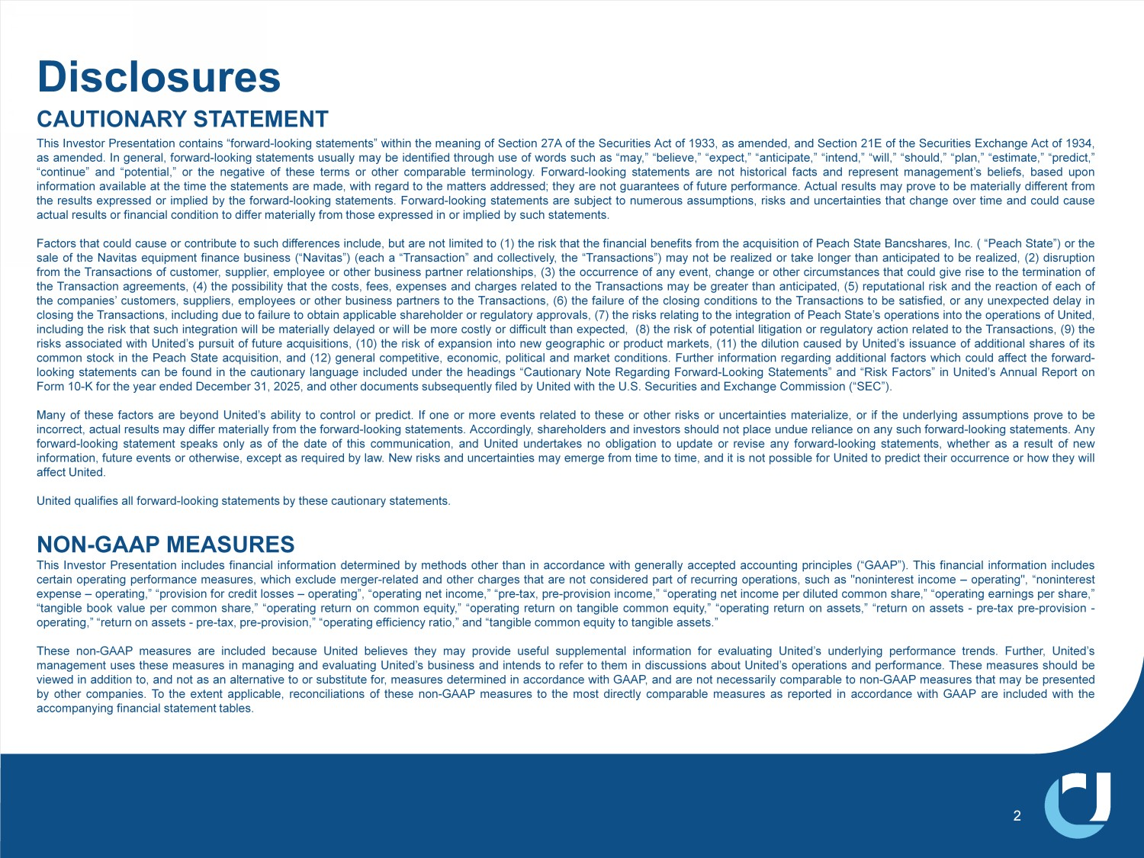
'LVFORVXUHV 2 CAUTIONARY STATEMENT This Investor Presentation contains “forward - looking statements” within the meaning of Section 27 A of the Securities Act of 1933 , as amended, and Section 21 E of the Securities Exchange Act of 1934 , as amended . In general, forward - looking statements usually may be identified through use of words such as “may,” “believe,” “expect,” “anticipate,” “intend,” “will,” “should,” “plan,” “estimate,” “predict,” “continue” and “potential,” or the negative of these terms or other comparable terminology . Forward - looking statements are not historical facts and represent management’s beliefs, based upon information available at the time the statements are made, with regard to the matters addressed; they are not guarantees of future performance . Actual results may prove to be materially different from the results expressed or implied by the forward - looking statements . Forward - looking statements are subject to numerous assumptions, risks and uncertainties that change over time and could cause actual results or financial condition to differ materially from those expressed in or implied by such statements . Factors that could cause or contribute to such differences include, but are not limited to ( 1 ) the risk that the financial benefits from the acquisition of Peach State Bancshares, Inc . ( “Peach State”) or the sale of the Navitas equipment finance business (“Navitas”) (each a “Transaction” and collectively, the “Transactions”) may not be realized or take longer than anticipated to be realized, ( 2 ) disruption from the Transactions of customer, supplier, employee or other business partner relationships, ( 3 ) the occurrence of any event, change or other circumstances that could give rise to the termination of the Transaction agreements, ( 4 ) the possibility that the costs, fees, expenses and charges related to the Transactions may be greater than anticipated, ( 5 ) reputational risk and the reaction of each of the companies’ customers, suppliers, employees or other business partners to the Transactions, ( 6 ) the failure of the closing conditions to the Transactions to be satisfied, or any unexpected delay in closing the Transactions, including due to failure to obtain applicable shareholder or regulatory approvals, ( 7 ) the risks relating to the integration of Peach State’s operations into the operations of United, including the risk that such integration will be materially delayed or will be more costly or difficult than expected, ( 8 ) the risk of potential litigation or regulatory action related to the Transactions, ( 9 ) the risks associated with United’s pursuit of future acquisitions, ( 10 ) the risk of expansion into new geographic or product markets, ( 11 ) the dilution caused by United’s issuance of additional shares of its common stock in the Peach State acquisition, and ( 12 ) general competitive, economic, political and market conditions . Further information regarding additional factors which could affect the forward - looking statements can be found in the cautionary language included under the headings “Cautionary Note Regarding Forward - Looking Statements” and “Risk Factors” in United’s Annual Report on Form 10 - K for the year ended December 31 , 2025 , and other documents subsequently filed by United with the U . S . Securities and Exchange Commission (“SEC”) . Many of these factors are beyond United’s ability to control or predict . If one or more events related to these or other risks or uncertainties materialize, or if the underlying assumptions prove to be incorrect, actual results may differ materially from the forward - looking statements . Accordingly, shareholders and investors should not place undue reliance on any such forward - looking statements . Any forward - looking statement speaks only as of the date of this communication, and United undertakes no obligation to update or revise any forward - looking statements, whether as a result of new information, future events or otherwise, except as required by law . New risks and uncertainties may emerge from time to time, and it is not possible for United to predict their occurrence or how they will affect United . United qualifies all forward - looking statements by these cautionary statements . NON - GAAP MEASURES This Investor Presentation includes financial information determined by methods other than in accordance with generally accepted accounting principles (“GAAP”) . This financial information includes certain operating performance measures, which exclude merger - related and other charges that are not considered part of recurring operations, such as "noninterest income – operating", “ noninterest expense – operating,” “provision for credit losses – operating”, “operating net income,” “pre - tax, pre - provision income,” “operating net income per diluted common share,” “operating earnings per share,” “tangible book value per common share,” “operating return on common equity,” “operating return on tangible common equity,” “operating return on assets,” “return on assets - pre - tax pre - provision - operating,” “return on assets - pre - tax, pre - provision,” “operating efficiency ratio,” and “tangible common equity to tangible assets . ” These non - GAAP measures are included because United believes they may provide useful supplemental information for evaluating United’s underlying performance trends . Further, United’s management uses these measures in managing and evaluating United’s business and intends to refer to them in discussions about United’s operations and performance . These measures should be viewed in addition to, and not as an alternative to or substitute for, measures determined in accordance with GAAP, and are not necessarily comparable to non - GAAP measures that may be presented by other companies . To the extent applicable, reconciliations of these non - GAAP measures to the most directly comparable measures as reported in accordance with GAAP are included with the accompanying financial statement tables .

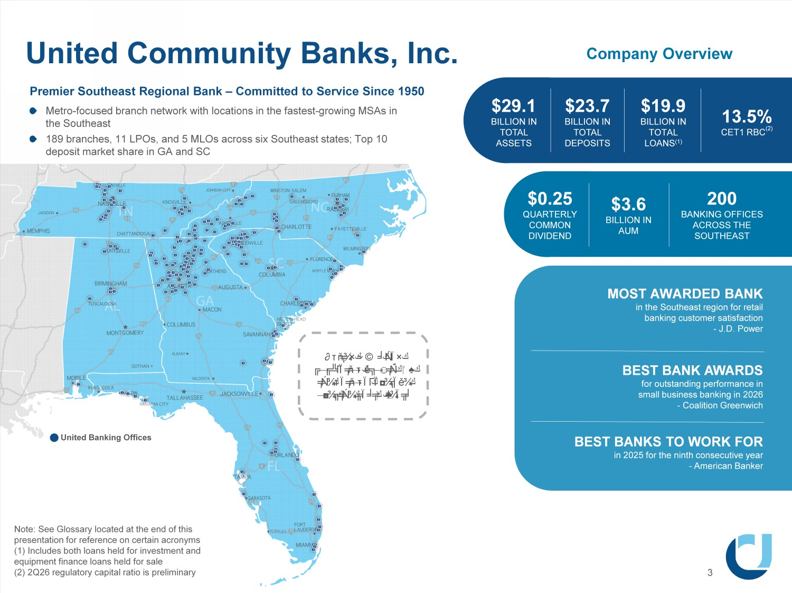
$29.1 BILLION IN TOTAL ASSETS United Community Banks, Inc. Note: See Glossary located at the end of this presentation for reference on certain acronyms (1) Includes both loans held for investment and equipment finance loans held for sale (2) 2Q26 regulatory capital ratio is preliminary 3 8QLWHG%DQNLQJ2IILFHV Company Overview $23.7 BILLION IN TOTAL DEPOSITS $3.6 BILLION IN AUM 13.5% CET1 RBC (2) $19.9 BILLION IN TOTAL LOANS (1) $0.25 QUARTERLY COMMON DIVIDEND 200 BANKING OFFICES ACROSS THE SOUTHEAST 0267$:$5'('%$1. LQWKH6RXWKHDVWUHJLRQIRUUHWDLO EDQNLQJFXVWRPHUVDWLVIDFWLRQ -'3RZHU BEST BANK AWARDS for outstanding performance in small business banking in 2026 - Coalition Greenwich BEST BANKS TO WORK FOR in 2025 for the ninth consecutive year - American Banker Premier Southeast Regional Bank – Committed to Service Since 1950 Metro - focused branch network with locations in the fastest - growing MSAs in the Southeast 189 branches, 11 LPOs, and 5 MLOs across six Southeast states; Top 10 deposit market share in GA and SC United MSAs had population growth >2x the national average over the past 5 years

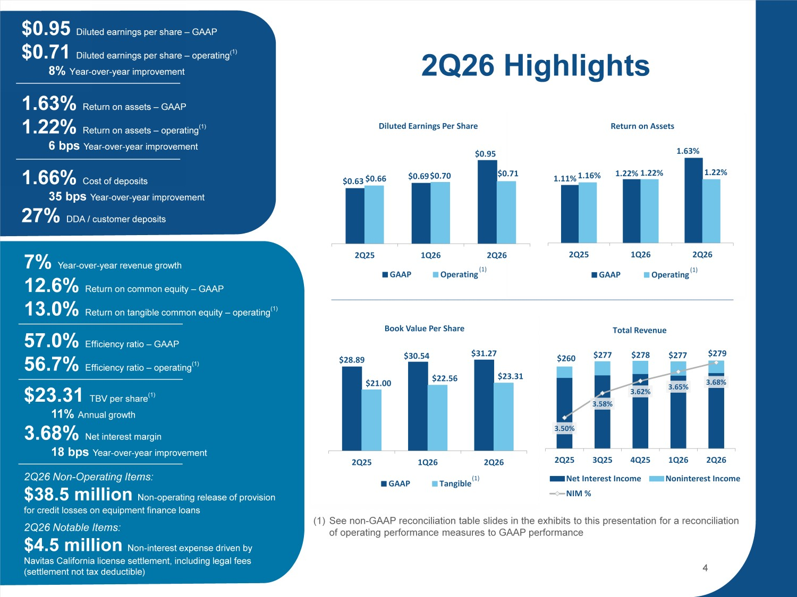
1.11% 1.22% 1.63% 1.16% 1.22% 2Q25 1Q26 2Q26 Return on Assets GAAP Operating $0.63 $0.69 $0.95 $0.66 $0.70 $0.71 2Q25 1Q26 2Q26

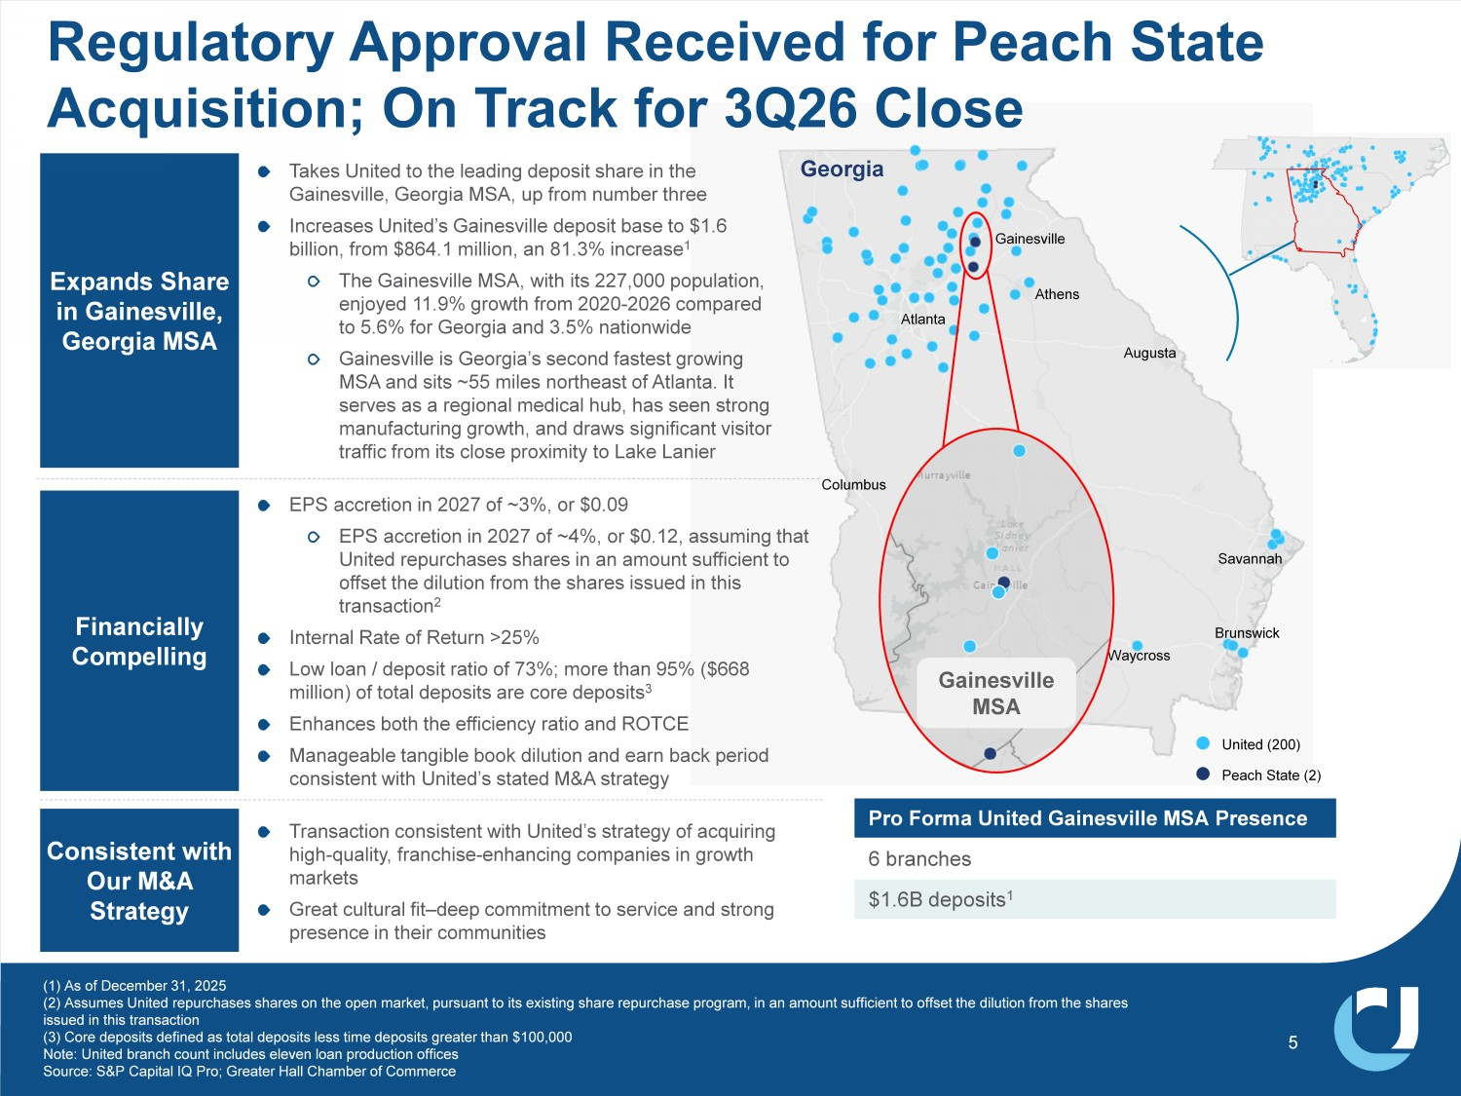
Georgia Columbus Waycross Augusta Gainesville Atlanta 0DFRQ Savannah Athens Brunswick Peach State (2) United (200) 1.87% Cost Pro Forma United Gainesville MSA Presence 6 branches $1.6B deposits 1 Expands Share in Gainesville, Georgia MSA 7DNHV8QLWHGWRWKHOHDGLQJGHSRVLWVKDUHLQWKH *DLQHVYLOOH*HRUJLD06$XSIURPQXPEHUWKUHH ,QFUHDVHV8QLWHG V*DLQHVYLOOHGHSRVLWEDVHWR ELOOLRQIURP PLOOLRQDQ LQFUHDVH 7KH*DLQHVYLOOH06$ZLWKLWV SRSXODWLRQ HQMR\HG JURZWKIURP FRPSDUHG WR IRU*HRUJLDDQG QDWLRQZLGH *DLQHVYLOOHLV*HRUJLD VVHFRQGIDVWHVWJURZLQJ 06$DQGVLWVa PLOHVQRUWKHDVWRI$WODQWD,W VHUYHVDVDUHJLRQDOPHGLFDOKXEKDVVHHQVWURQJ PDQXIDFWXULQJJURZWKDQGGUDZVVLJQLILFDQWYLVLWRU WUDIILFIURPLWVFORVHSUR[LPLW\WR/DNH/DQLHU Consistent with Our M&A Strategy Transaction consistent with United’s strategy of acquiring high - quality, franchise - enhancing companies in growth markets Great cultural fit – deep commitment to service and strong presence in their communities EPS accretion in 2027 of ~3%, or $0.09 EPS accretion in 2027 of ~4%, or $0.12, assuming that United repurchases shares in an amount sufficient to offset the dilution from the shares issued in this transaction 2 Internal Rate of Return >25% Low loan / deposit ratio of 73%; more than 95% ($668 million) of total deposits are core deposits 3 Enhances both the efficiency ratio and ROTCE Manageable tangible book dilution and earn back period consistent with United’s stated M&A strategy Financially Compelling (1) As of December 31, 2025 (2) Assumes United repurchases shares on the open market, pursuant to its existing share repurchase program, in an amount suf fic ient to offset the dilution from the shares issued in this transaction (3) Core deposits defined as total deposits less time deposits greater than $100,000 Note: United branch count includes eleven loan production offices Source: S&P Capital IQ Pro; Greater Hall Chamber of Commerce 5 Regulatory Approval Received for Peach State Acquisition; On Track for 3Q26 Close *DLQHVYLOOH 06$

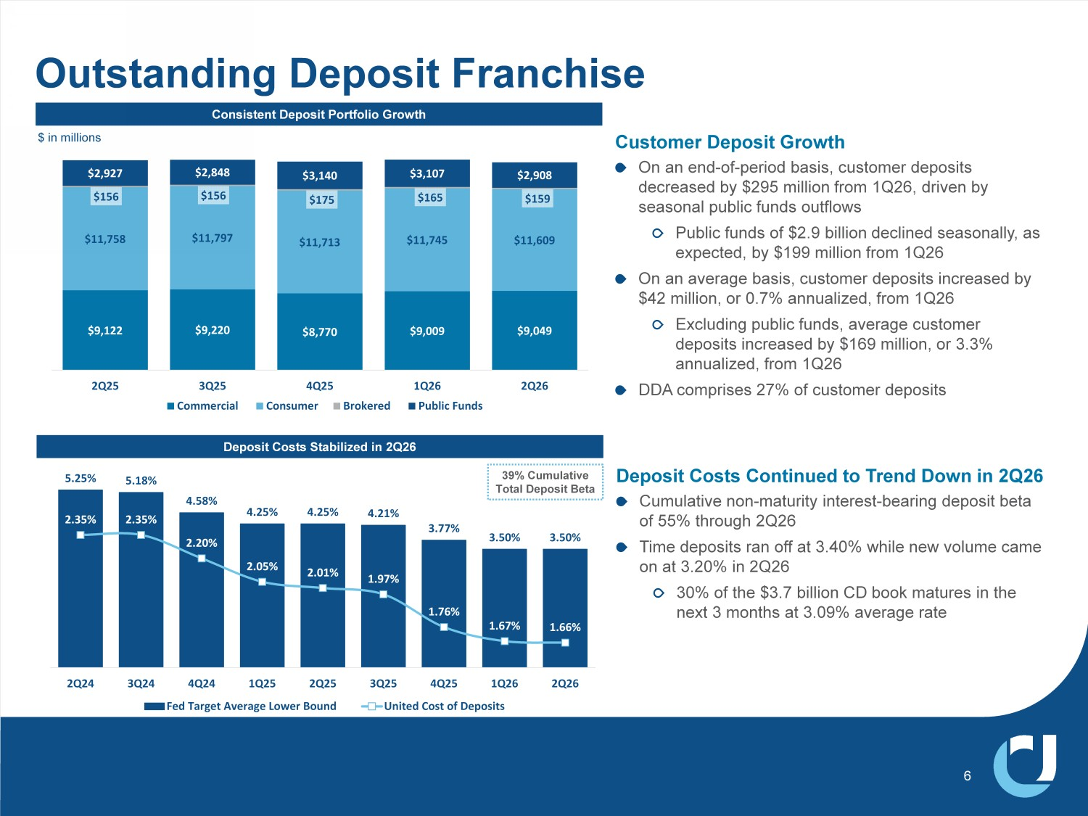
$9,122 $9,220 Ψ ϴ͕ϳϳϬ $9,009 $9,049 $11,758 $11,797 $11,713 $11,745 $11,609 Ψ ϱϲ $156 $175 $165 $159 $2,927 $2,848 $3,140 Ψ ϯ͕Ϭϳ $2,908 2Q25 3Q25 4Q25 1Q26 2Q26 Commercial Consumer Brokered Public Funds 5.25% 5.18% 4.58% 4.25% 4.25% 4.21% ϯϳϳ 3.50% 3.50% 2.35% 2.35% 2.20% 2.05% 2.01% ϵϳ 1.76% 1.67% 1.66% 2Q24 3Q24 4Q24 1Q25 2Q25 3Q25 4Q25 1Q26 2Q26 Fed Target Average Lower Bound United Cost of Deposits Outstanding Deposit Franchise Deposit Costs Stabilized in 2Q26 6 Customer Deposit Growth On an end - of - period basis, customer deposits decreased by $295 million from 1Q26, driven by seasonal public funds outflows Public funds of $2.9 billion declined seasonally, as expected, by $199 million from 1Q26 On an average basis, customer deposits increased by $42 million, or 0.7% annualized, from 1Q26 Excluding public funds, average customer deposits increased by $169 million, or 3.3% annualized, from 1Q26 DDA comprises 27% of customer deposits &RQVLVWHQW'HSRVLW3RUWIROLR*URZWK $ in millions Deposit Costs Continued to Trend Down in 2Q26 Cumulative non - maturity interest - bearing deposit beta of 55% through 2Q26 Time deposits ran off at 3.40% while new volume came on at 3.20% in 2Q26 30% of the $3.7 billion CD book matures in the next 3 months at 3.09% average rate 39% Cumulative Total Deposit Beta

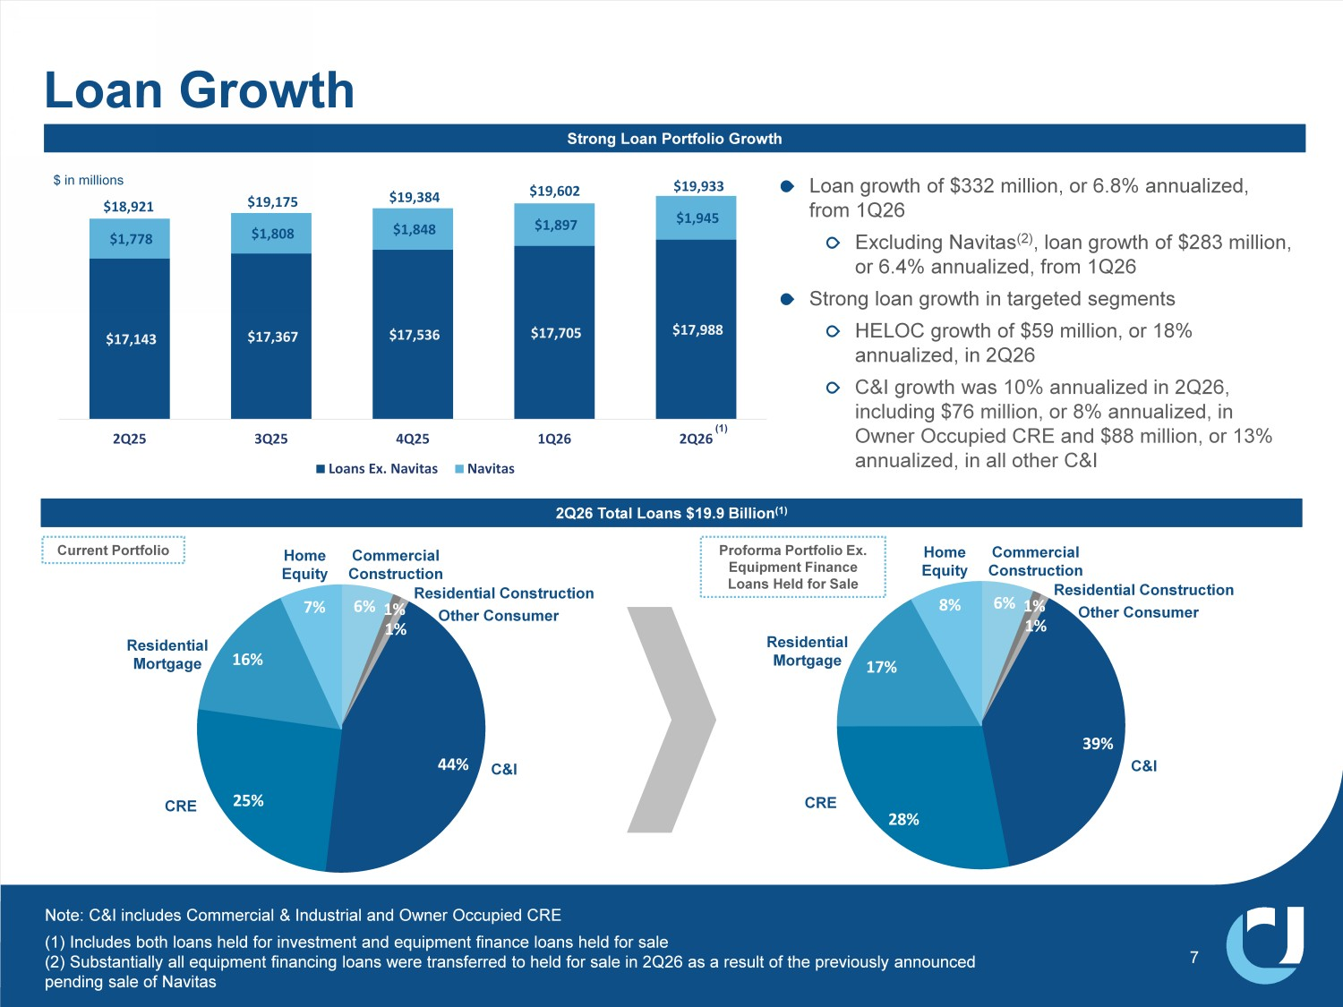
$17,143 Ψ ϳ͕ϯϲϳ $17,536 $17,705 $17,988 $1,778 $1,808 $1,848 $1,897 Ψ ͕ϵϰϱ $18,921 $19,175 $19,384 $19,602 $19,933 2Q25 3Q25 4Q25 1Q26 2Q26 Loans Ex. Navitas Navitas Strong Loan Portfolio Growth Loan Growth /RDQJURZWKRI PLOOLRQRU DQQXDOL]HG IURP 4 ([FOXGLQJ1DYLWDV ORDQJURZWKRI PLOOLRQ RU DQQXDOL]HGIURP 4 6WURQJORDQJURZWKLQWDUJHWHGVHJPHQWV +(/2&JURZWKRI PLOOLRQRU DQQXDOL]HGLQ 4 & ,JURZWKZDV DQQXDOL]HGLQ 4 LQFOXGLQJ PLOOLRQRU DQQXDOL]HGLQ 2ZQHU2FFXSLHG&5(DQG PLOOLRQRU DQQXDOL]HGLQDOORWKHU& , 7 2Q26 Total Loans $19.9 Billion (1) 6% 1% 1% 44% 25% ϲ 7% C&I Commercial Construction CRE Other Consumer Residential Mortgage Home Equity 5HVLGHQWLDO&RQVWUXFWLRQ $ in millions Note: C&I includes Commercial & Industrial and Owner Occupied CRE 6% 1% 1% 39% 28% ϳ 8% C&I Commercial Construction CRE Other Consumer Residential Mortgage Home Equity 5HVLGHQWLDO&RQVWUXFWLRQ Current Portfolio Proforma Portfolio Ex. Equipment Finance Loans Held for Sale (1) Includes both loans held for investment and equipment finance loans held for sale (2) Substantially all equipment financing loans were transferred to held for sale in 2Q26 as a result of the previously announced pending sale of Navitas (1)

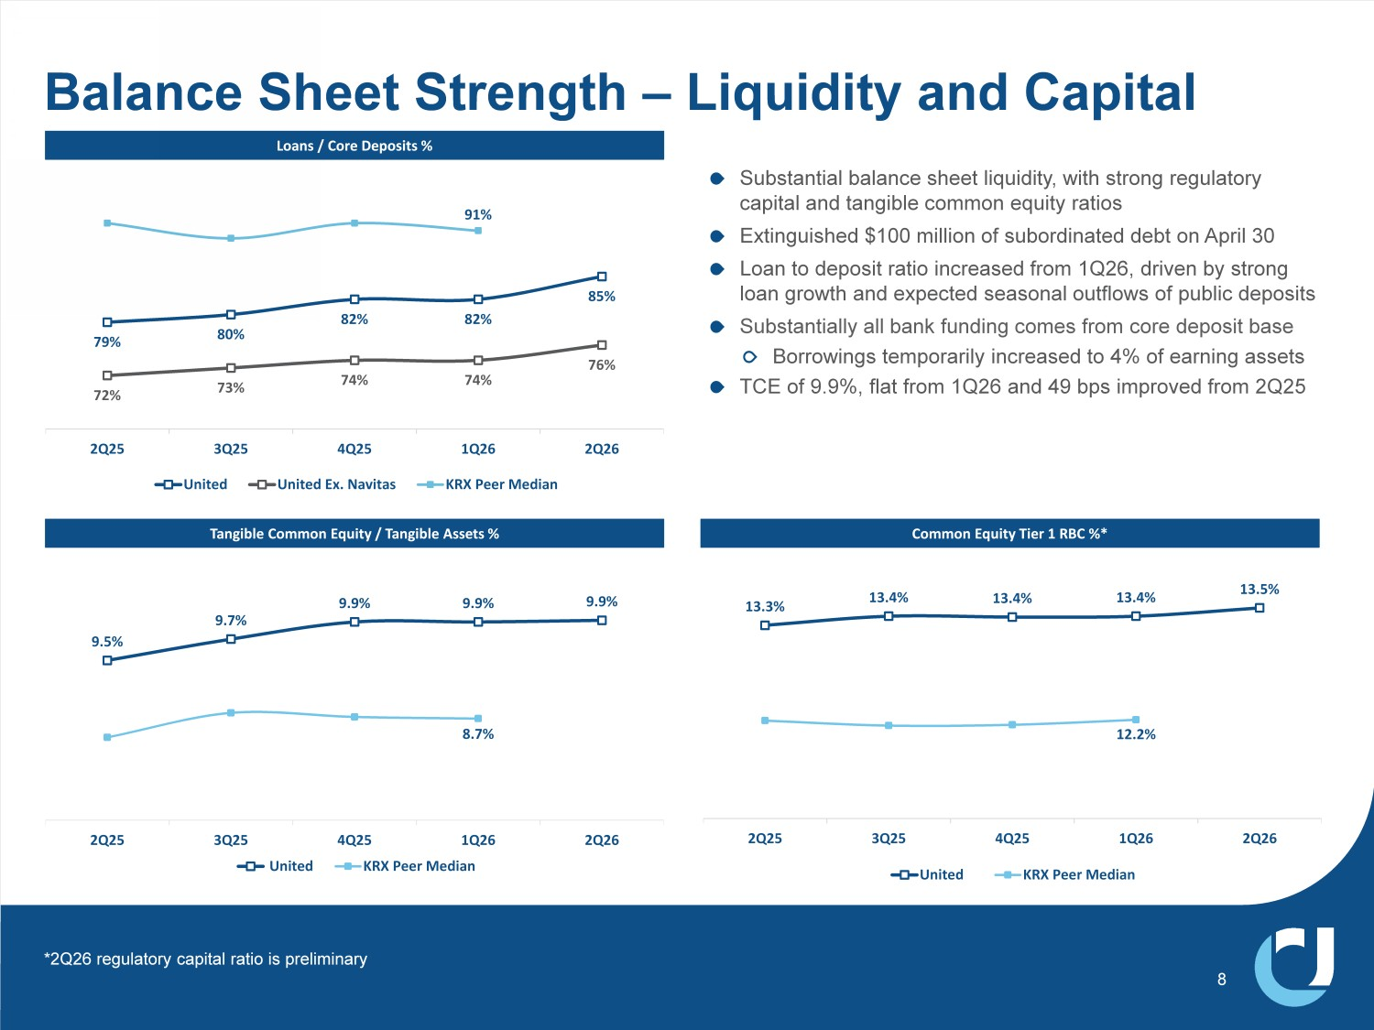
79% 80% ϴ 82% 85% 72% 73% 74% 74% 76% ϵ 2Q25 3Q25 4Q25 1Q26 2Q26 United United Ex. Navitas KRX Peer Median Substantial balance sheet liquidity, with strong regulatory capital and tangible common equity ratios Extinguished $100 million of subordinated debt on April 30 Loan to deposit ratio increased from 1Q26, driven by strong loan growth and expected seasonal outflows of public deposits Substantially all bank funding comes from core deposit base Borrowings temporarily increased to 4% of earning assets TCE of 9.9%, flat from 1Q26 and 49 bps improved from 2Q25 9.5% 9.7% 9.9% 9.9% 9.9% 8.7% 2Q25 3Q25 4Q25 1Q26 2Q26 United KRX Peer Median Loans / Core Deposits % Tangible Common Equity / Tangible Assets % Common Equity Tier 1 RBC %* 13.3% 13.4% 13.4% ϯϰ 13.5% 12.2% 2Q25 3Q25 4Q25 1Q26 2Q26 United KRX Peer Median Balance Sheet Strength – Liquidity and Capital 8 *2Q26 regulatory capital ratio is preliminary

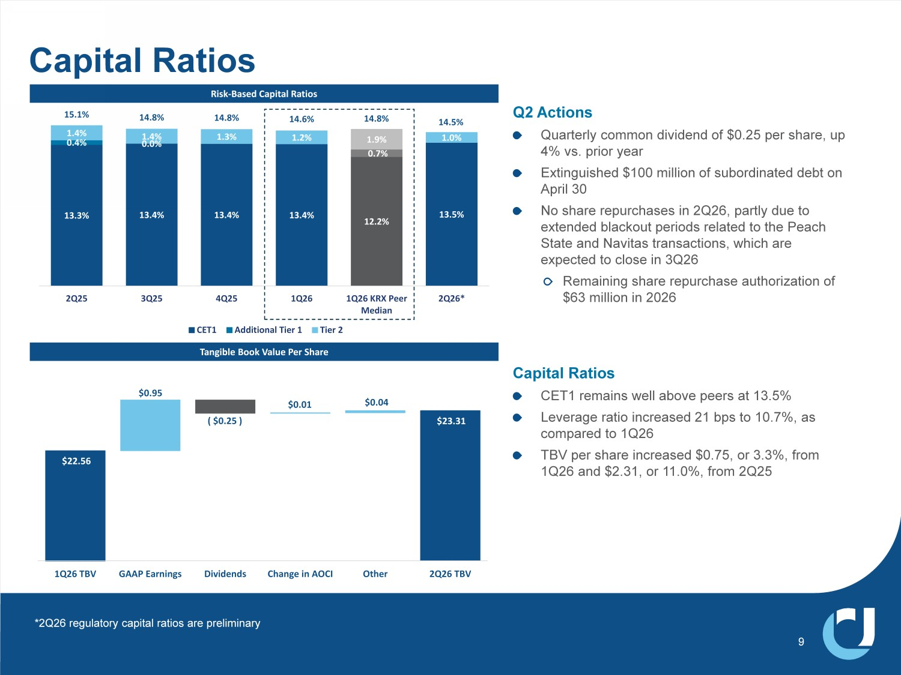
9 Risk - Based Capital Ratios Tangible Book Value Per Share 4 $FWLRQV 4XDUWHUO\FRPPRQGLYLGHQGRI SHUVKDUHXS YVSULRU\HDU ([WLQJXLVKHG PLOOLRQRIVXERUGLQDWHGGHEWRQ $SULO 1RVKDUHUHSXUFKDVHVLQ 4 SDUWO\GXHWR H[WHQGHGEODFNRXWSHULRGVUHODWHGWRWKH3HDFK 6WDWHDQG1DYLWDVWUDQVDFWLRQVZKLFKDUH H[SHFWHGWRFORVHLQ 4 5HPDLQLQJVKDUHUHSXUFKDVHDXWKRUL]DWLRQRI PLOOLRQLQ &DSLWDO5DWLRV &(7 UHPDLQVZHOODERYHSHHUVDW /HYHUDJHUDWLRLQFUHDVHG ESVWR DV FRPSDUHGWR 4 7%9SHUVKDUHLQFUHDVHG RU IURP 4 DQG RU IURP 4 13.3% 13.4% 13.4% 13.4% 12.2% 13.5% 0.4% ϬϬ 0.7% 1.4% 1.4% 1.3% 1.2% 1.9% 1.0% ϱ 14.8% 14.8% 14.6% 14.8% 14.5% 2Q25 3Q25 4Q25 1Q26 1Q26 KRX Peer Median 2Q26* CET1 Additional Tier 1 Tier 2 Capital Ratios Ψ ϯϯ $22.56 $0.95 ( $0.25 ) $0.01 $0.04 1Q26 TBV GAAP Earnings Dividends Change in AOCI Other 2Q26 TBV *2Q26 regulatory capital ratios are preliminary

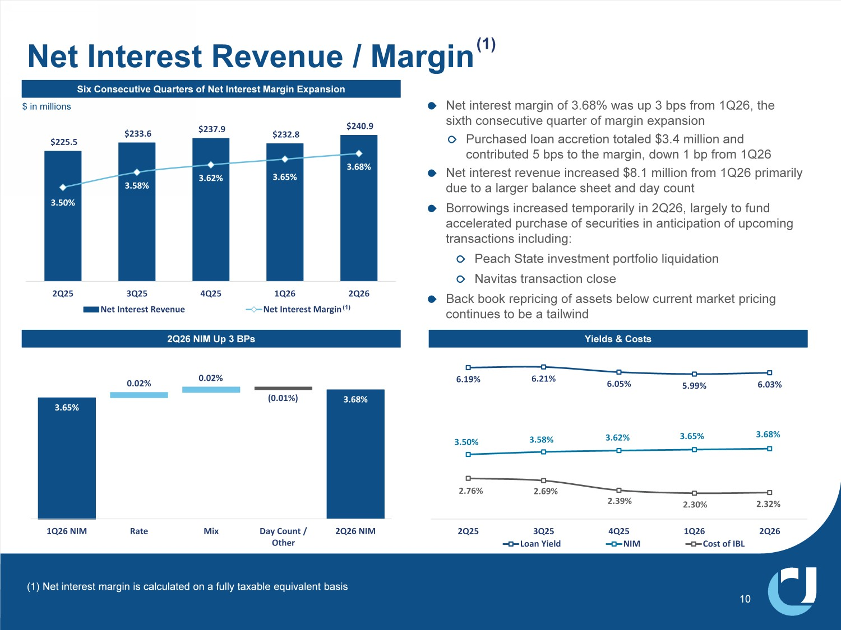
Ψ ϱϱ $233.6 $237.9 $232.8 $240.9 3.50% 3.58% 3.62% ϯϲϱ 3.68% $100.0 $120.0 $140.0 $160.0 $180.0 $200.0 $220.0 $240.0 3.00% 3.10% 3.20% 3.30% 3.40% 3.50% 3.60% 3.70% 3.80% 2Q25 3Q25 4Q25 1Q26 2Q26 Net Interest Revenue Net Interest Margin 3.68% 3.65% 0.02% 0.02% ( 0.01% ) 1Q26 NIM Rate Mix Day Count / Other 2Q26 NIM Six Consecutive Quarters of Net Interest Margin Expansion 4 1,08S %3V Net interest margin of 3.68% was up 3 bps from 1Q26, the sixth consecutive quarter of margin expansion Purchased loan accretion totaled $3.4 million and contributed 5 bps to the margin, down 1 bp from 1Q26 Net interest revenue increased $8.1 million from 1Q26 primarily due to a larger balance sheet and day count Borrowings increased temporarily in 2Q26, largely to fund accelerated purchase of securities in anticipation of upcoming transactions including: Peach State investment portfolio liquidation Navitas transaction close Back book repricing of assets below current market pricing continues to be a tailwind Net Interest Revenue / Margin (1) Yields & Costs 6.19% 6.21% 6.05% ϱϵϵ 6.03% 3.50% 3.58% 3.62% 3.65% 3.68% 2.76% ϲϵ 2.39% 2.30% 2.32% 2Q25 3Q25 4Q25 1Q26 2Q26 Loan Yield NIM Cost of IBL (1) Net interest margin is calculated on a fully taxable equivalent basis (1) 10 $ in millions

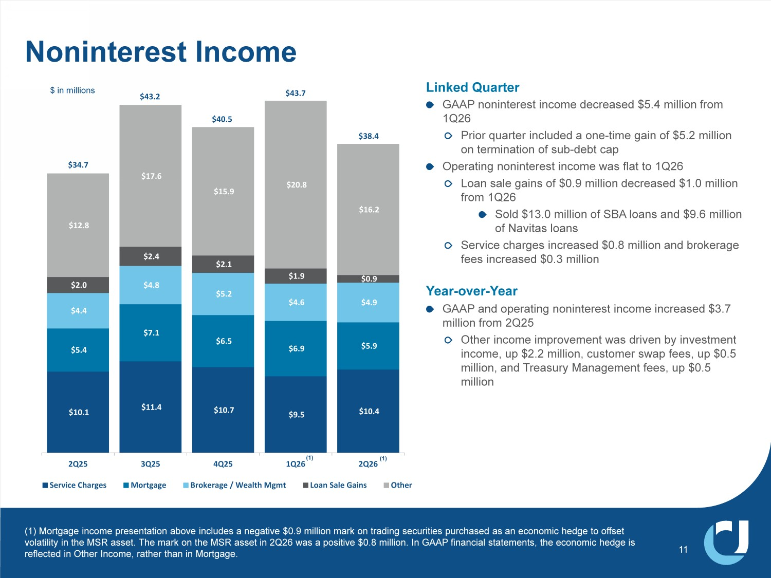
$10.1 $11.4 $10.7 $9.5 Ψ Ϭϰ $5.4 $7.1 $6.5 $6.9 $5.9 $4.4 $4.8 Ψ ϱ $4.6 $4.9 $2.0 $2.4 $2.1 $1.9 $0.9 Ψ ϴ $17.6 $15.9 $20.8 $16.2 2Q25 3Q25 4Q25 1Q26 2Q26 Service Charges Mortgage Brokerage / Wealth Mgmt Loan Sale Gains Other Linked Quarter GAAP noninterest income decreased $5.4 million from 1Q26 Prior quarter included a one - time gain of $5.2 million on termination of sub - debt cap Operating noninterest income was flat to 1Q26 Loan sale gains of $0.9 million decreased $1.0 million from 1Q26 Sold $13.0 million of SBA loans and $9.6 million of Navitas loans Service charges increased $0.8 million and brokerage fees increased $0.3 million Year - over - Year GAAP and operating noninterest income increased $3.7 million from 2Q25 Other income improvement was driven by investment income, up $2.2 million, customer swap fees, up $0.5 million, and Treasury Management fees, up $0.5 million 11 Noninterest Income LQPLOOLRQV $34.7 $43.2 $40.5 $43.7 (1) Mortgage income presentation above includes a negative $0.9 million mark on trading securities purchased as an economic h edg e to offset volatility in the MSR asset. The mark on the MSR asset in 2Q26 was a positive $0.8 million. In GAAP financial statements, the ec onomic hedge is reflected in Other Income, rather than in Mortgage. (1) (1) Ψ ϯϴϰ

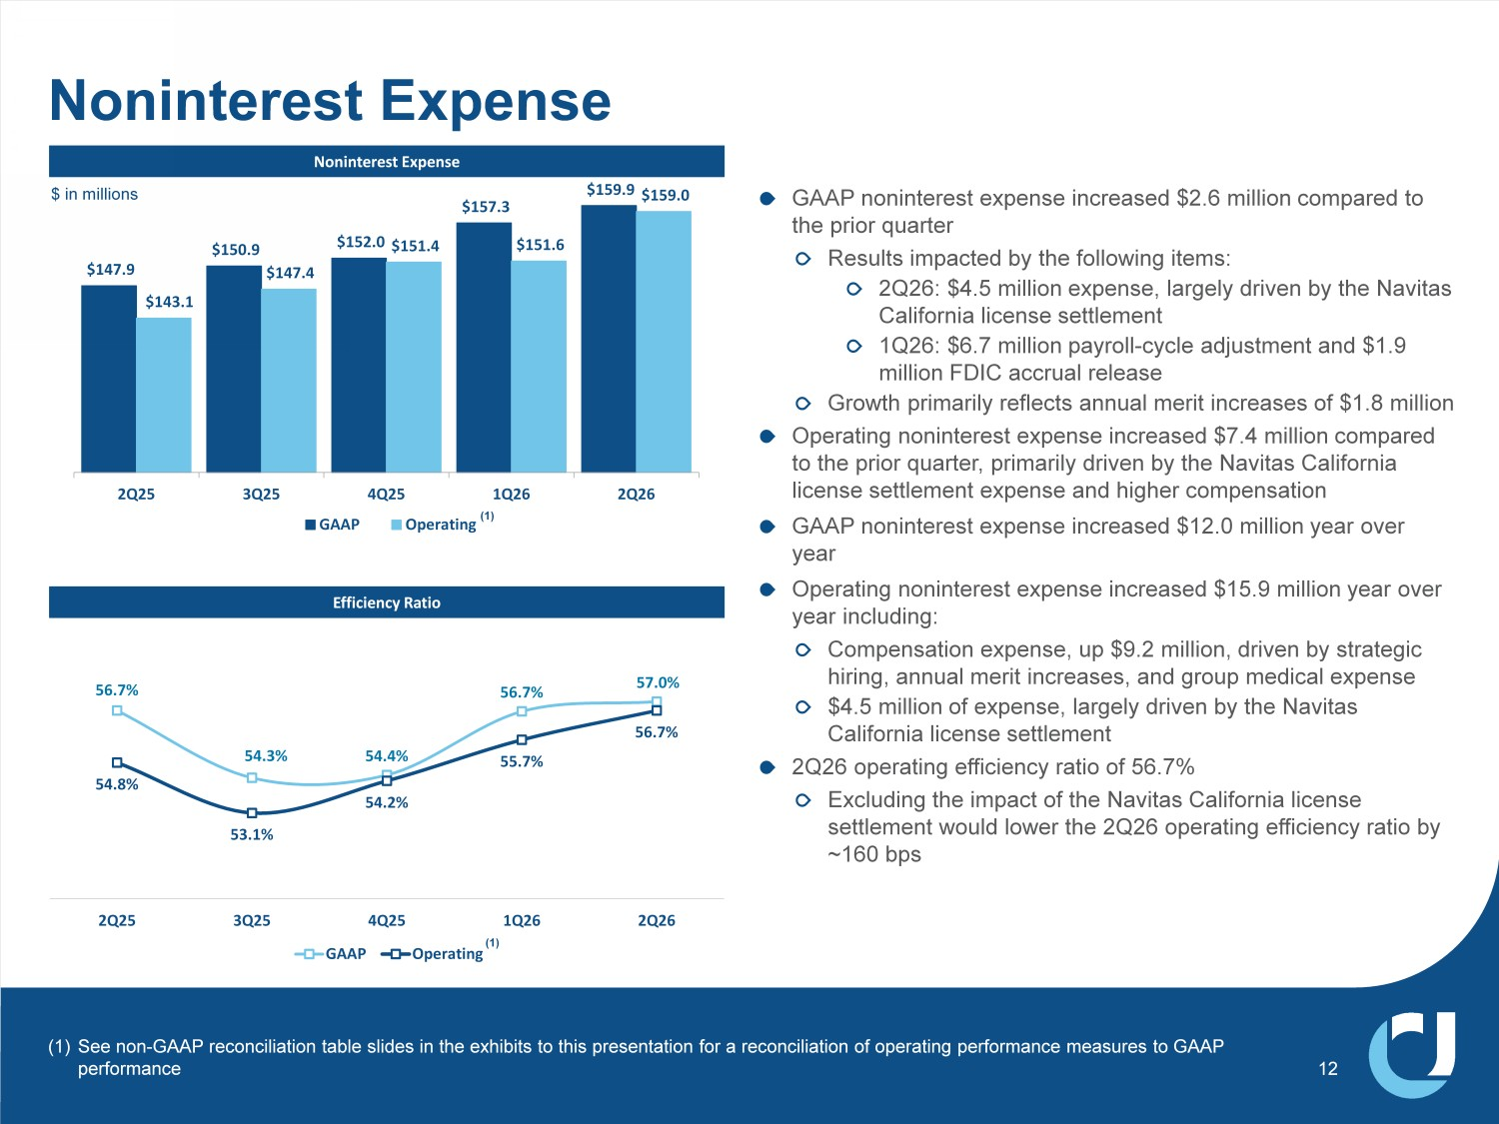
$147.9 $150.9 Ψ ϱϬ $157.3 $159.9 $143.1 $147.4 $151.4 $151.6 $159.0 2Q25 3Q25 4Q25 1Q26 2Q26 GAAP Operating 1RQLQWHUHVW([SHQVH Efficiency Ratio Noninterest Expense 56.7% 54.3% 54.4% 56.7% 57.0% ϱϰϴ 53.1% 54.2% 55.7% 56.7% 2Q25 3Q25 4Q25 1Q26 2Q26 GAAP Operating GAAP noninterest expense increased $2.6 million compared to the prior quarter Results impacted by the following items: 2Q26: $4.5 million expense, largely driven by the Navitas California license settlement 1Q26: $6.7 million payroll - cycle adjustment and $1.9 million FDIC accrual release Growth primarily reflects annual merit increases of $1.8 million Operating noninterest expense increased $7.4 million compared to the prior quarter, primarily driven by the Navitas California license settlement expense and higher compensation GAAP noninterest expense increased $12.0 million year over year Operating noninterest expense increased $15.9 million year over year including: Compensation expense, up $9.2 million, driven by strategic hiring, annual merit increases, and group medical expense $4.5 million of expense, largely driven by the Navitas California license settlement 2Q26 operating efficiency ratio of 56.7% Excluding the impact of the Navitas California license settlement would lower the 2Q26 operating efficiency ratio by ~160 bps 12 (1) See non - GAAP reconciliation table slides in the exhibits to this presentation for a reconciliation of operating performance meas ures to GAAP performance $ in millions (1)

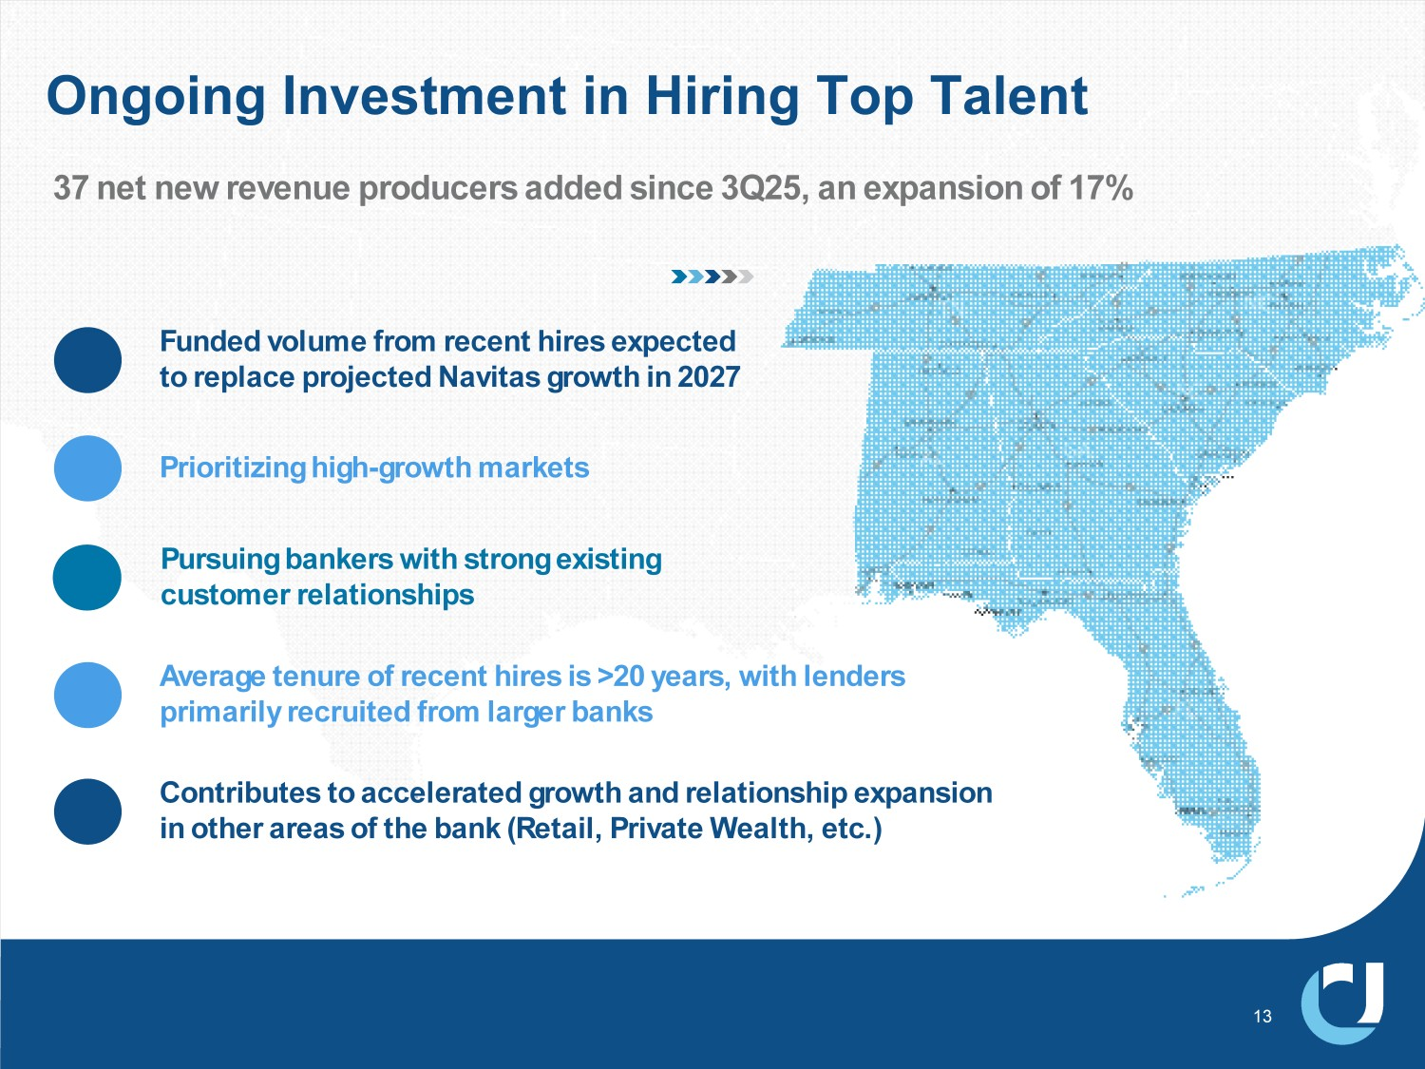
Ongoing Investment in Hiring Top Talent 13 37 net new revenue producers added since 3Q25, an expansion of 17% Prioritizing high - growth markets Pursuing bankers with strong existing customer relationships ĺĲťŘĖæŪťôŜϙťĺϙÍèèôīôŘÍťôîϙČŘĺſťēϙÍĲîϙŘôīÍťĖĺĲŜēĖŕϙôƄŕÍĲŜĖĺĲϙ ĖĲϙĺťēôŘϙÍŘôÍŜϙĺċϙťēôϙæÍĲħϙϼôťÍĖīϠϙŘĖŽÍťôϙ®ôÍīťēϠϙôťèϟϽ Average tenure of recent hires is >20 years, with lenders primarily recruited from larger banks Funded volume from recent hires expected to replace projected Navitas growth in 2027

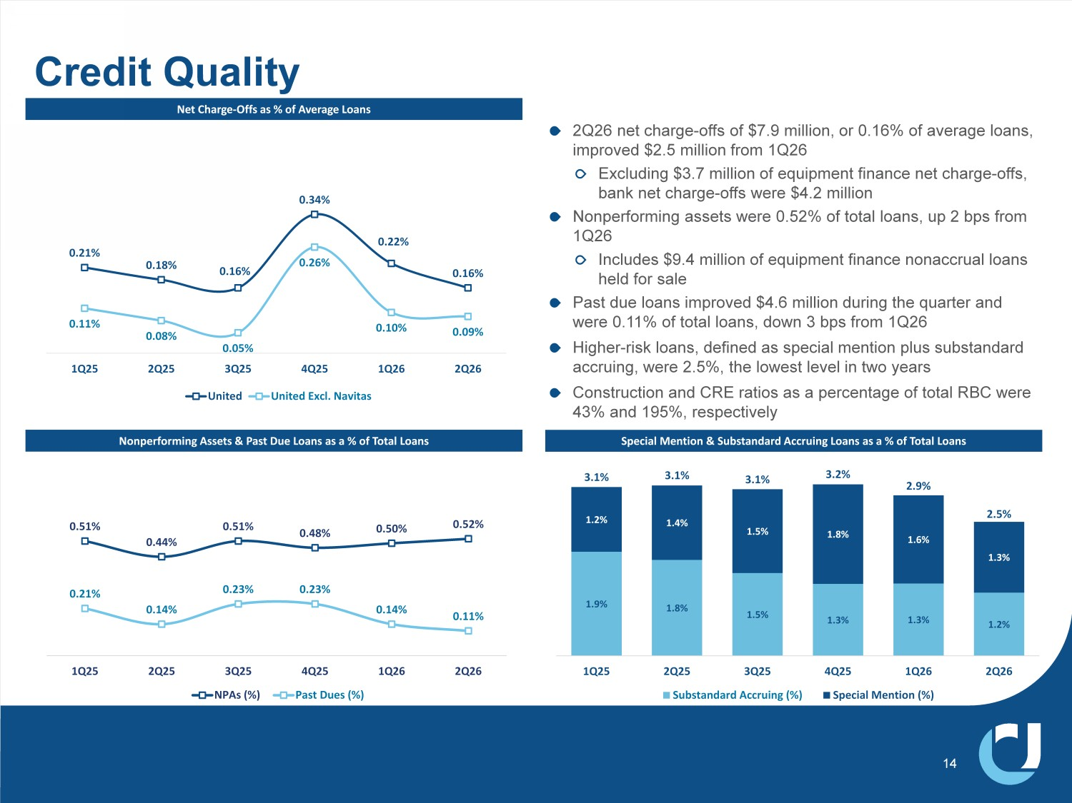
2Q26 net charge - offs of $7.9 million, or 0.16% of average loans, improved $2.5 million from 1Q26 Excluding $3.7 million of equipment finance net charge - offs, bank net charge - offs were $4.2 million Nonperforming assets were 0.52% of total loans, up 2 bps from 1Q26 Includes $9.4 million of equipment finance nonaccrual loans held for sale Past due loans improved $4.6 million during the quarter and were 0.11% of total loans, down 3 bps from 1Q26 Higher - risk loans, defined as special mention plus substandard accruing, were 2.5%, the lowest level in two years Construction and CRE ratios as a percentage of total RBC were 43% and 195%, respectively Credit Quality EĞƚŚĂƌŐĞ Ͳ KĨĨƐĂƐŽĨǀĞƌĂŐĞ>ŽĂŶƐ Nonperforming Assets & Past Due Loans as a % of Total Loans 0.51% 0.44% 0.51% 0.48% 0.50% 0.52% Ϭ 0.14% 0.23% 0.23% 0.14% 0.11% 1Q25 2Q25 3Q25 4Q25 1Q26 2Q26 NPAs (%) Past Dues (%) 1.9% 1.8% ϱ 1.3% 1.3% 1.2% 1.2% 1.4% 1.5% 1.8% ϲ 1.3% 3.1% 3.1% 3.1% 3.2% 2.9% 2.5% 1Q25 2Q25 3Q25 4Q25 1Q26 2Q26 Substandard Accruing (%) Special Mention (%) ^ƉĞĐŝĂůDĞŶƚŝŽŶΘ^ƵďƐƚĂŶĚĂƌĚĐĐƌƵŝŶŐ>ŽĂŶƐĂƐĂŽĨdŽƚĂů>ŽĂŶƐ 14 0.21% 0.18% 0.16% 0.34% 0.22% 0.16% Ϭ 0.08% 0.05% 0.26% 0.10% 0.09% 1Q25 2Q25 3Q25 4Q25 1Q26 2Q26 United United Excl. Navitas

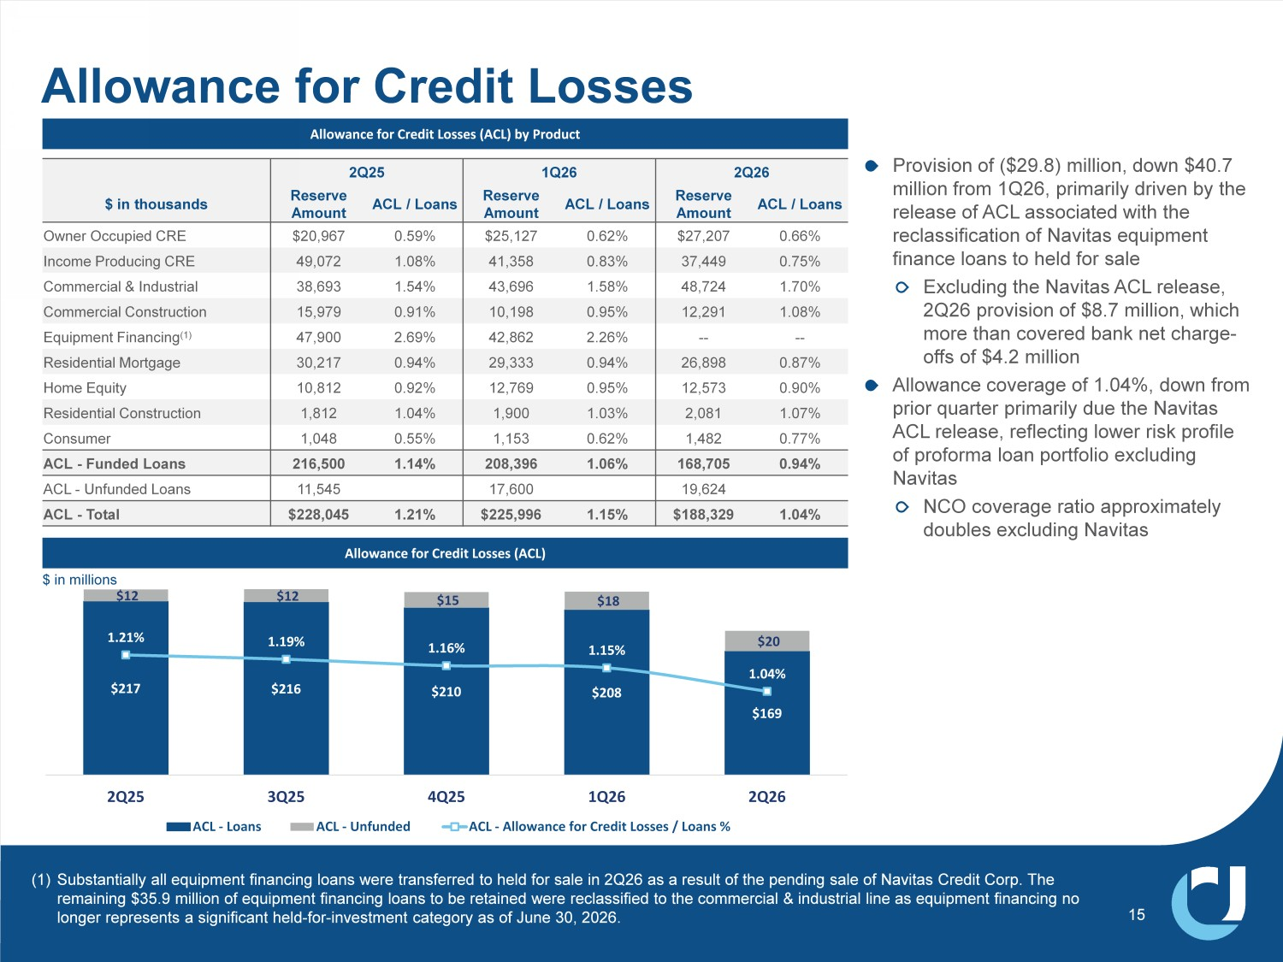
Allowance for Credit Losses Allowance for Credit Losses (ACL) by Product Allowance for Credit Losses (ACL) Provision of ($29.8) million, down $40.7 million from 1Q26, primarily driven by the release of ACL associated with the reclassification of Navitas equipment finance loans to held for sale Excluding the Navitas ACL release, 2Q26 provision of $8.7 million, which more than covered bank net charge - offs of $4.2 million Allowance coverage of 1.04%, down from prior quarter primarily due the Navitas ACL release, reflecting lower risk profile of proforma loan portfolio excluding Navitas NCO coverage ratio approximately doubles excluding Navitas $217 $216 $210 $208 $169 $12 $12 $15 $18 $20 1.21% 1.19% 1.16% 1.15% 1.04% 0.65% 0.75% 0.85% 0.95% 1.05% 1.15% 1.25% 1.35% 1.45% 1.55% $50 $70 $90 $110 $130 $150 $170 $190 $210 $230 2Q25 3Q25 4Q25 1Q26 2Q26 ACL - Loans ACL - Unfunded ACL - Allowance for Credit Losses / Loans % 15 $ in millions 2Q26 1Q26 4 ACL / Loans Reserve Amount ACL / Loans Reserve Amount ACL / Loans Reserve Amount $ in thousands 0.66% $27,207 0.62% $25,127 0.59% $20,967 Owner Occupied CRE 0.75% 37,449 0.83% 41,358 1.08% 49,072 Income Producing CRE 1.70% 48,724 1.58% 43,696 1.54% 38,693 Commercial & Industrial 1.08% 12,291 0.95% 10,198 0.91% 15,979 Commercial Construction -- -- 2.26% 42,862 2.69% 47,900 Equipment Financing (1) 0.87% 26,898 0.94% 29,333 0.94% 30,217 Residential Mortgage 0.90% 12,573 0.95% 12,769 0.92% 10,812 Home Equity 1.07% 2,081 1.03% 1,900 1.04% 1,812 Residential Construction 0.77% 1,482 0.62% 1,153 0.55% 1,048 Consumer 0.94% 168,705 1.06% 208,396 1.14% 216,500 ACL - Funded Loans 19,624 17,600 11,545 ACL - Unfunded Loans 1.04% $188,329 1.15% $225,996 1.21% $228,045 ACL - Total (1) Substantially all equipment financing loans were transferred to held for sale in 2Q26 as a result of the pending sale of Navi tas Credit Corp. The remaining $35.9 million of equipment financing loans to be retained were reclassified to the commercial & industrial line as equ ipment financing no longer represents a significant held - for - investment category as of June 30, 2026.


0HPEHU)',& 8QLWHG&RPPXQLW\%DQN_ XFELFRP 2 Q26 INVESTOR PRESENTATION Exhibits


&XOWXUDO)RXQGDWLRQVRI8QLWHG&RPPXQLW\ 17 Our Story Founded 76 years ago as Union County Bank, United Community has stayed true to its roots by prioritizing service. We continue to embrace our small - town, personal touch while offering a comprehensive range of personal and business banking services. Team We play to win together as a team Truth We want to see things as they are, not as we want them to be Trust We trust in people Caring We treat our customers, and each other, the way that we would want to be treated %HVW%DQNWR:RUN ) RU LQ IRUWKH WK FRQVHFXWLYH\HDU Most Awarded Bank in the Southeast Region for Retail Banking Customer Satisfaction Best Bank Awards for outstanding small business banking in 2026 To Be a Legendary Bank Our Vision Our Core Values Our Accolades Our Purpose 7R%XLOG&RPPXQLWLHV

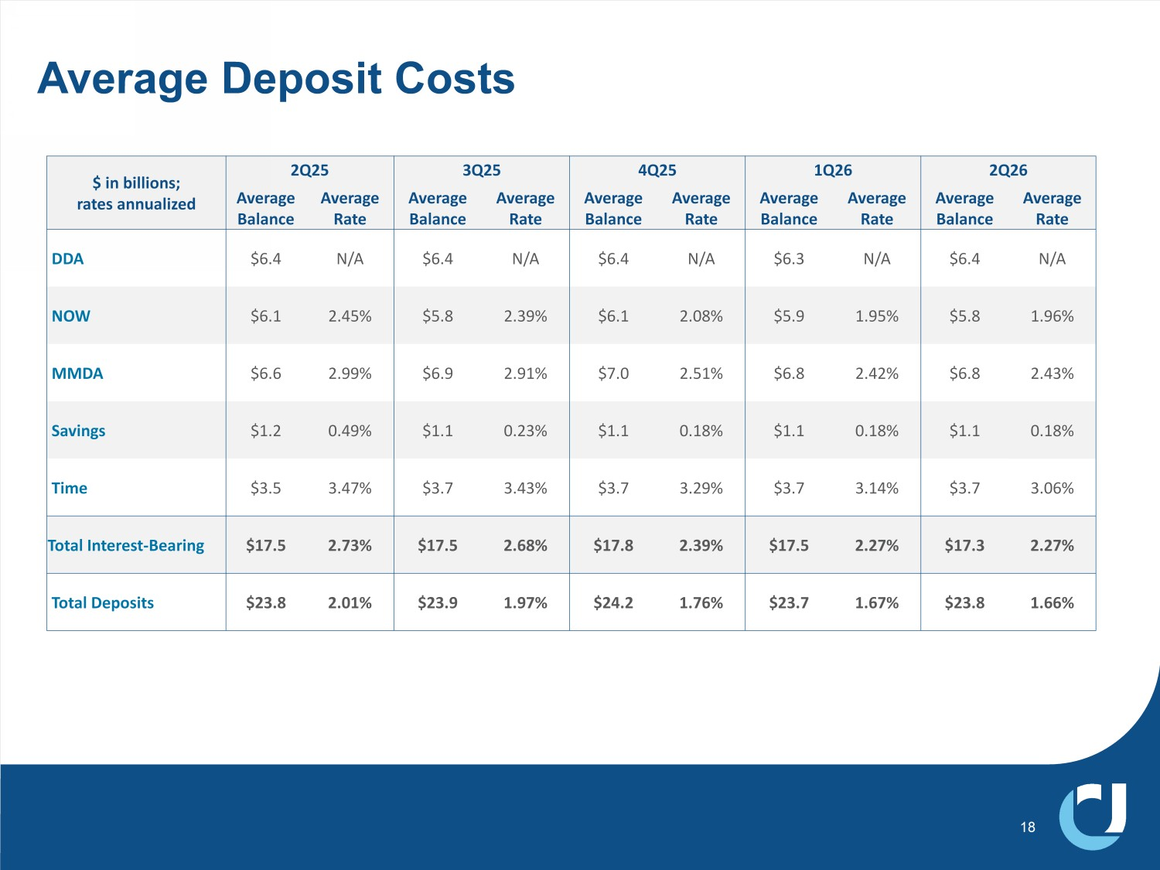
Average Deposit Costs 18 2Q26 1Q26 4Q25 3Q25 2Q25 $ in billions; rates annualized Average Rate Average Balance Average Rate Average Balance Average Rate Average Balance Average Rate Average Balance Average Rate Average Balance N/A $6.4 N/A $6.3 N/A $6.4 N/A $6.4 N/A $6.4 DDA 1.96% $5.8 1.95% $5.9 2.08% $6.1 2.39% $5.8 2.45% $6.1 NOW 2.43% $6.8 2.42% $6.8 2.51% $7.0 2.91% $6.9 2.99% $6.6 MMDA 0.18% $1.1 0.18% $1.1 0.18% $1.1 0.23% $1.1 0.49% $1.2 Savings 3.06% $3.7 3.14% $3.7 3.29% $3.7 3.43% $3.7 3.47% $3.5 Time 2.27% $17.3 2.27% $17.5 2.39% $17.8 2.68% $17.5 2.73% $17.5 Total Interest - Bearing 1.66% $23.8 1.67% $23.7 1.76% $24.2 1.97% $23.9 2.01% $23.8 Total Deposits

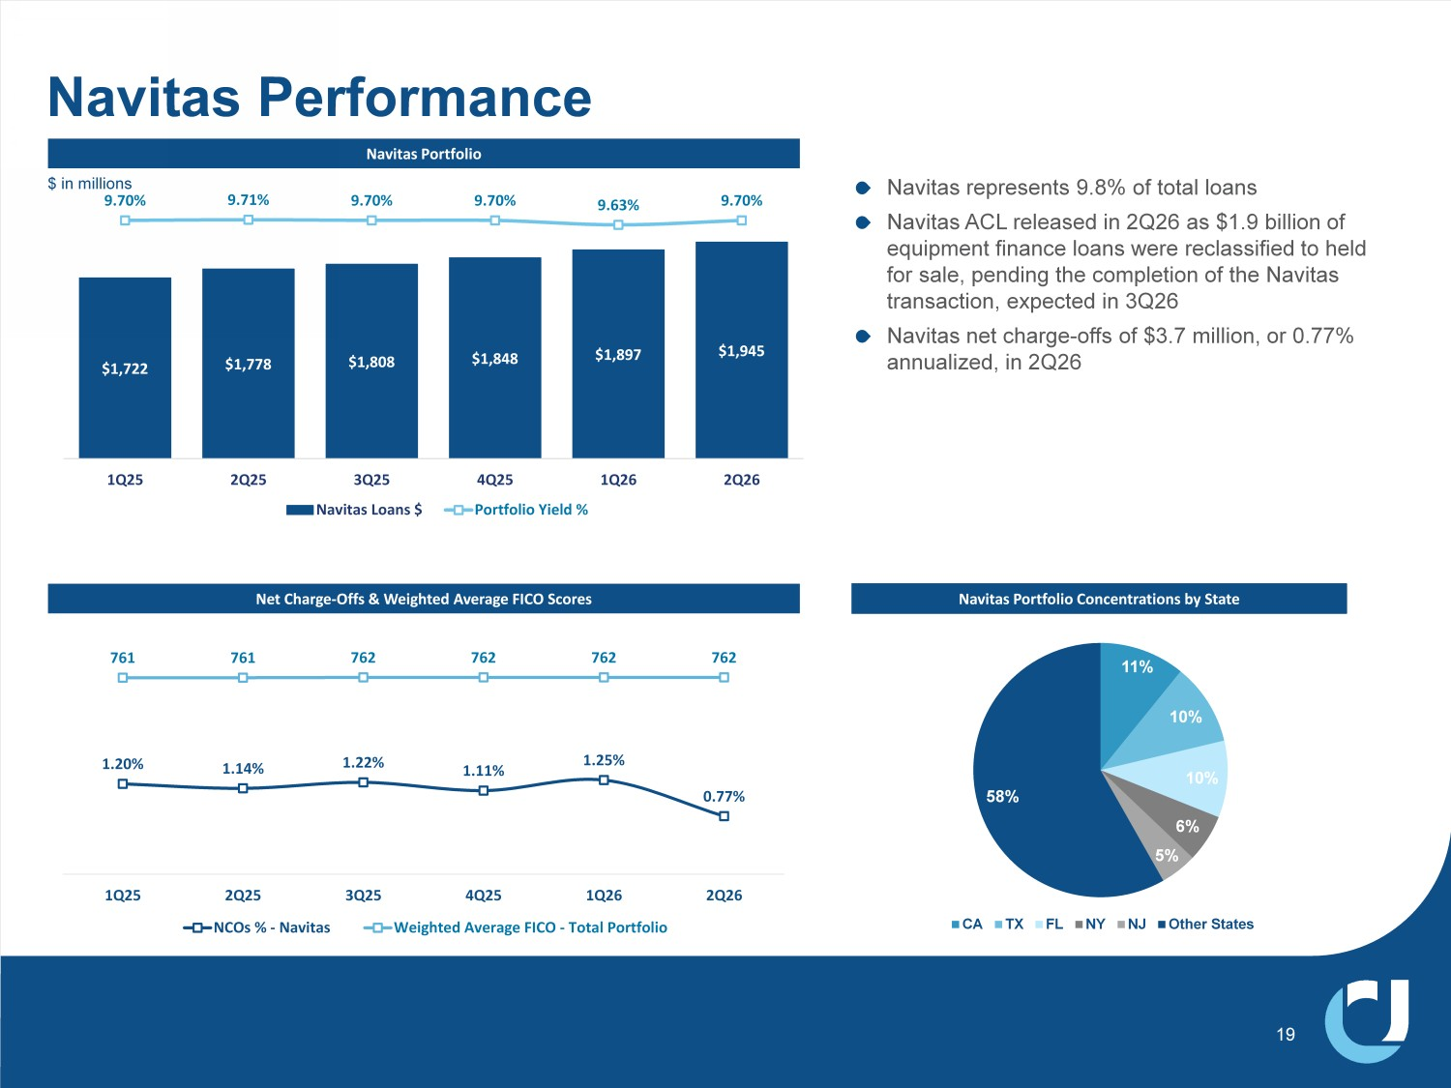
EĂǀŝƚĂƐWŽƌƚĨŽůŝŽ Net Charge - Offs & Weighted Average FICO Scores Navitas represents 9.8% of total loans Navitas ACL released in 2Q26 as $1.9 billion of equipment finance loans were reclassified to held for sale, pending the completion of the Navitas transaction, expected in 3Q26 Navitas net charge - offs of $3.7 million, or 0.77% annualized, in 2Q26 Navitas Performance $1,722 $1,778 $1,808 $1,848 Ψ ͕ϴϵϳ $1,945 9.70% 9.71% 9.70% 9.70% 9.63% 9.70% 1Q25 2Q25 3Q25 4Q25 1Q26 2Q26 Navitas Loans $ Portfolio Yield % 1.20% 1.14% 1.22% 1.11% 1.25% 0.77% 761 ϳϲ 762 762 762 762 1Q25 2Q25 3Q25 4Q25 1Q26 2Q26 NCOs % - Navitas Weighted Average FICO - Total Portfolio $ in millions Navitas Portfolio Concentrations by State 11% 10% 6% 5% 58% CA TX FL NY NJ Other States

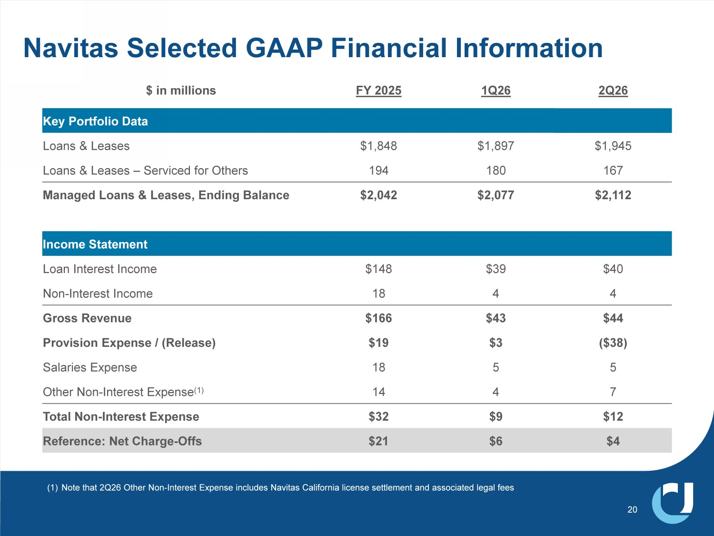
Navitas Selected GAAP Financial Information 20 2Q26 1Q26 FY 2025 $ in millions Key Portfolio Data $1,945 $1,897 $1,848 Loans & Leases 167 180 194 Loans & Leases – Serviced for Others $2,112 $2,077 $2,042 Managed Loans & Leases, Ending Balance Income Statement $40 $39 $148 Loan Interest Income 4 4 18 Non - Interest Income $44 $43 $166 Gross Revenue ($38) $3 $19 Provision Expense / (Release) 5 5 18 Salaries Expense 7 4 14 Other Non - Interest Expense (1) $12 $9 $32 Total Non - Interest Expense $4 $6 $21 Reference: Net Charge - Offs (1) Note that 2Q26 Other Non - Interest Expense includes Navitas California license settlement and associated legal fees

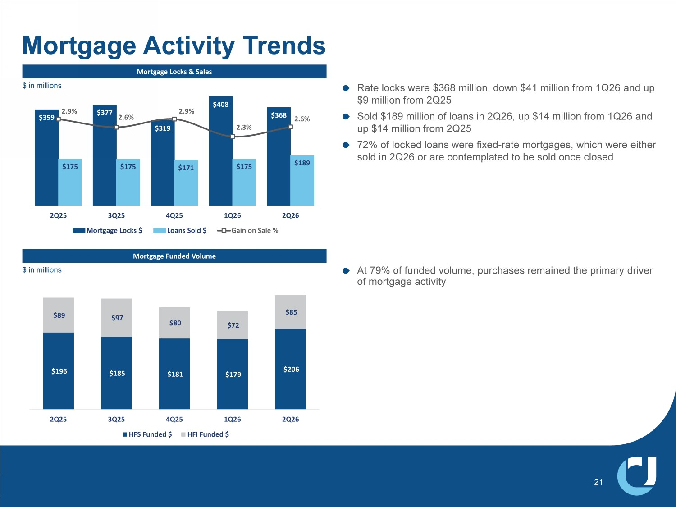
Rate locks were $368 million, down $41 million from 1Q26 and up $9 million from 2Q25 Sold $189 million of loans in 2Q26, up $14 million from 1Q26 and up $14 million from 2Q25 72% of locked loans were fixed - rate mortgages, which were either sold in 2Q26 or are contemplated to be sold once closed Mortgage Locks & Sales Mortgage Funded Volume Mortgage Activity Trends $359 $377 $319 $408 $368 $175 $175 $171 $175 $189 2.9% 2.6% 2.9% 2.3% 2.6% 2Q25 3Q25 4Q25 1Q26 2Q26 Mortgage Locks $ Loans Sold $ Gain on Sale % $196 $185 $181 $179 $206 $89 $97 $80 $72 $85 2Q25 3Q25 4Q25 1Q26 2Q26 HFS Funded $ HFI Funded $ 21 At 79% of funded volume, purchases remained the primary driver of mortgage activity $ in millions $ in millions

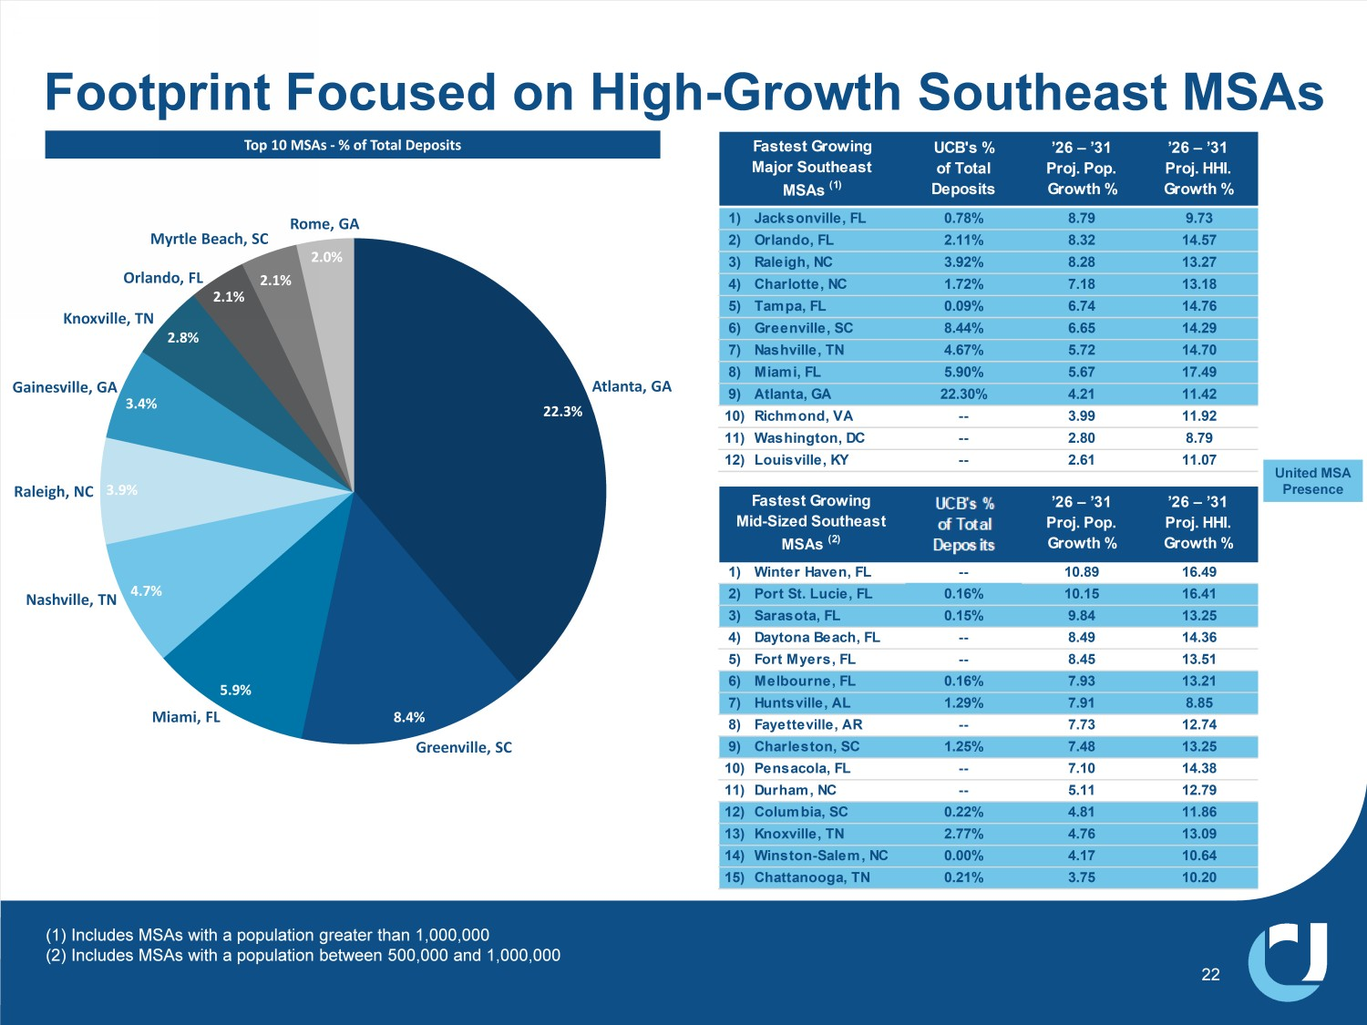
(1) Includes MSAs with a population greater than 1,000,000 (2) Includes MSAs with a population between 500,000 and 1,000,000 Footprint Focused on High - Growth Southeast MSAs 22 22.3% 8.4% 5.9% 4.7% 3.9% 3.4% 2.8% 2.1% 2.1% 2.0% Atlanta, GA Greenville, SC Nashville, TN Miami, FL Raleigh, NC Gainesville, GA Knoxville, TN Orlando, FL Rome, GA Myrtle Beach, SC Top 10 MSAs - % of Total Deposits UCB's % of Total Deposits ’26 – ’31 Proj. Pop. Growth % ’26 – ’31 Proj. HHI. Growth % 1) Jacksonville, FL 0.78% 8.79 9.73 2) Orlando, FL 2.11% 8.32 14.57 3) Raleigh, NC 3.92% 8.28 13.27 4) Charlotte, NC 1.72% 7.18 13.18 5) Tampa, FL 0.09% 6.74 14.76 6) Greenville, SC 8.44% 6.65 14.29 7) Nashville, TN 4.67% 5.72 14.70 8) Miami, FL 5.90% 5.67 17.49 9) Atlanta, GA 22.30% 4.21 11.42 10) Richmond, VA -- 3.99 11.92 11) Washington, DC -- 2.80 8.79 12) Louisville, KY -- 2.61 11.07 Fastest Growing Major Southeast MSAs (1) United MSA Presence UCBI's % of Total Deposits ’26 – ’31 Proj. Pop. Growth % ’26 – ’31 Proj. HHI. Growth % 1) Winter Haven, FL -- 10.89 16.49 2) Port St. Lucie, FL 0.16% 10.15 16.41 3) Sarasota, FL 0.15% 9.84 13.25 4) Daytona Beach, FL -- 8.49 14.36 5) Fort Myers, FL -- 8.45 13.51 6) Melbourne, FL 0.16% 7.93 13.21 7) Huntsville, AL 1.29% 7.91 8.85 8) Fayetteville, AR -- 7.73 12.74 9) Charleston, SC 1.25% 7.48 13.25 10) Pensacola, FL -- 7.10 14.38 11) Durham, NC -- 5.11 12.79 12) Columbia, SC 0.22% 4.81 11.86 13) Knoxville, TN 2.77% 4.76 13.09 14) Winston-Salem, NC 0.00% 4.17 10.64 15) Chattanooga, TN 0.21% 3.75 10.20 Fastest Growing Mid-Sized Southeast MSAs (2)

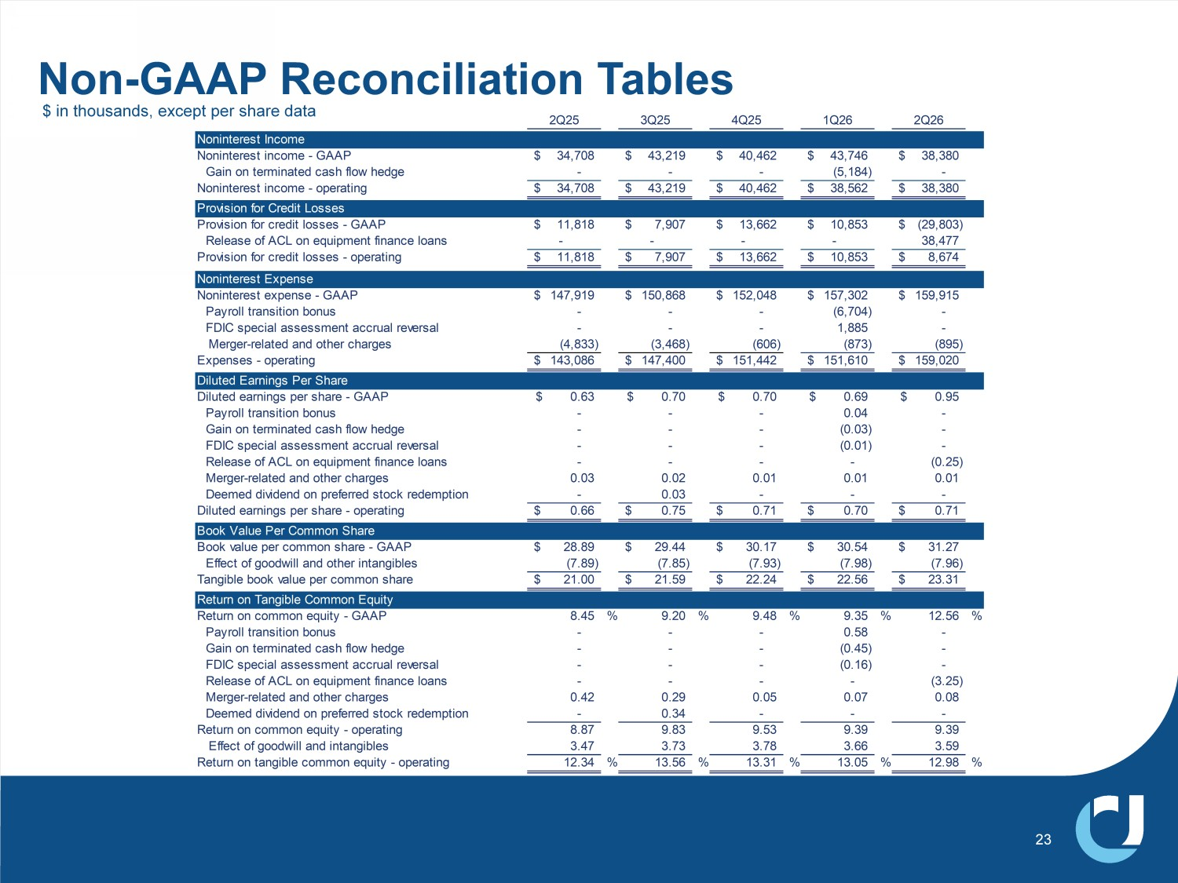
Non - GAAP Reconciliation Tables 23 2Q25 3Q25 4Q25 1Q26 2Q26 Noninterest Income Noninterest income - GAAP 34,708$ 43,219$ 40,462$ 43,746$ 38,380$ Gain on terminated cash flow hedge - - - (5,184) - Noninterest income - operating 34,708$ 43,219$ 40,462$ 38,562$ 38,380$ Provision for Credit Losses Provision for credit losses - GAAP 11,818$ 7,907$ 13,662$ 10,853$ (29,803)$ Release of ACL on equipment finance loans - - - - 38,477 Provision for credit losses - operating 11,818$ 7,907$ 13,662$ 10,853$ 8,674$ Noninterest Expense Noninterest expense - GAAP 147,919$ 150,868$ 152,048$ 157,302$ 159,915$ Payroll transition bonus - - - (6,704) - FDIC special assessment accrual reversal - - - 1,885 - Merger-related and other charges (4,833) (3,468) (606) (873) (895) Expenses - operating 143,086$ 147,400$ 151,442$ 151,610$ 159,020$ Diluted Earnings Per Share Diluted earnings per share - GAAP 0.63$ 0.70$ 0.70$ 0.69$ 0.95$ Payroll transition bonus - - - 0.04 - Gain on terminated cash flow hedge - - - (0.03) - FDIC special assessment accrual reversal - - - (0.01) - Release of ACL on equipment finance loans - - - - (0.25) Merger-related and other charges 0.03 0.02 0.01 0.01 0.01 Deemed dividend on preferred stock redemption - 0.03 - - - Diluted earnings per share - operating 0.66$ 0.75$ 0.71$ 0.70$ 0.71$ Book Value Per Common Share Book value per common share - GAAP 28.89$ 29.44$ 30.17$ 30.54$ 31.27$ Effect of goodwill and other intangibles (7.89) (7.85) (7.93) (7.98) (7.96) Tangible book value per common share 21.00$ 21.59$ 22.24$ 22.56$ 23.31$ Return on Tangible Common Equity Return on common equity - GAAP 8.45 % 9.20 % 9.48 % 9.35 % 12.56 % Payroll transition bonus - - - 0.58 - Gain on terminated cash flow hedge - - - (0.45) - FDIC special assessment accrual reversal - - - (0.16) - Release of ACL on equipment finance loans - - - - (3.25) Merger-related and other charges 0.42 0.29 0.05 0.07 0.08 Deemed dividend on preferred stock redemption - 0.34 - - - Return on common equity - operating 8.87 9.83 9.53 9.39 9.39 Effect of goodwill and intangibles 3.47 3.73 3.78 3.66 3.59 Return on tangible common equity - operating 12.34 % 13.56 % 13.31 % 13.05 % 12.98 % $ in thousands, except per share data

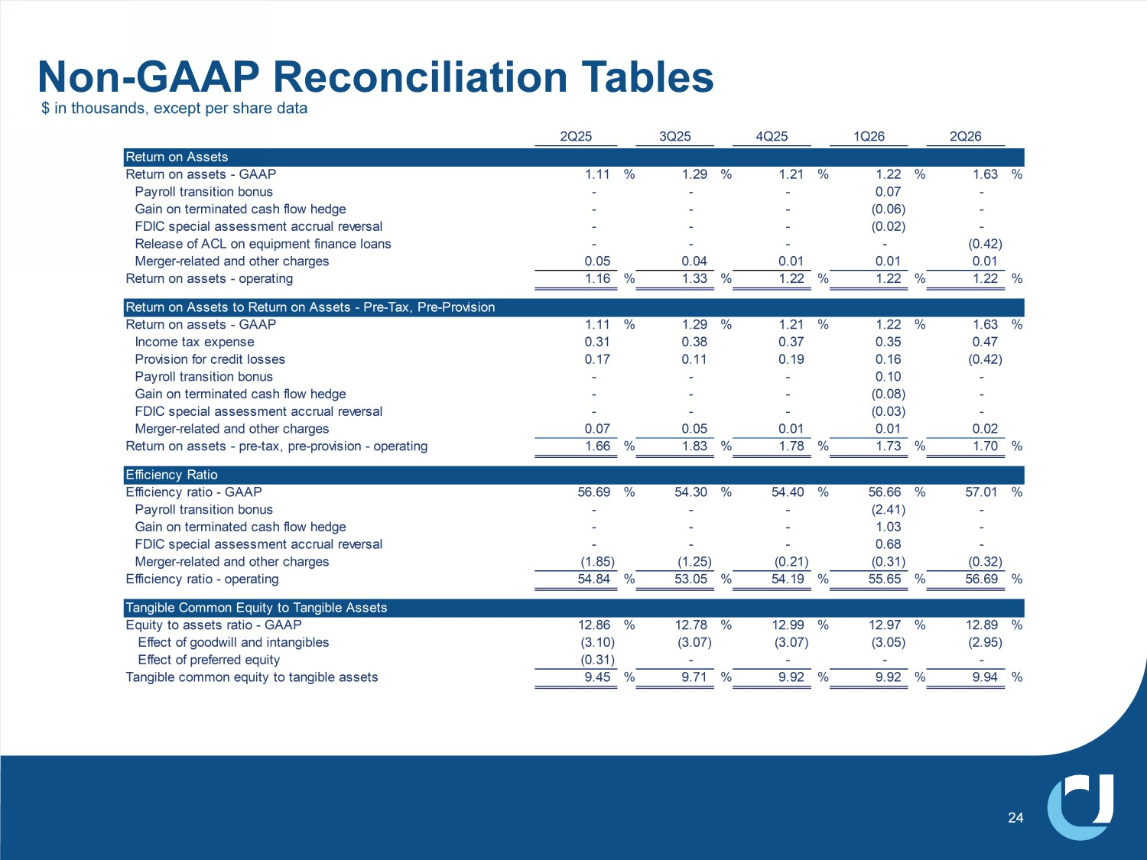
Non - GAAP Reconciliation Tables 24 2Q25 3Q25 4Q25 1Q26 2Q26 Return on Assets Return on assets - GAAP 1.11 % 1.29 % 1.21 % 1.22 % 1.63 % Payroll transition bonus - - - 0.07 - Gain on terminated cash flow hedge - - - (0.06) - FDIC special assessment accrual reversal - - - (0.02) - Release of ACL on equipment finance loans - - - - (0.42) Merger-related and other charges 0.05 0.04 0.01 0.01 0.01 Return on assets - operating 1.16 % 1.33 % 1.22 % 1.22 % 1.22 % Return on Assets to Return on Assets - Pre-Tax, Pre-Provision Return on assets - GAAP 1.11 % 1.29 % 1.21 % 1.22 % 1.63 % Income tax expense 0.31 0.38 0.37 0.35 0.47 Provision for credit losses 0.17 0.11 0.19 0.16 (0.42) Payroll transition bonus - - - 0.10 - Gain on terminated cash flow hedge - - - (0.08) - FDIC special assessment accrual reversal - - - (0.03) - Merger-related and other charges 0.07 0.05 0.01 0.01 0.02 Return on assets - pre-tax, pre-provision - operating 1.66 % 1.83 % 1.78 % 1.73 % 1.70 % Efficiency Ratio Efficiency ratio - GAAP 56.69 % 54.30 % 54.40 % 56.66 % 57.01 % Payroll transition bonus - - - (2.41) - Gain on terminated cash flow hedge - - - 1.03 - FDIC special assessment accrual reversal - - - 0.68 - Merger-related and other charges (1.85) (1.25) (0.21) (0.31) (0.32) Efficiency ratio - operating 54.84 % 53.05 % 54.19 % 55.65 % 56.69 % Tangible Common Equity to Tangible Assets Equity to assets ratio - GAAP 12.86 % 12.78 % 12.99 % 12.97 % 12.89 % Effect of goodwill and intangibles (3.10) (3.07) (3.07) (3.05) (2.95) Effect of preferred equity (0.31) - - - - Tangible common equity to tangible assets 9.45 % 9.71 % 9.92 % 9.92 % 9.94 % $ in thousands, except per share data

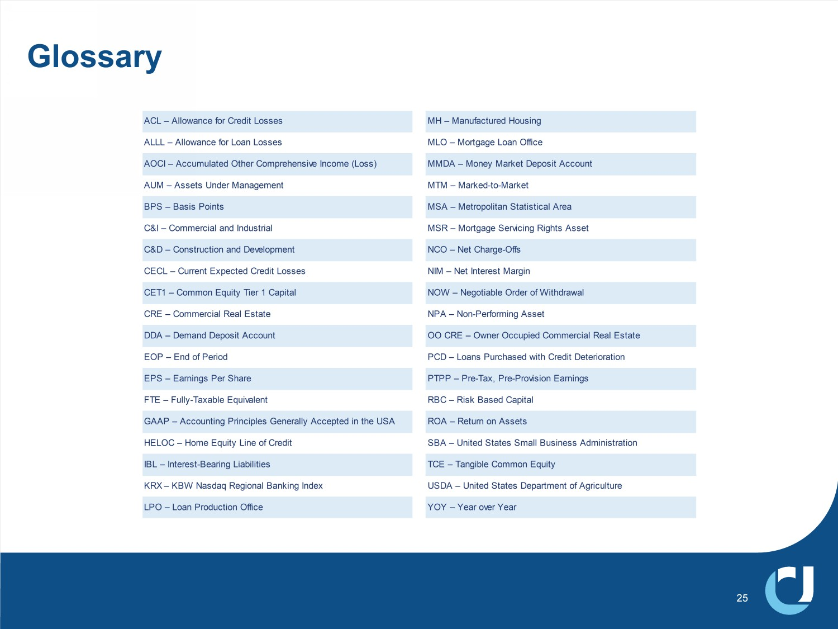
Glossary ACL – Allowance for Credit Losses MH – Manufactured Housing ALLL – Allowance for Loan Losses MLO – Mortgage Loan Office AOCI – Accumulated Other Comprehensive Income (Loss) MMDA – Money Market Deposit Account AUM – Assets Under Management MTM – Marked-to-Market BPS – Basis Points MSA – Metropolitan Statistical Area C&I – Commercial and Industrial MSR – Mortgage Servicing Rights Asset C&D – Construction and Development NCO – Net Charge-Offs CECL – Current Expected Credit Losses NIM – Net Interest Margin CET1 – Common Equity Tier 1 Capital NOW – Negotiable Order of Withdrawal CRE – Commercial Real Estate NPA – Non-Performing Asset DDA – Demand Deposit Account OO CRE – Owner Occupied Commercial Real Estate EOP – End of Period PCD – Loans Purchased with Credit Deterioration EPS – Earnings Per Share PTPP – Pre-Tax, Pre-Provision Earnings FTE – Fully-Taxable Equivalent RBC – Risk Based Capital GAAP – Accounting Principles Generally Accepted in the USA ROA – Return on Assets HELOC – Home Equity Line of Credit SBA – United States Small Business Administration IBL – Interest-Bearing Liabilities TCE – Tangible Common Equity KRX – KBW Nasdaq Regional Banking Index USDA – United States Department of Agriculture LPO – Loan Production Office YOY – Year over Year 25

