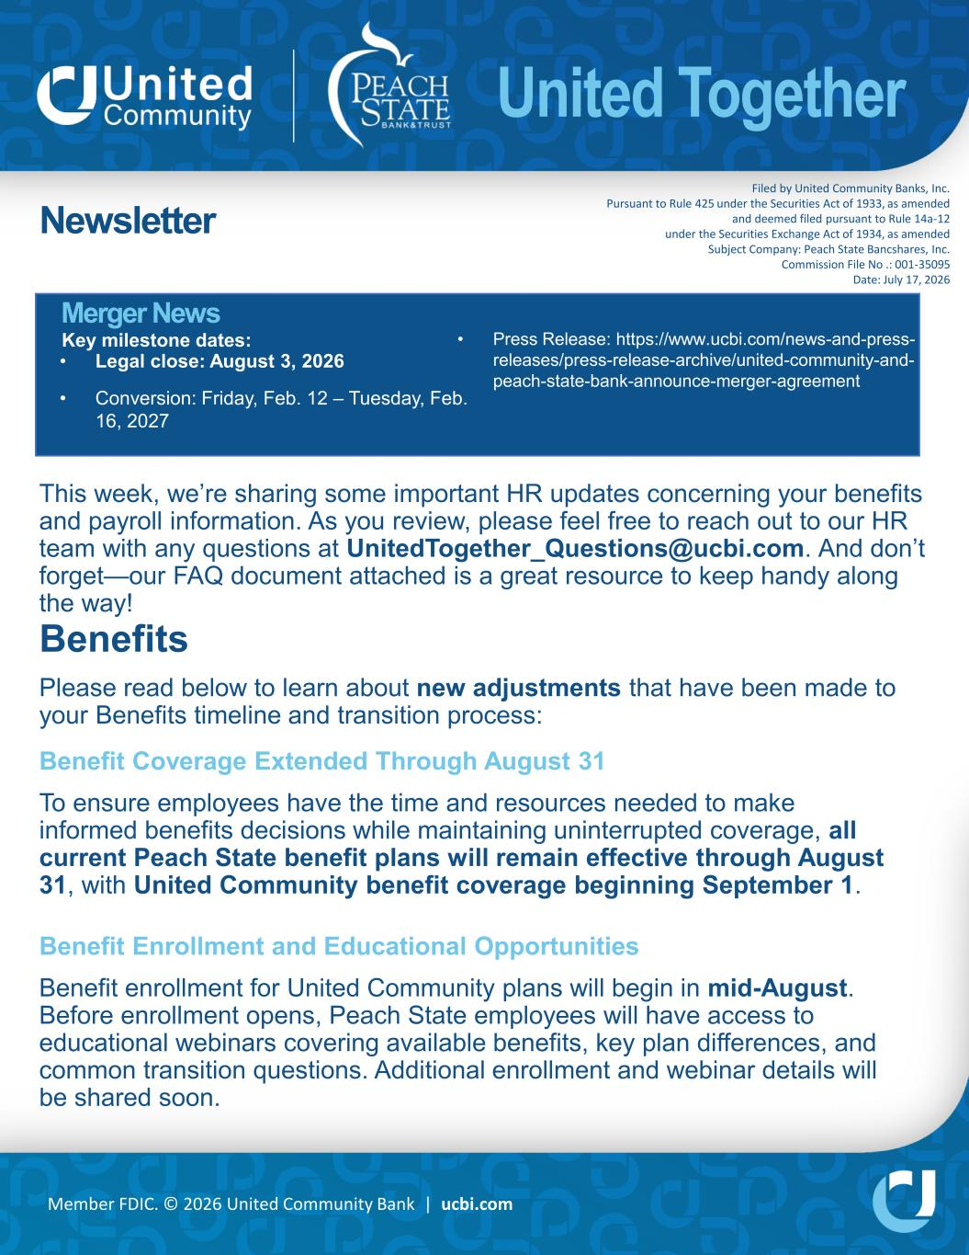
United Together Member FDIC. © 2026 United Community Bank | ucbi.com Newsletter Merger News Key milestone dates: • Legal close: August 3, 2026 • Conversion: Friday, Feb. 12 – Tuesday, Feb. 16, 2027 This week, we’re sharing some important HR updates concerning your benefits and payroll information. As you review, please feel free to reach out to our HR team with any questions at UnitedTogether_Questions@ucbi.com. And don’t forget—our FAQ document attached is a great resource to keep handy along the way! Benefits Please read below to learn about new adjustments that have been made to your Benefits timeline and transition process: Benefit Coverage Extended Through August 31 To ensure employees have the time and resources needed to make informed benefits decisions while maintaining uninterrupted coverage, all current Peach State benefit plans will remain effective through August 31, with United Community benefit coverage beginning September 1. Benefit Enrollment and Educational Opportunities Benefit enrollment for United Community plans will begin in mid-August. Before enrollment opens, Peach State employees will have access to educational webinars covering available benefits, key plan differences, and common transition questions. Additional enrollment and webinar details will be shared soon. Filed by United Community Banks, Inc. Pursuant to Rule 425 under the Securities Act of 1933, as amended and deemed filed pursuant to Rule 14a-12 under the Securities Exchange Act of 1934, as amended Subject Company: Peach State Bancshares, Inc. Commission File No .: 001-35095 Date: July 17, 2026 • Press Release: https://www.ucbi.com/news-and-press- releases/press-release-archive/united-community-and- peach-state-bank-announce-merger-agreement

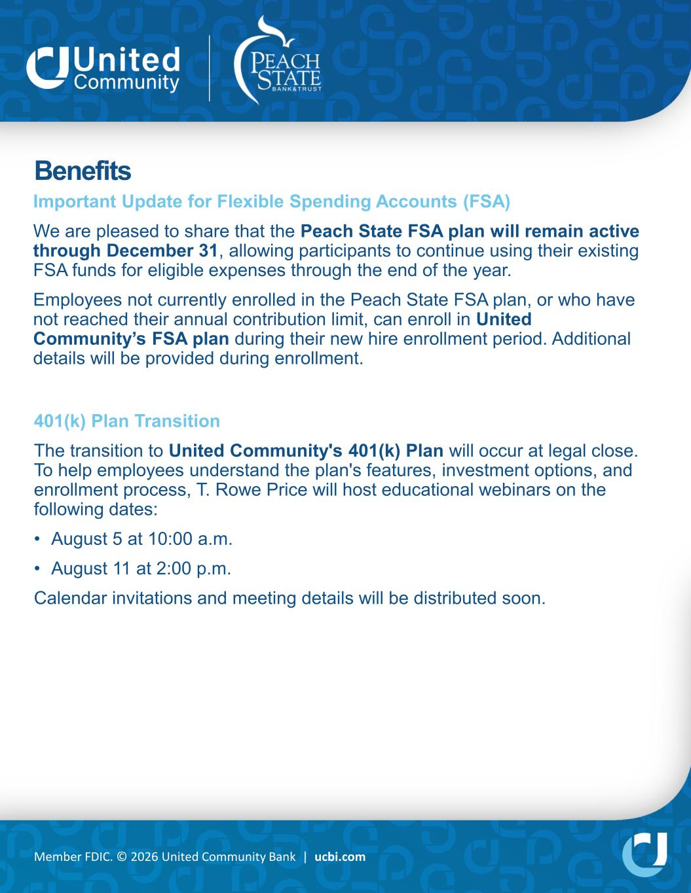
Member FDIC. © 2026 United Community Bank | ucbi.com Benefits Important Update for Flexible Spending Accounts (FSA) We are pleased to share that the Peach State FSA plan will remain active through December 31, allowing participants to continue using their existing FSA funds for eligible expenses through the end of the year. Employees not currently enrolled in the Peach State FSA plan, or who have not reached their annual contribution limit, can enroll in United Community’s FSA plan during their new hire enrollment period. Additional details will be provided during enrollment. 401(k) Plan Transition The transition to United Community's 401(k) Plan will occur at legal close. To help employees understand the plan's features, investment options, and enrollment process, T. Rowe Price will host educational webinars on the following dates: • August 5 at 10:00 a.m. • August 11 at 2:00 p.m. Calendar invitations and meeting details will be distributed soon.

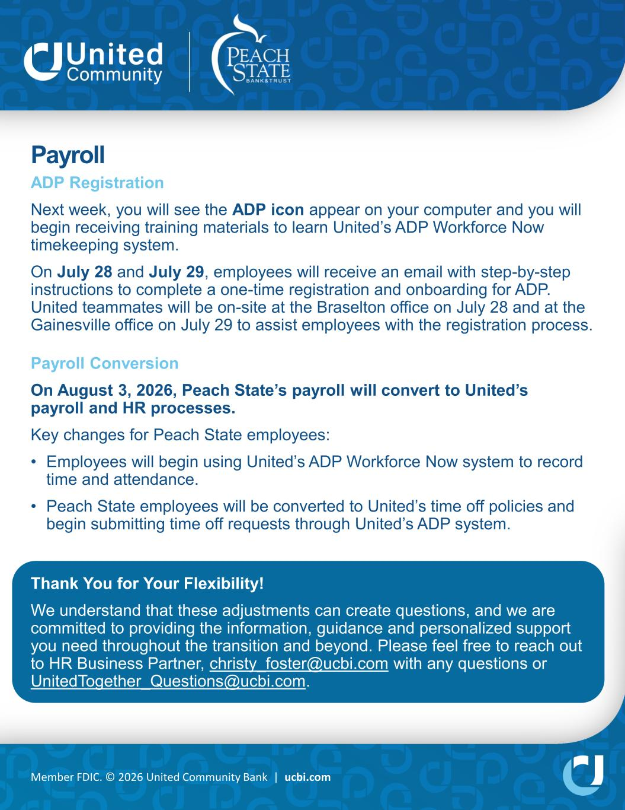
Member FDIC. © 2026 United Community Bank | ucbi.com Payroll ADP Registration Next week, you will see the ADP icon appear on your computer and you will begin receiving training materials to learn United’s ADP Workforce Now timekeeping system. On July 28 and July 29, employees will receive an email with step-by-step instructions to complete a one-time registration and onboarding for ADP. United teammates will be on-site at the Braselton office on July 28 and at the Gainesville office on July 29 to assist employees with the registration process. Payroll Conversion On August 3, 2026, Peach State’s payroll will convert to United’s payroll and HR processes. Key changes for Peach State employees: • Employees will begin using United’s ADP Workforce Now system to record time and attendance. • Peach State employees will be converted to United’s time off policies and begin submitting time off requests through United’s ADP system. Thank You for Your Flexibility! We understand that these adjustments can create questions, and we are committed to providing the information, guidance and personalized support you need throughout the transition and beyond. Please feel free to reach out to HR Business Partner, christy_foster@ucbi.com with any questions or UnitedTogether_Questions@ucbi.com.

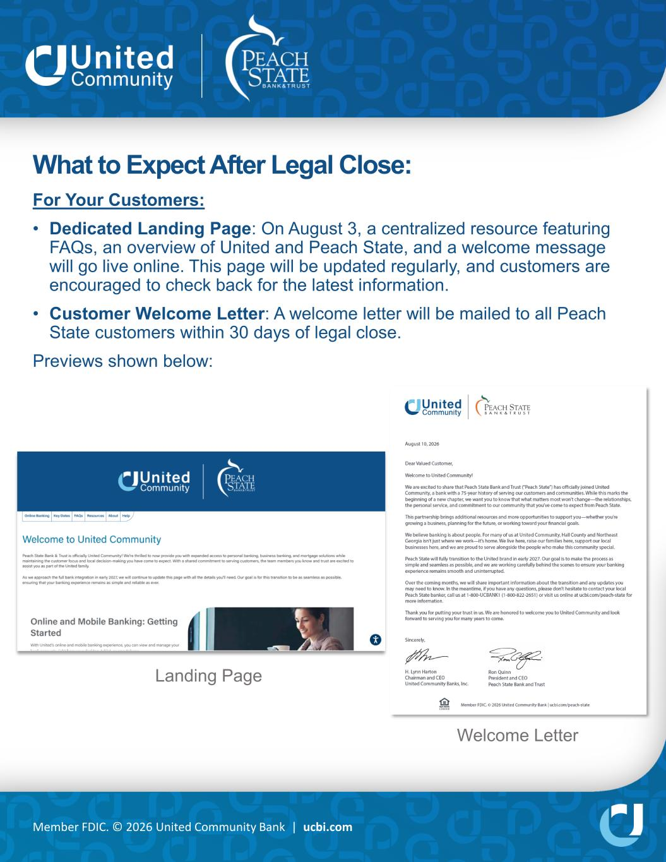
Member FDIC. © 2026 United Community Bank | ucbi.com What to Expect After Legal Close: For Your Customers: • Dedicated Landing Page: On August 3, a centralized resource featuring FAQs, an overview of United and Peach State, and a welcome message will go live online. This page will be updated regularly, and customers are encouraged to check back for the latest information. • Customer Welcome Letter: A welcome letter will be mailed to all Peach State customers within 30 days of legal close. Previews shown below: Welcome Letter Landing Page

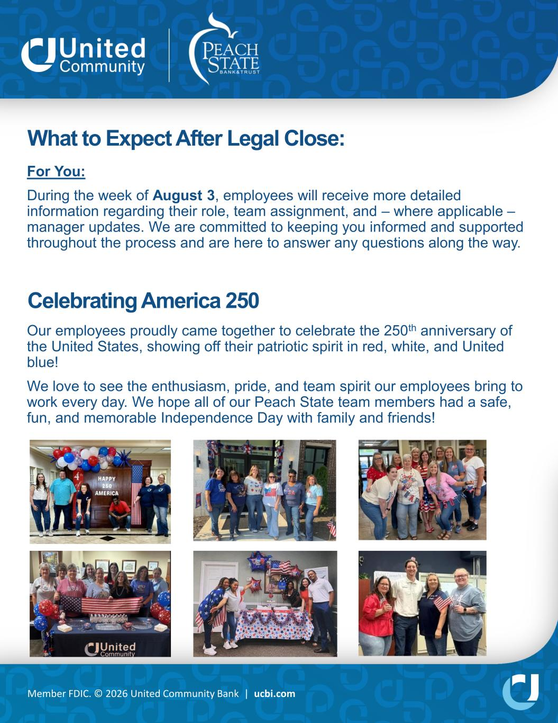
Member FDIC. © 2026 United Community Bank | ucbi.com What to Expect After Legal Close: For You: During the week of August 3, employees will receive more detailed information regarding their role, team assignment, and – where applicable – manager updates. We are committed to keeping you informed and supported throughout the process and are here to answer any questions along the way. Celebrating America 250 Our employees proudly came together to celebrate the 250th anniversary of the United States, showing off their patriotic spirit in red, white, and United blue! We love to see the enthusiasm, pride, and team spirit our employees bring to work every day. We hope all of our Peach State team members had a safe, fun, and memorable Independence Day with family and friends!

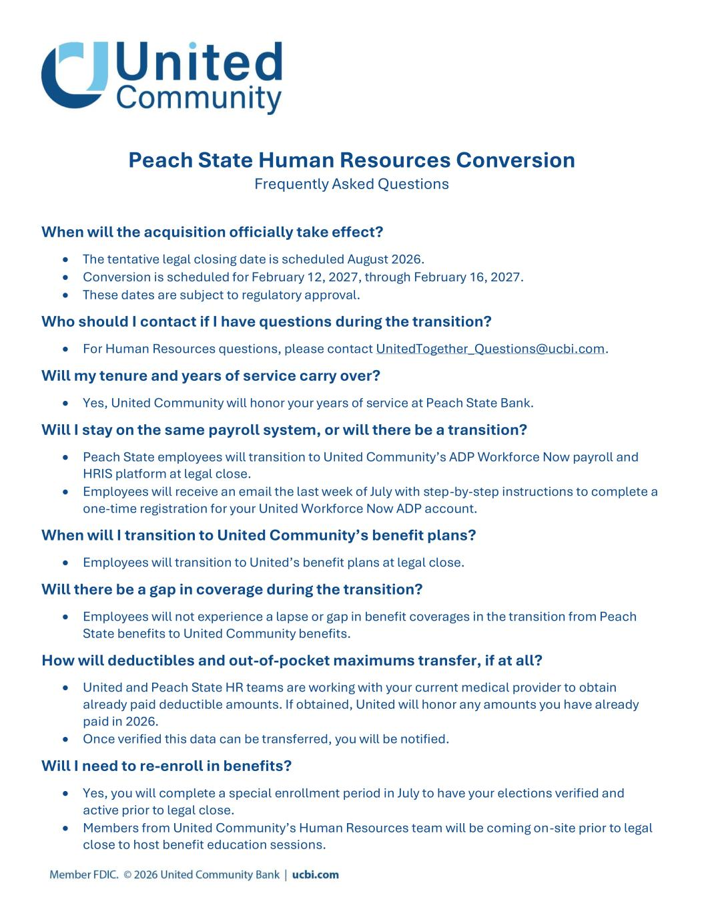
Peach State Human Resources Conversion Frequently Asked Questions When will the acquisition officially take effect? • The tentative legal closing date is scheduled August 2026. • Conversion is scheduled for February 12, 2027, through February 16, 2027. • These dates are subject to regulatory approval. Who should I contact if I have questions during the transition? • For Human Resources questions, please contact UnitedTogether_Questions@ucbi.com. Will my tenure and years of service carry over? • Yes, United Community will honor your years of service at Peach State Bank. Will I stay on the same payroll system, or will there be a transition? • Peach State employees will transition to United Community’s ADP Workforce Now payroll and HRIS platform at legal close. • Employees will receive an email the last week of July with step-by-step instructions to complete a one-time registration for your United Workforce Now ADP account. When will I transition to United Community’s benefit plans? • Employees will transition to United’s benefit plans at legal close. Will there be a gap in coverage during the transition? • Employees will not experience a lapse or gap in benefit coverages in the transition from Peach State benefits to United Community benefits. How will deductibles and out-of-pocket maximums transfer, if at all? • United and Peach State HR teams are working with your current medical provider to obtain already paid deductible amounts. If obtained, United will honor any amounts you have already paid in 2026. • Once verified this data can be transferred, you will be notified. Will I need to re-enroll in benefits? • Yes, you will complete a special enrollment period in July to have your elections verified and active prior to legal close. • Members from United Community’s Human Resources team will be coming on-site prior to legal close to host benefit education sessions.

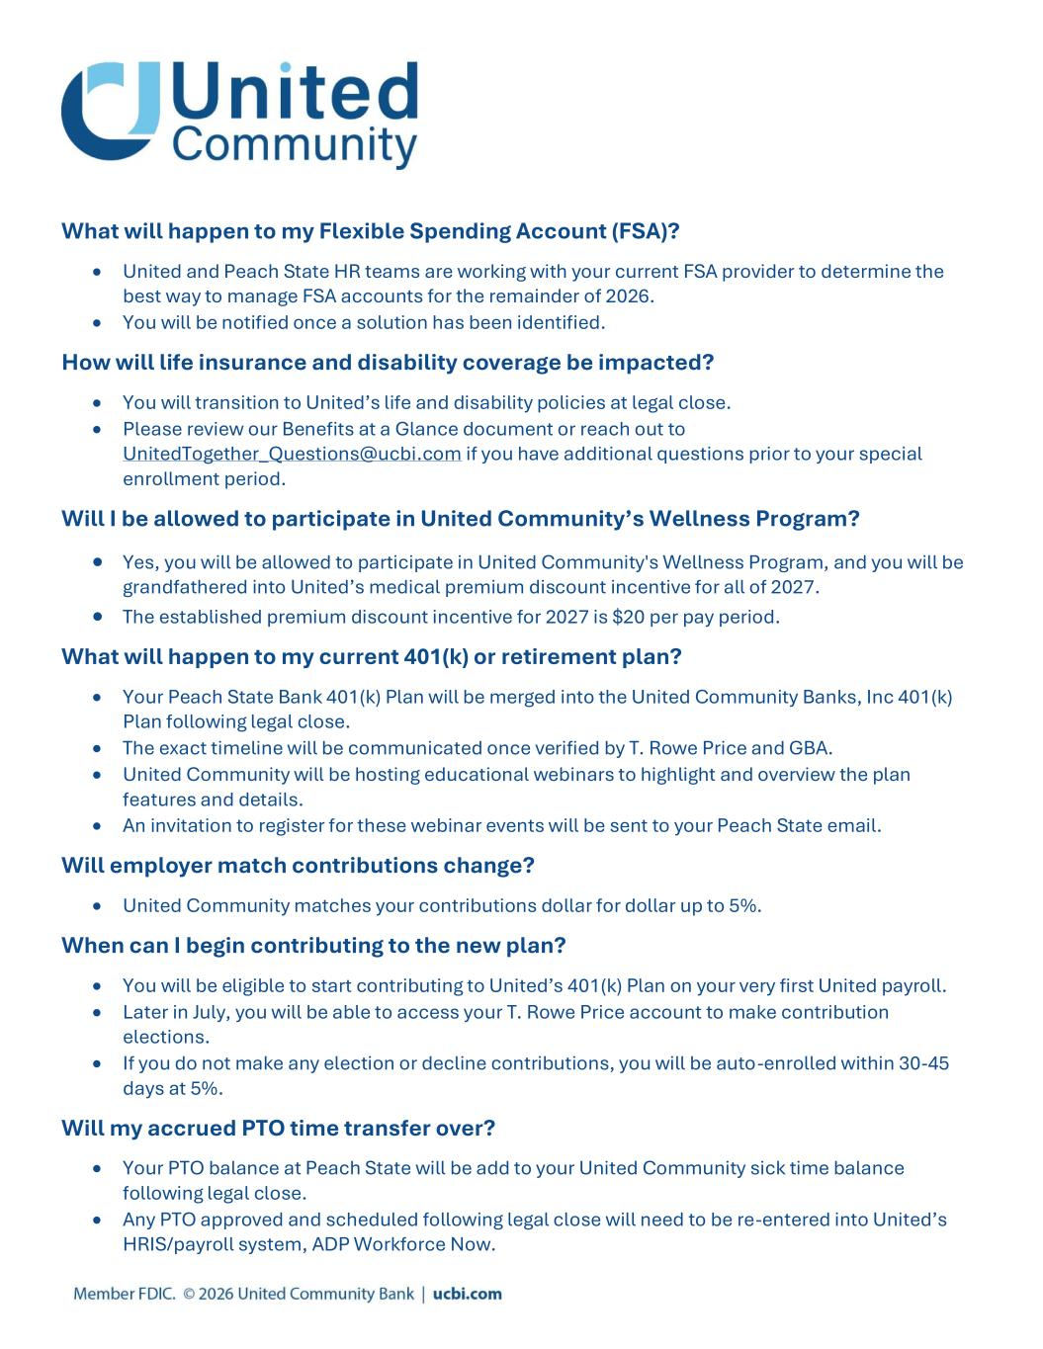
What will happen to my Flexible Spending Account (FSA)? • United and Peach State HR teams are working with your current FSA provider to determine the best way to manage FSA accounts for the remainder of 2026. • You will be notified once a solution has been identified. How will life insurance and disability coverage be impacted? • You will transition to United’s life and disability policies at legal close. • Please review our Benefits at a Glance document or reach out to UnitedTogether_Questions@ucbi.com if you have additional questions prior to your special enrollment period. Will I be allowed to participate in United Community’s Wellness Program? • Yes, you will be allowed to participate in United Community's Wellness Program, and you will be grandfathered into United’s medical premium discount incentive for all of 2027. • The established premium discount incentive for 2027 is $20 per pay period. What will happen to my current 401(k) or retirement plan? • Your Peach State Bank 401(k) Plan will be merged into the United Community Banks, Inc 401(k) Plan following legal close. • The exact timeline will be communicated once verified by T. Rowe Price and GBA. • United Community will be hosting educational webinars to highlight and overview the plan features and details. • An invitation to register for these webinar events will be sent to your Peach State email. Will employer match contributions change? • United Community matches your contributions dollar for dollar up to 5%. When can I begin contributing to the new plan? • You will be eligible to start contributing to United’s 401(k) Plan on your very first United payroll. • Later in July, you will be able to access your T. Rowe Price account to make contribution elections. • If you do not make any election or decline contributions, you will be auto-enrolled within 30-45 days at 5%. Will my accrued PTO time transfer over? • Your PTO balance at Peach State will be add to your United Community sick time balance following legal close. • Any PTO approved and scheduled following legal close will need to be re-entered into United’s HRIS/payroll system, ADP Workforce Now.

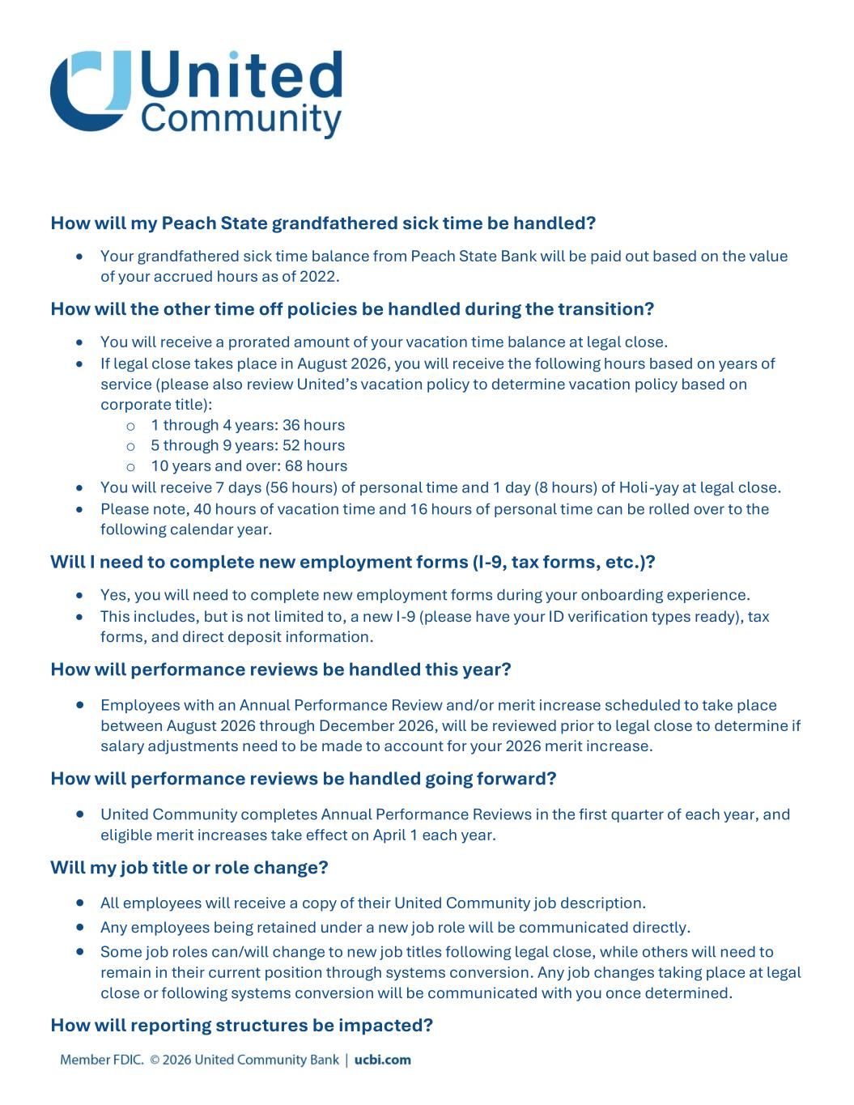
How will my Peach State grandfathered sick time be handled? • Your grandfathered sick time balance from Peach State Bank will be paid out based on the value of your accrued hours as of 2022. How will the other time off policies be handled during the transition? • You will receive a prorated amount of your vacation time balance at legal close. • If legal close takes place in August 2026, you will receive the following hours based on years of service (please also review United’s vacation policy to determine vacation policy based on corporate title): o 1 through 4 years: 36 hours o 5 through 9 years: 52 hours o 10 years and over: 68 hours • You will receive 7 days (56 hours) of personal time and 1 day (8 hours) of Holi-yay at legal close. • Please note, 40 hours of vacation time and 16 hours of personal time can be rolled over to the following calendar year. Will I need to complete new employment forms (I-9, tax forms, etc.)? • Yes, you will need to complete new employment forms during your onboarding experience. • This includes, but is not limited to, a new I-9 (please have your ID verification types ready), tax forms, and direct deposit information. How will performance reviews be handled this year? • Employees with an Annual Performance Review and/or merit increase scheduled to take place between August 2026 through December 2026, will be reviewed prior to legal close to determine if salary adjustments need to be made to account for your 2026 merit increase. How will performance reviews be handled going forward? • United Community completes Annual Performance Reviews in the first quarter of each year, and eligible merit increases take effect on April 1 each year. Will my job title or role change? • All employees will receive a copy of their United Community job description. • Any employees being retained under a new job role will be communicated directly. • Some job roles can/will change to new job titles following legal close, while others will need to remain in their current position through systems conversion. Any job changes taking place at legal close or following systems conversion will be communicated with you once determined. How will reporting structures be impacted?

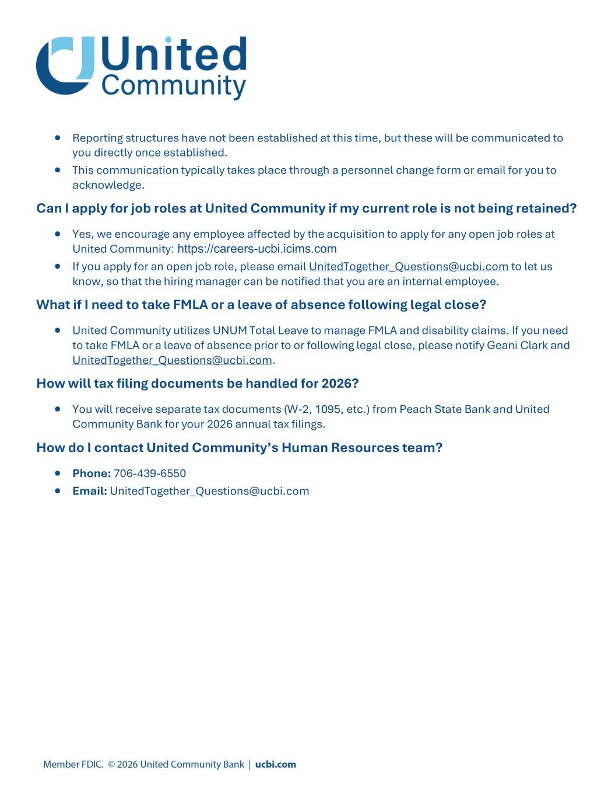
• Reporting structures have not been established at this time, but these will be communicated to you directly once established. • This communication typically takes place through a personnel change form or email for you to acknowledge. Can I apply for job roles at United Community if my current role is not being retained? • Yes, we encourage any employee affected by the acquisition to apply for any open job roles at United Community: https://careers-ucbi.icims.com • If you apply for an open job role, please email UnitedTogether_Questions@ucbi.com to let us know, so that the hiring manager can be notified that you are an internal employee. What if I need to take FMLA or a leave of absence following legal close? • United Community utilizes UNUM Total Leave to manage FMLA and disability claims. If you need to take FMLA or a leave of absence prior to or following legal close, please notify Geani Clark and UnitedTogether_Questions@ucbi.com. How will tax filing documents be handled for 2026? • You will receive separate tax documents (W-2, 1095, etc.) from Peach State Bank and United Community Bank for your 2026 annual tax filings. How do I contact United Community’s Human Resources team? • Phone: 706-439-6550 • Email: UnitedTogether_Questions@ucbi.com

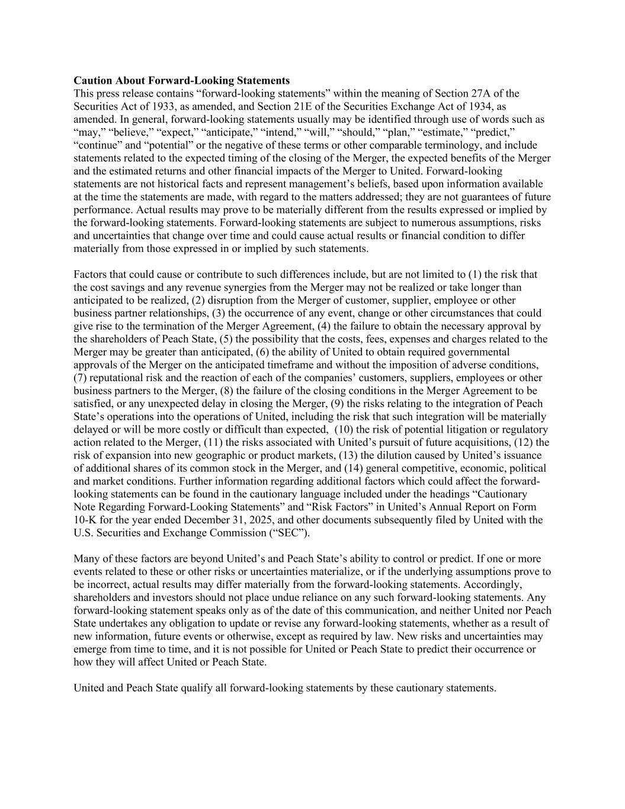
Caution About Forward-Looking Statements This press release contains “forward-looking statements” within the meaning of Section 27A of the Securities Act of 1933, as amended, and Section 21E of the Securities Exchange Act of 1934, as amended. In general, forward-looking statements usually may be identified through use of words such as “may,” “believe,” “expect,” “anticipate,” “intend,” “will,” “should,” “plan,” “estimate,” “predict,” “continue” and “potential” or the negative of these terms or other comparable terminology, and include statements related to the expected timing of the closing of the Merger, the expected benefits of the Merger and the estimated returns and other financial impacts of the Merger to United. Forward-looking statements are not historical facts and represent management’s beliefs, based upon information available at the time the statements are made, with regard to the matters addressed; they are not guarantees of future performance. Actual results may prove to be materially different from the results expressed or implied by the forward-looking statements. Forward-looking statements are subject to numerous assumptions, risks and uncertainties that change over time and could cause actual results or financial condition to differ materially from those expressed in or implied by such statements. Factors that could cause or contribute to such differences include, but are not limited to (1) the risk that the cost savings and any revenue synergies from the Merger may not be realized or take longer than anticipated to be realized, (2) disruption from the Merger of customer, supplier, employee or other business partner relationships, (3) the occurrence of any event, change or other circumstances that could give rise to the termination of the Merger Agreement, (4) the failure to obtain the necessary approval by the shareholders of Peach State, (5) the possibility that the costs, fees, expenses and charges related to the Merger may be greater than anticipated, (6) the ability of United to obtain required governmental approvals of the Merger on the anticipated timeframe and without the imposition of adverse conditions, (7) reputational risk and the reaction of each of the companies’ customers, suppliers, employees or other business partners to the Merger, (8) the failure of the closing conditions in the Merger Agreement to be satisfied, or any unexpected delay in closing the Merger, (9) the risks relating to the integration of Peach State’s operations into the operations of United, including the risk that such integration will be materially delayed or will be more costly or difficult than expected, (10) the risk of potential litigation or regulatory action related to the Merger, (11) the risks associated with United’s pursuit of future acquisitions, (12) the risk of expansion into new geographic or product markets, (13) the dilution caused by United’s issuance of additional shares of its common stock in the Merger, and (14) general competitive, economic, political and market conditions. Further information regarding additional factors which could affect the forward- looking statements can be found in the cautionary language included under the headings “Cautionary Note Regarding Forward-Looking Statements” and “Risk Factors” in United’s Annual Report on Form 10-K for the year ended December 31, 2025, and other documents subsequently filed by United with the U.S. Securities and Exchange Commission (“SEC”). Many of these factors are beyond United’s and Peach State’s ability to control or predict. If one or more events related to these or other risks or uncertainties materialize, or if the underlying assumptions prove to be incorrect, actual results may differ materially from the forward-looking statements. Accordingly, shareholders and investors should not place undue reliance on any such forward-looking statements. Any forward-looking statement speaks only as of the date of this communication, and neither United nor Peach State undertakes any obligation to update or revise any forward-looking statements, whether as a result of new information, future events or otherwise, except as required by law. New risks and uncertainties may emerge from time to time, and it is not possible for United or Peach State to predict their occurrence or how they will affect United or Peach State. United and Peach State qualify all forward-looking statements by these cautionary statements.

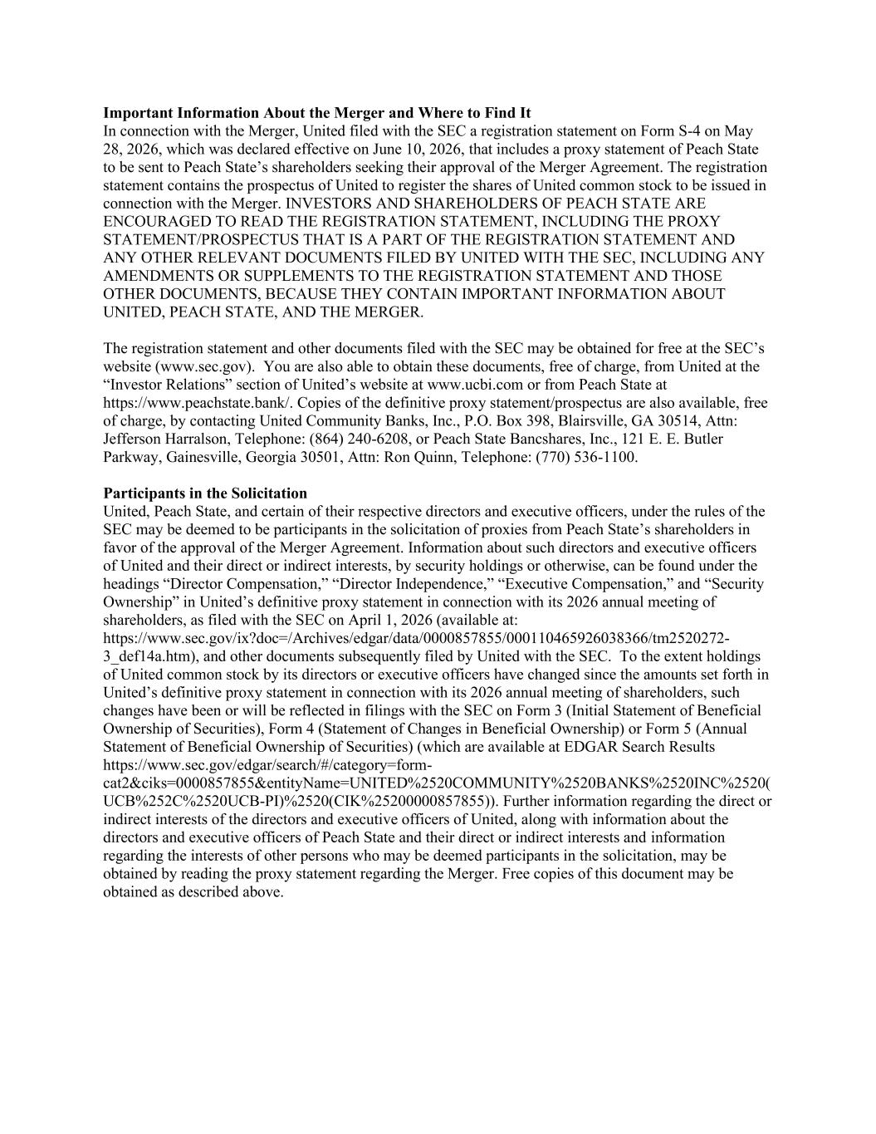
Important Information About the Merger and Where to Find It In connection with the Merger, United filed with the SEC a registration statement on Form S-4 on May 28, 2026, which was declared effective on June 10, 2026, that includes a proxy statement of Peach State to be sent to Peach State’s shareholders seeking their approval of the Merger Agreement. The registration statement contains the prospectus of United to register the shares of United common stock to be issued in connection with the Merger. INVESTORS AND SHAREHOLDERS OF PEACH STATE ARE ENCOURAGED TO READ THE REGISTRATION STATEMENT, INCLUDING THE PROXY STATEMENT/PROSPECTUS THAT IS A PART OF THE REGISTRATION STATEMENT AND ANY OTHER RELEVANT DOCUMENTS FILED BY UNITED WITH THE SEC, INCLUDING ANY AMENDMENTS OR SUPPLEMENTS TO THE REGISTRATION STATEMENT AND THOSE OTHER DOCUMENTS, BECAUSE THEY CONTAIN IMPORTANT INFORMATION ABOUT UNITED, PEACH STATE, AND THE MERGER. The registration statement and other documents filed with the SEC may be obtained for free at the SEC’s website (www.sec.gov). You are also able to obtain these documents, free of charge, from United at the “Investor Relations” section of United’s website at www.ucbi.com or from Peach State at https://www.peachstate.bank/. Copies of the definitive proxy statement/prospectus are also available, free of charge, by contacting United Community Banks, Inc., P.O. Box 398, Blairsville, GA 30514, Attn: Jefferson Harralson, Telephone: (864) 240-6208, or Peach State Bancshares, Inc., 121 E. E. Butler Parkway, Gainesville, Georgia 30501, Attn: Ron Quinn, Telephone: (770) 536-1100. Participants in the Solicitation United, Peach State, and certain of their respective directors and executive officers, under the rules of the SEC may be deemed to be participants in the solicitation of proxies from Peach State’s shareholders in favor of the approval of the Merger Agreement. Information about such directors and executive officers of United and their direct or indirect interests, by security holdings or otherwise, can be found under the headings “Director Compensation,” “Director Independence,” “Executive Compensation,” and “Security Ownership” in United’s definitive proxy statement in connection with its 2026 annual meeting of shareholders, as filed with the SEC on April 1, 2026 (available at: https://www.sec.gov/ix?doc=/Archives/edgar/data/0000857855/000110465926038366/tm2520272- 3_def14a.htm), and other documents subsequently filed by United with the SEC. To the extent holdings of United common stock by its directors or executive officers have changed since the amounts set forth in United’s definitive proxy statement in connection with its 2026 annual meeting of shareholders, such changes have been or will be reflected in filings with the SEC on Form 3 (Initial Statement of Beneficial Ownership of Securities), Form 4 (Statement of Changes in Beneficial Ownership) or Form 5 (Annual Statement of Beneficial Ownership of Securities) (which are available at EDGAR Search Results https://www.sec.gov/edgar/search/#/category=form- cat2&ciks=0000857855&entityName=UNITED%2520COMMUNITY%2520BANKS%2520INC%2520( UCB%252C%2520UCB-PI)%2520(CIK%25200000857855)). Further information regarding the direct or indirect interests of the directors and executive officers of United, along with information about the directors and executive officers of Peach State and their direct or indirect interests and information regarding the interests of other persons who may be deemed participants in the solicitation, may be obtained by reading the proxy statement regarding the Merger. Free copies of this document may be obtained as described above.

